

Drone Command Center

Autonomous Fleet Management System with Hybrid Reinforcement-Learning Navigation
Mohamad Alayli, 202301662
Dr. Seifedine Kadry
Department of Computer Science & Mathematics
Capstone
Spring 2026
May 5, 2026

Preface

About This Document
This document is the consolidated capstone report for the Drone Command Center (DCC) project. It covers the full end-to-end system backend services, mobile frontend, database schema, and an AI navigation layer that wraps the published NavRL deep reinforcement-learning framework [1] inside a hybrid planner suitable for structured urban environments simulated in Microsoft AirSim.

Acknowledgements
We acknowledge the authors of the NavRL framework, Z. Xu, X. Han, H. Shen, H. Jin, andK. Shimada at Carnegie Mellon University, whose published PPO-based navigation policy and LiDAR-based velocity-obstacle safety shield form the foundation of the AI layer evaluated in this work [1]. Microsoft Research is acknowledged for the AirSim simulator and the Unreal Engine 4 City environment used for evaluation.

Scope of This Document
The document describes the system as actually implemented all REST endpoints, database tables, Flutter screens, configuration keys, and AI modules referenced are present in the Drone Command Center repository at the time of submission. Items that have not yet been delivered are explicitly listed under Out of Scope in Figure1.3 and revisited in Chapter 10 (System Evolution and Roadmap).

Abstract
The Drone Command Center (DCC) is an autonomous fleet-management platform consisting of (i) a Spring Boot 4.0.2 backend exposing a versioned REST API, real-time WebSocket telemetry, stateless JWT authentication, and Hibernate-managed PostgreSQL persistence; (ii) a Flutter cross-platform frontend providing tactical dashboards, mission planning, drone telemetry visualization, and an interactive map; and (iii) an AI navigation layer that integrates the published NavRL deep reinforcement-learning framework [1] with a custom hybrid city planner combining A* global path planning, a city altitude state machine, Pure-Pursuit lookahead, and a velocity-obstacle (VO) safety shield.
The platform satisfies 45 functional and 35 non-functional requirements, spans 8 database tables governed by versioned migrations, exposes 8 REST endpoint groups plus a STOMP/SockJS WebSocket channel, and is delivered alongside a docker-compose stack that brings up the entire local development environment with a single command.
The AI layer was systematically benchmarked in Microsoft AirSim against a 12-waypoint urban roam mission spanning approximately 800 m of dense city terrain. The hybrid controller achieved a 75.00% goal-success rate at 0.69 collisions/km, compared with 36.66% / 9.31 collisions/km for pure NavRL alone a 2× improvement in success and a 13× reduction in collision rate, validating the central thesis that structured urban navigation requires global planning combined with reactive RL control.
This consolidated report documents the architecture, requirements, models, implementation, testing strategy evaluation results, entrepreneurial positioning, project management, and long-term roadmap of the integrated system.
Table of Contents
Preface ii
About This Document ii
Acknowledgements ii
Scope of This Document ii
1. Abstract iii
1.1 Background and Motivation 1
1.2 Problem Statement 3
1.3 Project Objectives 4
1.4 Scope 6
1.5 Significance and Document Organization 7
2. Literature Review 8
2.1 Drone Fleet-Management Platforms 9
2.1.1 Commercial and Open-Source Landscape 9
2.1.2 Modern Backend Architectures for IoT and Robotics 11
2.2 Traditional UAV Navigation 13
2.2.1 Classical Planning and Reactive Control 13
2.2.2 UAV Physical Modelling, Dynamics, and the Role of CAD 14
2.3 Deep Reinforcement Learning for UAV Navigation 16
2.3.1 From Q-Learning to Continuous-Control PPO 16
2.3.2 The NavRL Framework 17
2.3.3 Known Limitations of End-to-End DRL 19
2.4 Sim-to-Real Transfer 21
2.5 Hybrid Architectures and the Position of This Work 22
3. System Analysis & Design 24
3.1 Stakeholders & User Stories 24
Authentication and Identity (US-01 … US-04) 24
Drone Fleet (US-05 … US-09) 25
Mission Planning (US-10 … US-15) 25
Command and Control (US-16 … US-19) 26
Telemetry and Sensors (US-20 … US-23) 26
Operations (US-24 … US-26) 26
3.2 Use Cases 27
• UC Cluster A, Authentication 27
• UC Cluster B, Fleet Operations 28
• UC Cluster C, Mission Management 28
3.3 Functional & Non-Functional Requirements 29
3.3.1 Functional Requirements Authentication and User Management 29
3.3.2 Functional Requirements Drone Fleet Management 30
3.3.3 Functional Requirements Mission Management 31
3.3.4 Functional Requirements Command and Control 33
3.3.5 Functional Requirements Telemetry and Sensor Monitoring 34
3.3.6 Functional Requirements System Operations 35
3.3.7 Non-Functional Requirements Performance 36
3.3.8 Non-Functional Requirements Security 37
3.3.9 Non-Functional Requirements Reliability and Availability 38
3.3.10 Non-Functional Requirements Usability 38
3.3.11 Non-Functional Requirements Scalability and Maintainability 39
3.3.12 Non-Functional Requirements Portability 40
3.4 Four-Tier System Architecture 40
3.5 Backend Component Design 42
3.5.1 Five-Layer Security Model 43
3.5.2 Endpoint Authentication Matrix 44
3.6 Frontend Component Design 45
3.6.1 Riverpod State Topology 45
3.6.2 Tactical Design Tokens 46
3.7 Deployment Architecture 47
3.8 NavRL Theoretical Foundations 47
3.8.1 Markov Decision Process 47
3.8.2 Internal State 48
3.8.3 Lidar Observation 48
3.8.4 Action Distribution 49
3.8.5 World-Frame Transformation 49
3.8.6 Reward Components 50
3.8.7 PPO Clipped Objective 50
3.8.8 Curriculum 51
3.8.9 Velocity-Obstacle Safety Shield 53
3.8.10 Published Performance 54
3.9 Hybrid City-Planner Design 54
3.9.1 Pure-Pursuit Lookahead 55
3.9.2 Altitude State Machine 55
3.10.6 Hardware Design (CAD Model): 56
3.10.1 List of Parts 56
3.11 System Models 59
3.11.1 Entity-Relationship Model 60
3.11.2 Sequence User Authentication 61
3.11.3 Sequence Goal Dispatch and Auto-Mission Creation 61
3.11.4 Sequence Real-Time Telemetry 62
3.11.5 Telemetry Pipeline 62
3.4.4 Feasibility and Risk Analysis 62
4. Implementation 63
4.1 Development Methodology and Tooling 63
4.2 Backend Implementation (Spring Boot) 64
4.2.1 Module Map 64
4.2.2 Authentication Path 65
4.2.3 Validation, Errors, and Audit 65
4.3 Frontend Implementation (Flutter) 66
4.3.1 Routing and Guards 66
4.3.2 Networking Layer 66
4.3.3 Real-Time Telemetry 66
4.3.4 Map and Mission Visualization 67
4.4 AirSim Bridge and NavRL Integration 67
4.4.1 Component Overview 67
4.4.2 Inference Loop 68
4.4.3 Sensor Noise Injection 68
4.4.4 Database Schema and Migrations 69
5. Testing and Evaluation 69
5.1 Test Strategy Overview 69
5.2 Backend Testing 71
5.2.1 Unit Tests Service Layer 71
5.2.2 REST API Contract Testing (Postman) 72
5.2.3 OWASP ZAP Baseline Security Scan 78
5.2.4 JaCoCo Backend Test Coverage 79
5.3 Frontend Testing 82
5.3.1 Unit Tests 82
5.3.2 Widget Tests 82
5.4 NavRL + CityPlanner Quantitative Evaluation 90
5.4.1 Simulation Environment and Test Mission 90
5.4.2 Test Suites 92
5.4.3 Standard Suite Primary Benchmark 92
5.4.4 Ablation Study 95
5.4.5 Domain Randomization Suite 96
5.4.6 Sensor-Noise Suite 98
5.5 CAD Model Test: 99
5.6 Test Coverage Summary 105
6. Entrepreneurial and Innovation Aspects 106
6.1 Market and Research Relevance 106
6.2 Innovation Positioning 107
6.3 Ethical and Societal Considerations 108
6.4 Known Deviations from Requirements 108
7. Results and Discussion 109
7.1 Why Pure RL Fails at the City Scale 109
7.2 The Hybrid Architecture's Trade-offs 110
7.3 Altitude as a Navigation Dimension 111
7.4 Hardware Design for Real-World Deployment 112
7.5 Limitations 113
7.5.1 Autonomy-stack limitations 113
7.5.2 Software-platform limitations: 114
7.5.3 Sim-to-real gap: 114
8. Conclusion, Future Work and Roadmap 115
8.1 Summary of Contributions 115
8.2 Future Work 116
8.3 Roadmap 117
References 118
Appendix A Technology Stack 121
A.1 Backend Dependencies 121
A.2 Frontend Dependencies 122
Appendix B REST API Endpoint Catalogue 124
B.1 Authentication (/api/auth) 124
B.2 Drone Management (/api/drones) 125
B.3 Mission Management (/api/missions) 126
B.4 Commands (/api/commands) 127
B.5 Telemetry (/api/telemetry) 128
B.6 User Management (/api/users) 129
B.7 System (/actuator) 129
B.8 AirSim Bridge / NavRL / Logs 130
B.9 WebSocket 130
Appendix C Database Schema Reference 131
C.1 Table: users 131
C.2 Table: refresh_tokens 132
C.3 Table: drones 133
C.4 Table: missions 136
C.5 Table: waypoints 137
C.6 Table: telemetry 139
C.7 Table: sensors 140
C.8 Table: commands 141
Appendix D Enumeration Reference 143
Appendix E Frontend Screen Inventory 144
Appendix F Configuration Reference 145
F.1 Key application.properties Parameters 145
F.2 Environment Variables (Secrets) 147
Appendix G Document Control 148

1. Introduction

1.1 Background and Motivation
Unmanned aerial vehicles (UAVs) have transitioned from experimental platforms into operational infrastructure. They are now deployed routinely for power-line inspection, precision agriculture, parcel delivery, search-and-rescue coordination, and urban security patrol [2]. Market analysts project the global drone-services market will reach USD 63.6 billion by 2030, driven primarily by last-mile delivery, infrastructure inspection, and urban air mobility [6]. Operating a fleet of such vehicles at scale rather than a single manually piloted airframe introduces three distinct and largely unsolved engineering challenges that motivate this work.
Challenge 1 Fleet Management Infrastructure. Scaling from one drone to many demands a software platform capable of registering heterogeneous hardware, supervising concurrent missions with persistent waypoint sequences, issuing and auditing commands in real time, ingesting high-frequency telemetry from multiple airframes simultaneously, and authenticating a diverse operator base against a hardened API. Existing commercial offerings DJI FlightHub 2, Skydio Cloud, AirData UAV, and Auterion Suite address portions of this problem but are vendor-locked, closed-source, and priced on a per-airframe SaaS model that is prohibitive for academic labs, small rescue teams, and early-stage start-ups [2]. Open-source counterparts such as QGroundControl and the PX4 stack focus on single-airframe MAVLink piloting and lack first-class REST APIs, versioned schema management, or audit-grade command histories suitable for multi-operator deployments [2]. A side-by-side feature analysis against the requirements derived in Chapter 3 (Table 2–7) reveals that no publicly available platform combines, in a single coherent codebase, binary JWT authentication over a versioned REST API, a migration-controlled persistence layer that survives schema evolution, and an integrated AI navigation interface.
Challenge 2 Urban Autonomous Navigation. Classical autonomous navigation pipelines occupancy-grid SLAM combined with sampling-based planners (PRM, RRT, RRT*) and trajectory-optimization controllers (MPC, B-spline smoothing) produce near-optimal trajectories in static, well-mapped environments [3]. However, they degrade predictably in dense or dynamic urban scenes, where re-planning latency and local-minima entrapment behind extended façades dominate performance [3], [4]. Deep reinforcement-learning (DRL) approaches address these failure modes: reactive policies trained via PPO or SAC [10] operate from raw sensor input without explicit maps, are robust to partial observability, and have demonstrated successful sim-to-real transfer [1]. The NavRL framework [1], the state-of-the-art method adopted in this work, achieves up to 96% success in sparse static environments but its success rate falls below 40% when evaluated on dense procedurally generated city geometry, because its 4 m reaction horizon cannot route around buildings that subtend 30°–90° of horizontal LiDAR coverage (replicated and quantified in §5.4). Re-training the policy on new geometry requires hundreds of GPU-hours across 1,024 parallel agents [1], making environment-specific retraining impractical for most operators.
Challenge 3 System Integration and Physical Realizability. A navigation policy evaluated only in simulation, on hardware it will never run on, provides limited engineering assurance. The controller's commanded velocity range, admissible acceleration envelope, and inference latency budget are all bounded by the physical constants of the target airframe constants that must be derived from a physical model before any controller can be responsibly tuned [13]. Without an explicit hardware model, the gap between simulated performance and real-world deployability remains an act of faith.
This capstone takes the position that a practical drone-control system must close all three challenges simultaneously: a robust full-stack management platform, an autonomy layer that combines a frozen learned reactive policy with classical global planning and a velocity-obstacle safety shield, and a hardware model that grounds the autonomy stack in physical realizability. A high-level view of the resulting integrated system is presented in Figure 3.4 (System Overview) and unpacked in Chapter 3.

1.2 Problem Statement
The three challenges above give rise to three formally separated research questions, each addressed by a distinct component of this work and each evaluated by an independent validation method in Chapter 5:
- P1 Software Engineering Problem. Can a single open-source backend platform satisfy enterprise-ready architectures, for REST fleet management, real-time WebSocket telemetry, stateless JWT security, and schema-versioned persistence, while remaining small enough to be deployed and extended by a small team without vendor infrastructure? Validated by: functional and non-functional requirements compliance testing, REST contract coverage (Postman, 48 endpoints), security audit (JWT integrity, rate limiting, OWASP header verification), and WebSocket latency measurement against NFR-02 (≤1 s).
- P2 Autonomous Navigation Problem. Can a hybrid architecture wrapping the published, frozen NavRL policy inside a deterministic city planner without retraining substantially outperform pure end-to-end DRL in both task success rate and collision rate on a structured 12-waypoint urban mission in Microsoft AirSim? Validated by: paired quantitative evaluation across a standard suite (n = 5), an ablation study (5 controller variants × n = 5), a domain-randomization suite (5 weather conditions), and a sensor-noise suite (4 LiDAR degradation levels × n = 5).
- P3 Physical Realizability Problem. Can the autonomy stack's commanded velocity range and inference latency budget be grounded in a physically credible airframe model, demonstrating that real-world deployment is mechanically and computationally feasible? Validated by: a Fusion 360 CAD model with interference, structural thickness, mass/CoG, and aerodynamic drag analysis; and a full hybrid-stack runtime budget estimate on the target NVIDIA Jetson Orin NX compute platform (Table 31).
Together, these three questions define the engineering scope of the Drone Command Center (DCC) and constitute the evaluation criteria against which the system is assessed in Chapter 5.

1.3 Project Objectives
Mapped directly to the three problem statements above, the project pursues five objectives:
- O1 Backend Platform (addresses P1). Design and implement a Spring Boot 4.0.2 service exposing 9 REST endpoint groups (authentication, drone fleet, missions, commands, telemetry, users, AirSim bridge, NavRL, logs), a STOMP/SockJS WebSocket telemetry channel, stateless JWT authentication with Bucket4j rate limiting, and a Flyway-versioned PostgreSQL schema across 8 tables, satisfying the 45 functional and 35 non-functional requirements catalogued in §3.3.
- O2 Frontend Application (addresses P1). Design and implement a Flutter cross-platform operator console supporting 11 screens (splash, login, register, dashboard, drone list/detail, mission list/detail, map, settings), Riverpod state management, Dio HTTP client with interceptor-based token refresh, WebSocket-driven Real-Time Telemetry visualization, and an interactive OpenStreetMap mission overlay.
- O3 AI Navigation Layer (addresses P2). Integrate the published NavRL policy [1] used unchanged, without retraining with a custom four-layer hybrid city planner comprising A* global path planning, an altitude state machine, Pure-Pursuit lookahead sub-goal injection, and a velocity-obstacle safety shield. Evaluate the complete stack on a fixed 12-waypoint urban roam mission in the Microsoft AirSim UE4 City environment.
- O4 Quantitative Validation (addresses P2). Demonstrate through a paired ablation study and domain-randomization and sensor-noise robustness suites that the hybrid controller substantially outperforms pure NavRL on both task success rate and collision rate, with effect sizes sufficient to support the central engineering thesis.
- O5 Hardware Integration Model (addresses P3). Produce a Fusion 360 CAD model of the target airframe (DJI F450 configuration with NVIDIA Jetson Orin NX payload bay) and extract the mass, inertia tensor, center-of-gravity offset, and aerodynamic drag parameters used by the AirSim vehicle configuration and the dynamic model of §2.2, demonstrating the physical realizability of the autonomy stack at the commanded velocity envelope.

1.4 Scope
In Scope
- Backend 9 REST endpoint groups, WebSocket telemetry, stateless JWT + Bucket4j rate limiting, PostgreSQL schema (8 tables, Hibernate-managed; V1 and V2 Flyway migrations applied during setup; runtime migration disabled per §4.4 with rationale).
- Frontend 11 screens, Riverpod state management, Dio HTTP client, web_socket_channel, fl_chart, flutter_map.
- AI Integration AirSim 1.8.1 + UE4 City environment; NavRL policy wrapped via nav_worker.py; hybrid planning orchestrated by navrl_city_planner.py.
- Quantitative Evaluation Paired ablation suite, sensor-noise suite, weather/domain-randomization suite; ≥30 total trials per condition; full statistical tables and Figures.
- Hardware Design Artefact Fusion 360 CAD model of airframe and Jetson Orin NX payload bay (proof-of-concept; no manufactured prototype).
Out of Scope (Deferred to Roadmap, §8.2)
- Real-hardware flight tests on physical UAVs.
- Multi-tenant SaaS deployment and Kubernetes Helm-chart packaging.
- Live video streaming (WebRTC / HLS) per drone.
- Regulatory compliance modules (FAA Part 107, EASA U-Space).
- Geofence enforcement runtime engine (data model only is in scope).
The explicit out-of-scope boundary ensures that each in-scope deliverable can be fully validated within the project timeline, and that deferred items are traceable to the roadmap in §8.2 rather than silently absent.

1.5 Significance and Document Organization
The Drone Command Center delivers three compounding contributions. First, it is, to the best of the authors' knowledge, the only open-source platform that combines a versioned REST fleet-management API, real-time WebSocket telemetry, and an integrated AI navigation interface in a single deployable codebase directly filling the feature gap identified in §1.1 and Table 1 (Chapter 2). Second, it demonstrates that a frozen, published RL policy can be augmented with a classical city planner to achieve a 2× improvement in goal-success rate and a 13× reduction in collision rate on structured urban terrain, without retraining and without proprietary infrastructure a result with direct commercial significance for operators who cannot absorb the GPU cost of domain-specific policy retraining. Third, the reproducible test harness (capstone_test_runner.py + analyze_results.py) produces deterministic CSV summaries and Figures from a single command, lowering the barrier for follow-on research to compare alternative planners against the same baseline.
The platform directly benefits three stakeholder groups: (i) academic UAV research labs requiring a free, inspectable alternative to FlightHub 2 and Skydio Cloud; (ii) low-budget search-and-rescue and humanitarian-response teams who need multi-drone fleet supervision without per-airframe fees; and (iii) early-stage robotics start-ups that need a defensible, well-tested engineering baseline on which to build a commercial product. The entrepreneurial implications are developed fully in Chapter 6.
Document Organization. Chapter 2 reviews related literature across fleet management, classical navigation, deep reinforcement learning, and hybrid architectures. Chapter 3 presents the full analysis and design phase: stakeholders, use cases, the FR/NFR catalogue, four-tier architecture, NavRL theoretical foundations, hybrid planner design, and the Fusion 360 hardware model. Chapter 4 describes the implementation. Chapter 5 presents the multi-layer test and evaluation strategy, including the quantitative AI evaluation and its statistical analysis. Chapters 6 through 8 address entrepreneurial positioning, results and discussion, and conclusions with future work. Appendices A through G provide the technology stack, REST endpoint catalogue, database schema reference, enumeration definitions, screen inventory, and configuration reference.

2. Literature Review
This chapter situates the Drone Command Center (DCC) within four bodies of literature: (i) commercial and open-source drone fleet-management platforms and the backend architectures that underpin them, (ii) classical UAV navigation and the physical modelling that drives controller design, (iii) deep reinforcement learning for UAV navigation, and (iv) sim-to-real transfer strategies. The chapter closes with a synthesis of hybrid autonomy architectures that establishes the novel positioning of this work and identifies the specific gap it fills.

2.1 Drone Fleet-Management Platforms

2.1.1 Commercial and Open-Source Landscape
Commercial fleet-management platforms DJI FlightHub 2, Skydio Cloud, AirData UAV, and Auterion Suite each address portions of the multi-drone supervision problem. DJI FlightHub 2 provides live map tracking, remote diagnostics, and mission replay for DJI hardware exclusively; its underlying API schema and storage layer are closed to operators [2]. Skydio Cloud offers autonomous obstacle-avoidance flights and a web dashboard but is architecturally coupled to Skydio airframes and provides no third-party REST surface for custom UI development. AirData UAV aggregates post-flight telemetry logs from multiple manufacturers but operates as a passive analytics layer, not a real-time command and control platform. Auterion Suite is the most enterprise-featured offering, exposing a MAVLink-compatible API and role-based access control, but its pricing model a per-airframe, per-month SaaS subscription places it out of reach for academic labs, small rescue teams, and early-stage start-ups [2].
Open-source counterparts occupy a different point in the design space. QGroundControl (QGC), maintained by the Dronecode Foundation, and the PX4 autopilot stack [2] are the dominant open-source tools for MAVLink-based UAV operation. Both excel at single-airframe manual and semi-autonomous piloting: QGC provides a rich ground-control station UI with real-time HUD and parameter editing, while PX4 closes the inner attitude-control loop at 400 Hz on supported flight controllers. However, neither was designed for multi-user, multi-drone fleet supervision. There is no first-class concept of a persistent mission entity with an ordered waypoint sequence, no audit-grade command history with per-user attribution, no RESTful API surface for third-party integrations, and no schema-versioned persistence layer that survives software upgrades without manual database intervention.
A structured feature comparison against the 45 functional requirements derived in Chapter 3 is presented in Table 1 (Figure 1). The analysis reveals that no publicly available platform commercial or open-source combines all of the following in a single coherent, self-hostable codebase: (i) stateless JWT authentication over a versioned REST API, (ii) a migration-controlled persistence layer that survives schema evolution without data loss, and (iii) an integrated AI navigation interface with a velocity-obstacle safety shield. The DCC is positioned to fill this gap as an open, academically reproducible reference platform that is compact enough to be read end-to-end by a graduate student and complete enough to form the foundation of a commercial product.
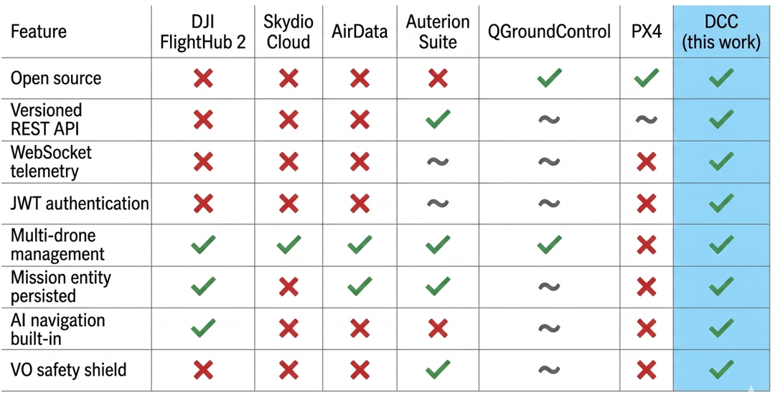
Figure 1 Feature matrix highlighting the gap addressed by the DCC.

2.1.2 Modern Backend Architectures for IoT and Robotics
- The choice of backend technology for a real-time fleet management platform is not architecturally neutral. Three established patterns exist in the IoT and robotics literature, and their trade-offs are relevant to the DCC's design decisions.
- Monolithic embedded controllers (e.g., C++/ROS2 nodes running directly on the companion computer) minimize round-trip latency and avoid network dependency, but couple the business logic to the hardware platform, make multi-user access control difficult to layer cleanly, and resist horizontal scaling [17]. This architecture is well suited to single-vehicle research platforms but is inappropriate for multi-drone fleet supervision.
- Microservice mesh architectures (e.g., Kubernetes-orchestrated gRPC services) offer maximum scalability and fault isolation but introduce significant operational complexity: service discovery, distributed tracing, and inter-service authentication all require dedicated infrastructure [17]. For a platform targeting academic labs and small operators without DevOps teams, this complexity is a barrier to adoption rather than a benefit.
- Modular monoliths with layered REST + WebSocket represent the pragmatic middle ground widely adopted by mid-market IoT SaaS products banking back-offices, energy-metering platforms, and industrial telemetry systems alike [17], [18]. Spring Boot has emerged as the leading Java framework for this pattern because it (a) ships an embedded servlet container that containerizes with a single Dockerfile, (b) integrates first-class WebSocket support (RFC 6455) for low-latency telemetry push, (c) exposes Spring Actuator endpoints for production observability without additional tooling, and (d) provides a clean migration path toward microservices via Spring Cloud without forcing the architectural commitment upfront [18]. Critically, Spring Boot's security stack (Spring Security with stateless JWT) and schema-migration support (Flyway) are mature, well-documented, and independently audited properties that justify the "enterprise-grade" label used in Chapter 1 and that would require significant custom engineering to replicate on a bespoke C++/MAVLink stack.
- Transport layer selection for Real-Time Telemetry involves a three-way trade-off among latency, bandwidth, and client-side compatibility. MQTT over TCP achieves the lowest bandwidth through binary framing and QoS guarantees but requires a broker process and has limited native support in browser-based clients [17]. gRPC streaming provides strongly typed contracts and efficient Protobuf encoding but imposes a binary-codec overhead that is difficult to consume from Flutter Web without additional bridging [18]. Raw WebSocket (RFC 6455) offers the lowest latency among the three and enjoys first-class browser and Flutter support via the web_socket_channel package. Given the DCC's dominant client (Flutter Web/desktop) and a message volume of approximately 10 Hz per drone well below the threshold at which gRPC's binary efficiency becomes advantageous WebSocket is the justified choice.
- Persistence for telemetry-heavy IoT workloads has likewise consolidated around PostgreSQL with optional JSONB columns, which combines relational guarantees (foreign keys, transactions, schema migrations) with the semi-structured flexibility needed for sensor payloads of variable shape [19]. The DCC adopts this pattern across eight Hibernate-managed tables, supplemented by Flyway versioned migrations for controlled schema evolution.

2.2 Traditional UAV Navigation

2.2.1 Classical Planning and Reactive Control
Classical autonomous navigation pipelines operate on three nested temporal scales. At the slowest scale (≈1 Hz), a SLAM algorithm such as LOAM, ORB-SLAM3, or FAST-LIO2 [8] maintains a consistent occupancy map from sensor data. At an intermediate scale (≈1–5 Hz), a global planner typically a sampling-based method such as PRM, RRT, or RRT* computes a collision-free path through the map [3]. At the fastest scale (≈20–50 Hz), a reactive controller artificial potential fields (APF) [4], dynamic window approach (DWA) [12], or velocity obstacles (VO) [11] handles moving obstacles and trajectory deviations between planning cycles.
Each component has well-characterized failure modes. Sampling-based planners such as RRT* are probabilistically complete and asymptotically optimal under accurate maps but suffer from high re-planning latency in dynamic environments where the map changes faster than the planner can recompute [3]. APF controllers are computationally cheap and real-time safe but are prone to local minima: a drone approaching a concave obstacle such as a building recess can become trapped in a potential well with no gradient toward the goal [4]. DWA and VO handle dynamic obstacles more gracefully by reasoning over future velocity trajectories, but their planning horizon is bounded by the sensor range, leaving them blind to obstacles beyond it [11], [12].
In dense procedurally generated urban environments the evaluation domain of this work all three failure modes are simultaneously active: the map updates slowly relative to the drone's speed, buildings create large concave local-minima regions, and the sensor range (4 m for the NavRL LiDAR configuration) is far shorter than the scale of the obstacles (multi-story buildings of 10–30 m). It is precisely this compound failure that motivates the adoption of a learned reactive layer (§2.3) layered on top of a classical global planner (Chapter 3): the classical planner eliminates the global topology problem that the reactive layer cannot solve, while the learned policy handles dynamic local avoidance that the classical planner cannot anticipate.

2.2.2 UAV Physical Modelling, Dynamics, and the Role of CAD
Every classical controller PID, LQR, MPC alike is parameterized by the physical constants of the airframe it commands. The standard quadrotor model expresses linear and angular dynamics as
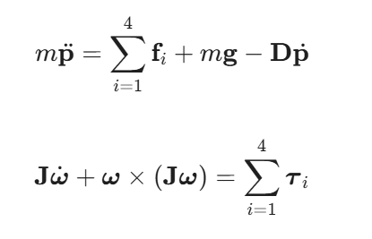
where m is the take-off mass, J the moment-of-inertia tensor, D a linear-drag coefficient, and {$f_{i},T_{i}$ }the rotor forces and body-torques. The control law's stability margins, the maximum admissible commanded velocity, the achievable hover endurance, and the safe minimum altitude over a given payload mass all depend on these constants; all of them must be measured or derived from a physical model before a controller can be tuned [13].
For this reason, this work includes an explicit physical-modelling stage: a Fusion 360 CAD model of the target airframe (see §3.7 and Appendix C) is used to estimate take-off mass, the principal moments of inertia $J_{xx}, J_{yy}, J_{zz},$ the centre-of-mass offset under a Jetson-Orion-NX payload, and the propeller-rotor arm length. These constants establish the bounded-velocity range that the NavRL Beta-distribution action head (§2.3) must respect, and they inform the runtime budget of the safety shield (§7.4). Without such a model, the autonomy stack would be evaluated only in simulation and the physical realizability of its commanded velocities would remain an act of faith exactly the gap that classical robotics literature has long warned against [3], [13].
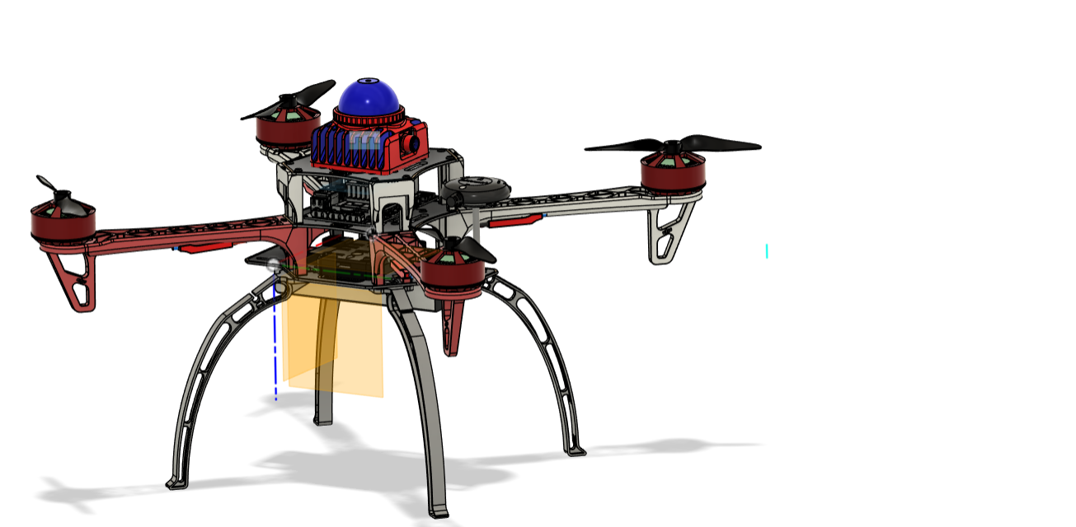
Figure 2 Fusion 360 CAD of the prototype airframe. X-configuration plastic fiber glass frame, four brushless motor mounts, central avionics tray housing the flight controller, small computer and lidar device (blue dome), and the battery bay. Used to extract mass and arm-length parameters for the dynamic model.

2.3 Deep Reinforcement Learning for UAV Navigation

2.3.1 From Q-Learning to Continuous-Control PPO
Deep reinforcement learning has produced increasingly capable UAV navigation policies over the past decade. Early DQN-based approaches discretized the action space into coarse heading and altitude bins and operated from compressed visual observations [5]; they demonstrated proof-of-concept obstacle avoidance but could not generalize beyond the specific obstacle densities of their training environments. The A3C algorithm [5] enabled asynchronous parallel training that substantially improved sample efficiency, making it feasible to train policies in simulation at the scale required for urban navigation research.
Modern UAV navigation research has converged on two continuous-control algorithms: Proximal Policy Optimization (PPO) [10] and Soft Actor-Critic (SAC) [9]. Both operate directly over continuous velocity command spaces three translational axes plus optional yaw and are stable under the partial observability typical of LiDAR-only sensing, where the drone cannot observe obstacles beyond the sensor's maximum range. PPO's clipped surrogate objective prevents destructive policy updates during training, making it more suitable for curriculum-based training schedules where environment difficulty increases progressively. SAC's entropy-maximization objective encourages broader exploration and can achieve higher asymptotic performance, but at the cost of greater sensitivity to reward shaping. NavRL adopts PPO for these reasons [1], and the theoretical foundations of its objective function are developed in §3.8.

2.3.2 The NavRL Framework
Among UAV-targeted DRL methods published through 2025, NavRL [1] is one of the most thoroughly characterized in terms of both training methodology and real-world validation. Its architecture combines three design choices that distinguish it from earlier reactive policies.
First, it uses a 36-ray, 360° horizontal LiDAR observation reshaped into a 35 × 4 temporal history matrix, encoding both spatial and temporal obstacle information. Crucially, raw range readings are inverted closer obstacles produce larger activations making the gradient signal from nearby obstacles stronger and facilitating faster learning of avoidance behavior.
Second, the actor network outputs the parameters (α, β) of a Beta distribution rather than the mean and variance of a Gaussian. This choice is motivated by the bounded nature of the velocity command space: a Beta distribution on [0, 1] has compact support, eliminating the clipping artefacts that arise when a Gaussian policy places probability mass outside the admissible velocity range. The exploration variance is controlled jointly through (α, β) rather than through a separately maintained σ, removing one hyperparameter from the training procedure.
Third, NavRL's dense reward function shapes five simultaneous behaviors: goal-seeking progress, smooth trajectories (jerk minimization), obstacle clearance, altitude maintenance, and terminal goal-reaching. This multi-component shaping substantially accelerates curriculum progression relative to sparse reward formulations.
On its own published evaluation suite [1], the trained policy attains near- saturation success in sparse static environments (96%) and maintains acceptable performance in dense dynamic scenarios (82%). It demonstrates successful sim-to- real transfer onto a physical quadrotor with NVIDIA Jetson Orin NX on-board inference at a total pipeline latency of 65 ms within the 50 ms control budget at 20 Hz.
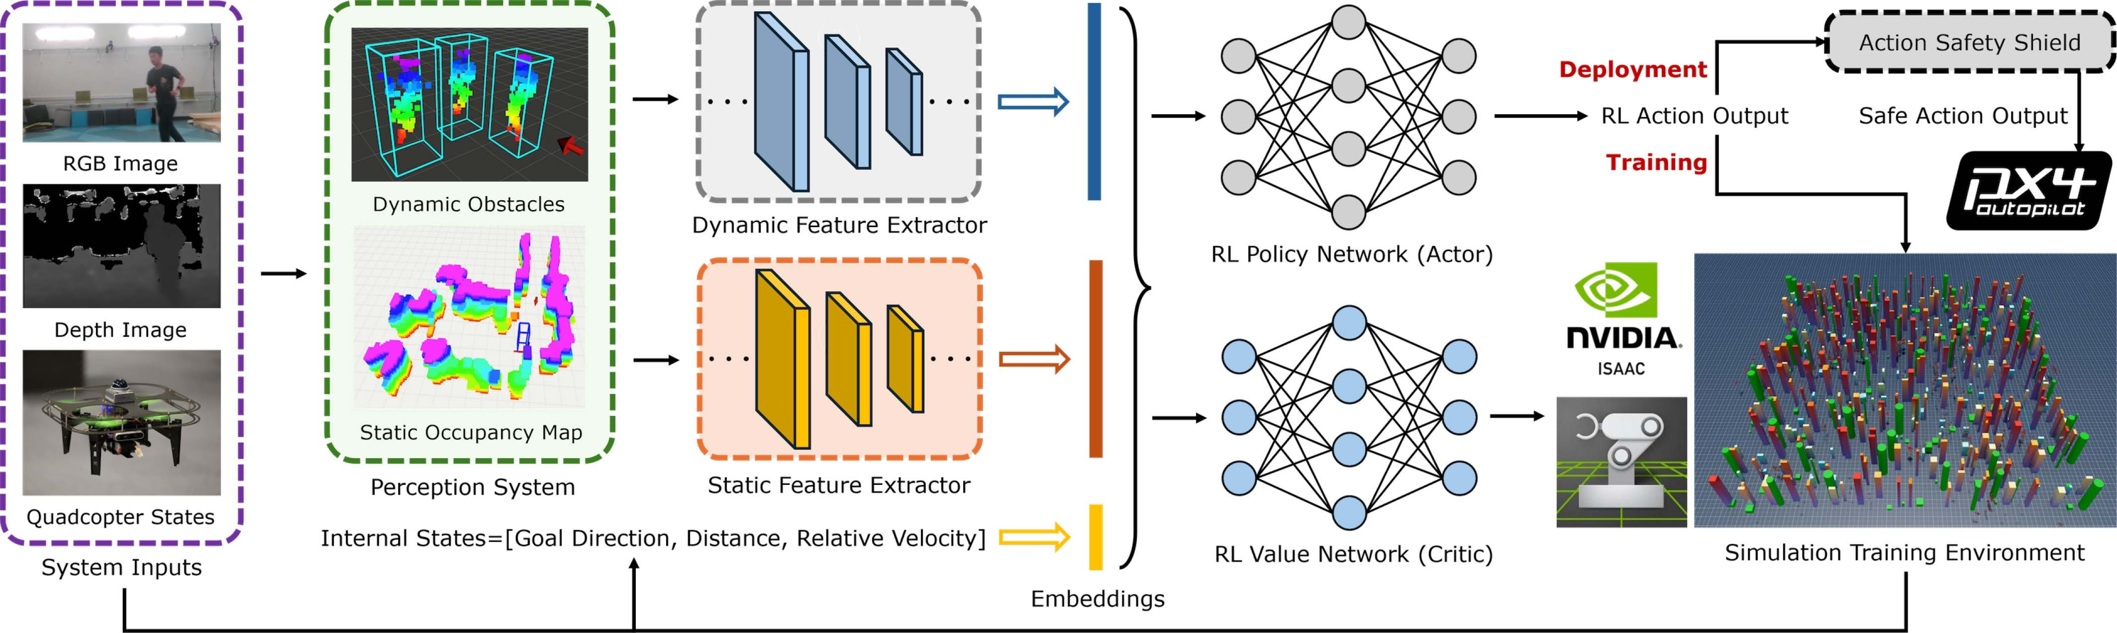
Figure. 3. The proposed NavRL framework. The perception system processes RGB-D images along with the robot’s internal states to generate representations for both static and dynamic obstacles. These representations are then fed into two feature extractors, which produce state embeddings concatenated with the robot’s internal states. In the training phase, an actor-critic network structure is utilized to train robots in parallel within the NVIDIA Isaac Sim environment. During the deployment stage, the policy network generates actions that are further refined by a safety shield mechanism to ensure safe robot control.

TABLE I
Benchmark of the Average Number of Collisions Evaluated From 20 Sample Runs in Different Types of Environments

2.3.3 Known Limitations of End-to-End DRL
Despite these strengths, end-to-end DRL navigation is known to suffer three structural weaknesses that are directly relevant to structured urban deployment.
No global goal-reaching guarantee. A reactive policy maps the current LiDAR observation to a velocity command with no notion of the global topology connecting the drone's position to the goal. When an obstacle subtends the full forward hemisphere as multi-story buildings commonly do in urban environments the policy has no information from which to derive a detour direction. It will spend its episode budget circling the obstacle until the step limit is reached. This failure mode is not a training artefact; it is a structural consequence of the policy's Markovian observation, which contains no map or goal-path information [3].
Trapping behind extended barriers. Building façades in dense urban environments commonly subtend 30°–90° of horizontal LiDAR coverage across the NavRL sensor's 4 m range. When the goal is occluded behind such a structure, the potential-field gradient toward the goal is obscured by a wall of near-maximum obstacle activations, leaving no clear steering signal. Empirically, this reduces NavRL's urban success rate to below 40% a figure replicated and quantified in §5.4 compared with 96% in the sparse environments of the original evaluation suite [1].
Distribution mismatch on procedurally generated city geometry. The NavRL policy was trained in a 50 m × 50 m arena with sparse random obstacles. Voxelized LIDAR returns from the photorealistic UE4 City environment procedurally generated buildings with non-textured, self-similar surfaces lie outside this training distribution. Adapting the policy to this geometry via retraining would require hundreds of GPU-hours across 1,024 parallel agents [1], a cost that is prohibitive for most operators and that defeats the purpose of adopting a pre-trained reactive policy.
These three weaknesses are not deficiencies of NavRL specifically; they are general properties of any reactive end-to-end DRL approach operating without global map information [3]. A wrapper-based augmentation strategy keeping the trained policy frozen, supplying it with locally smoothed sub-goals from a classical global planner, and gating its outputs through a safety shield is the engineering-pragmatic response that avoids retraining while restoring global goal-reaching capability. This is the strategy formalized in §2.5.

2.4 Sim-to-Real Transfer
The simulation-to-reality gap is the dominant threat to external validity for any autonomy system evaluated exclusively in simulation. Two complementary strategies have emerged as the field standard for mitigating it.
- Domain randomization [16] augments the training distribution by randomly sampling environment parameters obstacle density, obstacle texture, lighting conditions, and background geometry at the start of each training episode, forcing the policy to develop representations that are invariant to surface appearance rather than overfit to a specific simulated texture. This is the primary mechanism by which NavRL achieves its reported sim-to-real transfer [1].
- Dynamics randomization [15] addresses the mismatch between simulated and real-world physics by randomly perturbing mass, drag coefficients, rotor thrust constants, and control latency during training. Policies trained with dynamics randomization are demonstrably more robust to aerodynamic effects, motor degradation, and sensor lag in physical deployment all of which are impossible to model exactly in simulation.
A complementary and often neglected strand of sim-to-real work addresses evaluation robustness rather than training robustness: even a frozen policy can be systematically stress-tested by replaying it under swept noise and weather perturbations in simulation before any real flight is attempted [16]. This strategy provides a conservative lower bound on real-world performance without requiring physical hardware. The DCC adopts this approach in §5.4: the evaluation suite includes a sensor-noise suite (four LiDAR degradation regimes: clean, low-Gaussian, high-Gaussian, and drop-out) and a domain-randomization suite (five randomly sampled weather conditions with fog, rain, and wind up to 8.0 m/s) applied to both the hybrid controller and the PureRL baseline. Together, these suites address not only performance but the practical question of deployment robustness under real-world sensing imperfections.

2.5 Hybrid Architectures and the Position of This Work
The most reliable autonomous-stack designs in industry today are hybrid: a global planner produces a smooth desired path from a coarse occupancy or topological map; a geometric tracker (Pure-Pursuit [13] or MPC) follows the path at the look-ahead horizon; a learned policy performs reactive obstacle avoidance against the local LiDAR observation; and a velocity-obstacle shield [11] vetoes any command that would cause an imminent collision. This is exactly the architecture adopted by the AI layer of the DCC, with the novelty that the reactive policy is the published NavRL network, used unchanged but wrapped inside a city-aware planner that supplies it with locally smoothed sub-goals.
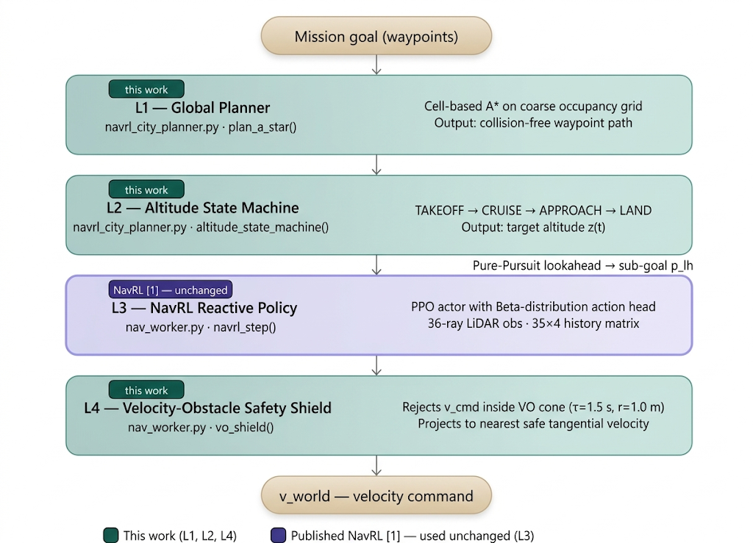
Figure 4 High-level view of the hybrid autonomy stack adopted by the Drone Command Center. Layers 1, 2, and 4 are this work's contribution; layer 3 is the published NavRL policy [1] used unchanged.
The combination satisfies all three structural weaknesses of pure DRL identified in §2.3.3: the global planner supplies the missing global guarantee, the look-ahead sub-goal eliminates the extended-barrier trap by translating long-range goals into locally feasible directions, and the safety shield bounds collision risk independently of policy quality.
To the best of our knowledge, the literature does not document a hybrid drone autonomy stack that simultaneously (i) operates within a complete fleet-management software platform with REST + WebSocket APIs, (ii) uses the published NavRL network as the reactive layer without re-training, and (iii) has been quantitatively benchmarked against the underlying NavRL baseline on a structured 12-waypoint urban mission with paired ablation, sensor-noise, and weather suites. The remainder of the report addresses precisely this gap: Chapter 3 specifies the analysis and design, Chapter 4 the implementation, Chapter 5 the empirical validation.

3. System Analysis & Design

3.1 Stakeholders & User Stories
A single authenticated-operator role interacts with the platform. Each role corresponds to a set of formal user stories captured during requirements elicitation.
A representative subset of the elicited user stories is listed below in standard “As an authenticated user, I want … so that …” form. The complete catalogue (US-01 … US-26) appears in the project requirements register.
Authentication and Identity (US-01 … US-04)
• US-01 As a new user, I want to register with username, email, and a strong password so that I can access the platform.
• US-02 As an authenticated user, I want to log in and receive JWT tokens so that I can authenticate API calls.
• US-03 As an authenticated user, I want token refresh so that long-running sessions are not interrupted.
• US-04 As an authenticated user, I want credential recovery handled operationally so that account access can be restored securely.
Drone Fleet (US-05 … US-09)
• US-05 As an authenticated user, I want to register a drone with serial, name, model, firmware, and home coordinates so that the platform tracks it.
• US-06 As an authenticated user, I want to view the fleet with status badges so that I have situational awareness.
• US-07 As an authenticated user, I want to filter drones by connection or flight status so that I focus on actionable airframes.
• US-08 As an authenticated user, I want to view a drone’s full detail including telemetry charts and sensor grid so that I can diagnose issues.
• US-09 As an authenticated user, I want to delete a decommissioned drone with cascade-delete of telemetry, sensors, and commands.
Mission Planning (US-10 … US-15)
• US-10 As an authenticated operator, I want to drop a navigation goal on the map so the system auto-creates a mission record for the selected drone
• US-11 As an authenticated operator, I want the AirSim bridge to seed a fixed 12-waypoint roam mission for AI evaluation; waypoints are not authored through the operator UI in the current build.
• US-12 As an authenticated operator, I want to start, complete, or abort a mission and have the lifecycle reflected in the database (pause/resume are reserved for a future release).
• US-13 As an authenticated user, I want to view missions filtered by status.
• US-14 As an authenticated user, I want a map view rendering planned mission and live drone position.
• US-15 As an authenticated user, I want a 12-waypoint roam mission via AirSim bridge for AI evaluation.
Command and Control (US-16 … US-19)
• US-16 As an authenticated user, I want to issue commands (TAKEOFF, LAND, RTH, HOVER, GO_TO_WAYPOINT, EMERGENCY_STOP, …) to any managed drone.
• US-17 As an authenticated user, I want commands to carry optional JSON payloads.
• US-18 As an authenticated user, I want command history per drone with status (PENDING / SENT / ACKNOWLEDGED / EXECUTED / FAILED / CANCELLED).
• US-19 As an authenticated user, I want EMERGENCY_STOP to supersede all other commands.
Telemetry and Sensors (US-20 … US-23)
• US-20 As an authenticated user, I want Real-Time Telemetry via WebSocket within one second of ingestion.
• US-21 As an authenticated user, I want historical telemetry query/export by time range.
• US-22 As an authenticated user, I want to render historical flight path on the map.
• US-23 As an authenticated user, I want a sensor grid with type, status, last reading, and timestamp.
Operations (US-24 … US-26)
• US-24 As an authenticated user, I want Actuator health/info visibility and authenticated access to protected ops endpoints.
• US-25 As a developer, I want Swagger UI at /swagger-ui/index.html documenting every API.
• US-26 As an authenticated user, I want rate limiting on auth endpoints to mitigate brute-force and credential-stuffing attacks.

3.2 Use Cases
Fifteen formal use cases (UC-01 … UC-15) bind the user stories to system behavior. The grouped use-case diagrams are given below.

UC Cluster A, Authentication
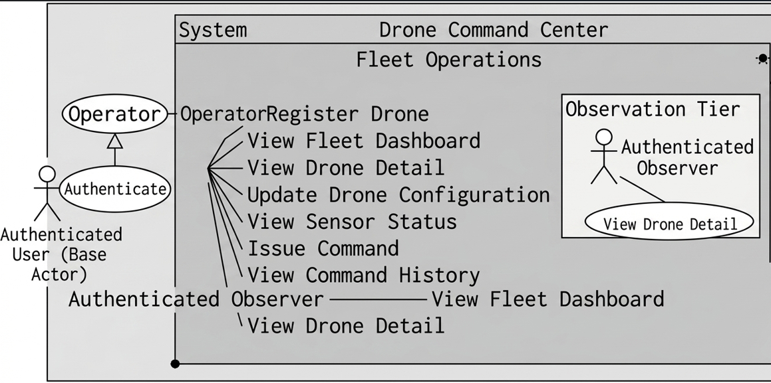
Figure 5 Authentication use-case cluster.

UC Cluster B, Fleet Operations
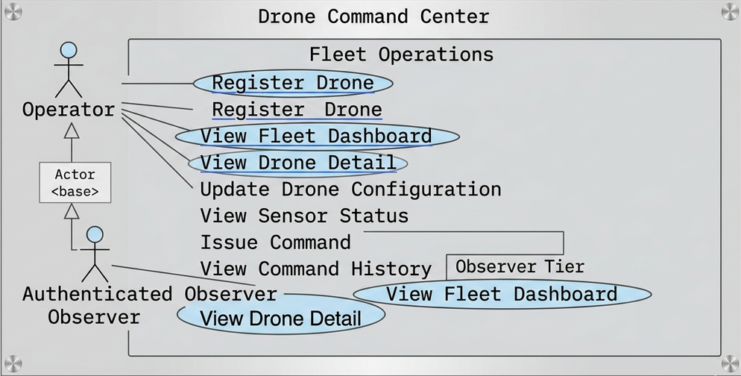
Figure 6 Fleet operations use-case cluster.

UC Cluster C, Mission Management
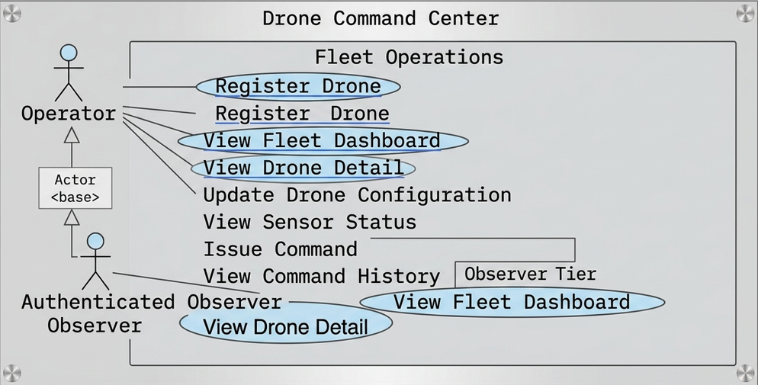
Figure 7 Mission management use-case cluster.

3.3 Functional & Non-Functional Requirements
The system has been decomposed into 45 functional and 35 non-functional requirements, captured in Tables 3.2–3.13. Each requirement carries a unique ID, a single-sentence statement, and a priority (Must / Should / Could) per the MoSCoW scheme

Functional Requirements Authentication and User Management
Table 2 Functional requirements: Authentication & User Management.
ID | Requirement | Priority
FR-01 | The system shall allow anonymous users to register by providing a unique username, unique email address, and a password satisfying the strength policy. | Must
FR-02 | The system shall authenticate registered users via username/password and return a signed JWT access token plus a refresh token upon success. | Must
FR-03 | The system shall validate the JWT on every protected request and reject expired or tampered tokens with HTTP 401. | Must
FR-04 | The system shall allow clients to exchange a valid refresh token for a new access token without re-authentication. | Must
FR-05 | The system shall invalidate the refresh token on logout, preventing further token renewal. | Must
FR-06 | The system shall enforce a password strength policy: minimum 8 characters, 1 uppercase, 1 lowercase, 1 digit, 1 special character. | Must
FR-07 | The system shall support email-based password reset using a time-limited single-use token. | Should
FR-08 | The system shall use a single authenticated-user permission model (no RBAC role matrix in production). | Must
FR-09 | The system shall enforce binary authentication (any valid JWT) on all protected API endpoints. | Must
FR-10 | The system shall allow authenticated operators to list, update, and deactivate user accounts. | Should

Functional Requirements Drone Fleet Management
Table 3 Functional requirements: Drone Fleet Management.
ID | Requirement | Priority
FR-11 | The system shall allow authorized users to register a drone with serial, name, model, firmware, home coordinates, and initial status. | Must
FR-12 | The system shall persist real-time drone state: connection status, flight status, battery, GPS, heading, speed, last heartbeat. | Must
FR-13 | The system shall return a paginated list of drones, sortable by name, battery, or status. | Must
FR-14 | The system shall return the full details of a single drone by UUID. | Must
FR-15 | The system shall allow authorized users to update drone configuration and status. | Must
FR-16 | The system shall allow authenticated operators to delete a drone and cascade-delete telemetry, sensors, and commands. | Should
FR-17 | The system shall filter drones by connection status and flight status. | Should
FR-18 | The system shall cache drone-list results in-memory (Caffeine) for up to 5 minutes. | Should

Functional Requirements Mission Management
Table .4 Functional requirements: Mission Management.
ID | Requirement | Priority
FR-19 | The system shall automatically create a mission record on the backend the moment an authenticated operator dispatches a navigation goal for a selected drone (no Create-Mission form is exposed to the operator). | Must
FR-20 | The system shall support mission states: PLANNED, IN_PROGRESS, COMPLETED, ABORTED, FAILED, PAUSED. | Must
FR-21 | The system shall persist an ordered list of waypoints per mission (lat/lon/alt, sequence, action, hover duration, speed, heading); waypoints are seeded server-side from the dispatched goal or from the 12-waypoint AirSim roam template. | Must
FR-22 | The backend shall expose REST endpoints to add, update, and remove individual waypoints from a mission for automated tooling and tests; these endpoints are not surfaced in the current operator UI. | Could
FR-23 | The system shall allow start, complete, and abort transitions on missions from the operator UI; pause and resume transitions remain available on the backend but are not driven by nav_worker in the current release. | Must
FR-24 | The system shall record start_time, end_time, and actual_duration_minutes on lifecycle changes. | Must
FR-25 | The system shall return paginated lists of missions, filterable by status. | Must
FR-26 | The system shall return all waypoints for a given mission in sequence order. | Must

Functional Requirements Command and Control
Table 5 Functional requirements: Command & Control.
ID | Requirement | Priority
FR-27 | The system shall accept commands from authorized users targeting a specific drone. | Must
FR-28 | The system shall support command types: TAKEOFF, LAND, RTH, HOVER, GO_TO_WAYPOINT, START_MISSION, ABORT_MISSION, EMERGENCY_STOP, SET_ALTITUDE, SET_SPEED, ROTATE, TAKE_PHOTO, START_STREAMING, STOP_STREAMING. | Must
FR-29 | The system shall assign command statuses: PENDING, SENT, ACKNOWLEDGED, EXECUTED, FAILED, CANCELLED. | Must
FR-30 | The system shall record timestamps when a command is issued, sent, executed, and completed. | Must
FR-31 | The system shall return command history per drone, paginated and sorted by issued time. | Should
FR-32 | The system shall store an optional JSON payload for parameterized commands. | Should

Functional Requirements Telemetry and Sensor Monitoring
Table 6 Functional requirements: Telemetry & Sensors.
ID | Requirement | Priority
FR-33 | The system shall accept telemetry ingestion: timestamp, GPS, speed, heading, battery, signal, GPS sats, temp, humidity, wind, flight mode. | Must
FR-34 | The system shall stream the most recent telemetry to all WebSocket clients within 1 s of receipt. | Must
FR-35 | The system shall maintain a persistent /ws/telemetry endpoint with native WS + SockJS fallback. | Must
FR-36 | The system shall return the latest telemetry record for a drone via REST. | Must
FR-37 | The system shall return paginated historical telemetry, optionally filtered by time range. | Should
FR-38 | The system shall return the historical flight-path lat/lon sequence for map rendering. | Should
FR-39 | The system shall persist sensor records: name, type, status, last reading, last reading time. | Should

Functional Requirements System Operations
Table 7 Functional requirements: System Operations.
ID | Requirement | Priority
FR-40 | The system shall expose Actuator health and info publicly; require authentication for other Actuator endpoints. | Must
FR-41 | The system shall apply rate limiting on auth endpoints (10 req/min per IP; 5 failed attempts = 15-min lockout). | Must
FR-42 | The system shall apply schema changes via Flyway versioned migrations on startup. | Must
FR-43 | The system shall expose a Swagger/OpenAPI 3.0 UI at /swagger-ui/index.html. | Should
FR-44 | The system shall publish domain events to RabbitMQ for asynchronous inter-service communication. | Could
FR-45 | The system shall run scheduled background tasks (expired-token cleanup, heartbeat checks). | Should

Non-Functional Requirements Performance
Table.8 Non-functional requirements: Performance.
ID | Requirement | Metric / Note
NFR-01 | REST API shall respond to 95% of read requests within 200 ms under normal load. | p95 - 200 ms
NFR-02 | WebSocket telemetry shall reach subscribed clients within 1 s of ingestion. | 1 000 ms
NFR-03 | Caffeine cache shall serve repeated reads without DB round-trips for up to 5 min per entry. | TTL = 5 min
NFR-04 | The system shall support 50 concurrent WebSocket connections without degradation. | 50 conns
NFR-05 | DB queries shall use indexes; no N+1 query patterns in production paths. | 0 N+1 queries

Non-Functional Requirements Security
Table 9 Non-functional requirements: Security.
ID | Requirement | Metric / Note
NFR-06 | All passwords shall be stored as BCrypt hashes with strength 10. | bcrypt(10+)
NFR-07 | JWT access tokens 1h; refresh tokens default 7 days. | 1h / 7d
NFR-08 | All API communication shall support TLS in production. | HTTPS
NFR-09 | No SQL injection exclusive use of parameterized JPA/Hibernate queries. | JPA only
NFR-10 | CSRF protection via stateless JWT with no server-side session cookies. | Stateless
NFR-11 | HSTS, X-Content-Type-Options, X-Frame-Options shall be set on responses. | 3 headers
NFR-12 | Secrets (DB, JWT, mail) shall be environment-variable-only never in VCS. | env vars
NFR-13 | Rate limiting on auth endpoints to mitigate brute-force / credential stuffing. | Bucket4j

Non-Functional Requirements Reliability and Availability
Table 10 Non-functional requirements: Reliability.
ID | Requirement | Metric / Note
NFR-14 | The backend shall target 99.5% uptime in production. | 99.5%
NFR-15 | Daily DB backups with 30-day retention. | Retention 30 d
NFR-16 | Flyway shall refuse to start on destructive migration conflict. | Schema gate
NFR-17 | WS disconnections handled gracefully; resume without > 1 polling-interval loss. | $≤$ 1 cycle
NFR-18 | All unhandled exceptions return structured error responses (no stack traces). | Structured

Non-Functional Requirements Usability
Table 11 Non-functional requirements: Usability
ID | Requirement | Metric / Note
NFR-19 | A trained operator shall locate any drone's status within 2 interactions from the dashboard. | $≤$2 taps
NFR-20 | All form inputs shall display inline validation messages near the relevant field. | Inline errors
NFR-21 | Async fetch operations shall display shimmer loading skeletons. | Shimmer
NFR-22 | Mobile UI shall support both portrait and landscape without layout degradation. | Responsive
NFR-23 | Swagger UI shall provide schemas, examples, and descriptions for every endpoint. | Full OpenAPI

Non-Functional Requirements Scalability and Maintainability
Table 12 Non-functional requirements: Scalability & Maintainability.
ID | Requirement | Metric / Note
NFR-24 | Backend shall be stateless to allow horizontal scaling behind a load balancer. | Stateless
NFR-25 | Cache layer replaceable by Redis via configuration only no code changes. | Cache abstraction
NFR-26 | DB connection pool shall be configurable through application.properties. | Pool tunable
NFR-27 | RabbitMQ decouples telemetry ingestion from downstream processing. | MQ decoupled
NFR-28 | Codebase shall preserve Controller / Service / Repository / Entity layering. | Layered
NFR-29 | Public endpoints shall be documented with OpenAPI 3.0 annotations. | OpenAPI 3.0
NFR-30 | Schema changes only through Flyway migrations direct DDL prohibited. | Flyway-only
NFR-31 | Structured Logback/SLF4J logs (ERROR/WARN/INFO/DEBUG) with split log files. | SLF4J
NFR-32 | Service-layer unit-test coverage 70%. | Coverage 70%

Non-Functional Requirements Portability
Table 13 Non-functional requirements: Portability.
ID | Requirement | Metric / Note
NFR-33 | Backend deployable as a JAR on JVM 17+ or as a Docker container. | JVM 17+ /  Docker
NFR-34 | Flutter app shall compile to Android APK, iOS IPA, and web bundle from one codebase. | Multi-target
NFR-35 | docker-compose.yml shall bring up the full local environment with one command. | 1-command

Four-Tier System Architecture
The platform decomposes into four logical tiers (Table 3.14, Figure 3.4). Tier boundaries are enforced by package structure on the backend and feature folders on the frontend; cross-tier communication is exclusively via DTOs and well-typed API responses.

Table 14 Four-tier architecture.
Tier | Responsibility | Technology
1. Presentation | Tactical UI, mission planning, telemetry visualization, command issuance. | Flutter 3.0 / Dart  3
2. Application API | REST controllers, WebSocket handlers, request validation, stateless JWT authentication enforcement. | Spring Boot 4.0.2 / Java 17
3. Domain / Service | Business logic, mission lifecycle, command orchestration, AirSim/NavRL bridge. | Spring Service beans + Python AI workers
4. Persistence | Schema-versioned storage of users, drones, missions, telemetry, sensors, commands. | PostgreSQL 15+ / Flyway / Caffeine / RabbitMQ

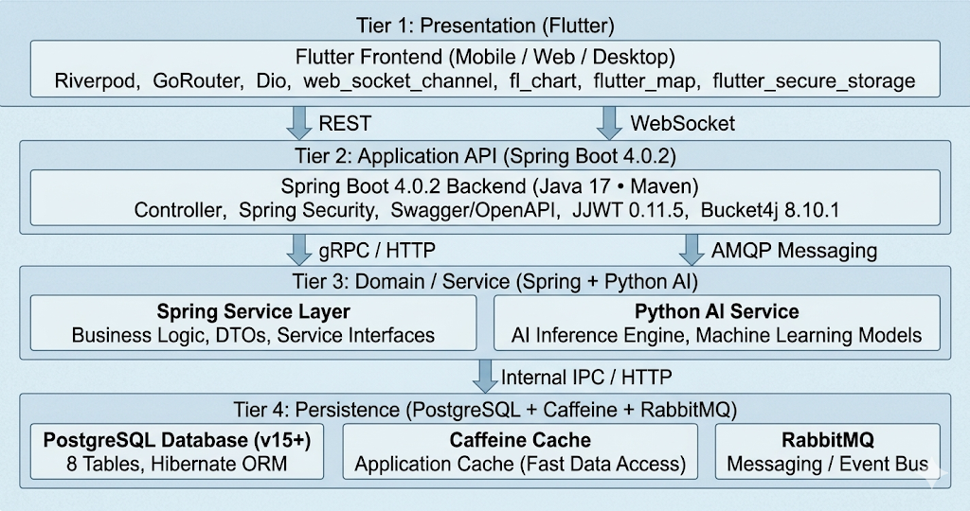
Figure 8 Four-tier deployment view of the Drone Command Center.

Backend Component Design
The backend is organized under com.drone_command_center with strict package-level layering. Configuration is centralized; security artefacts live in a dedicated package; controllers expose REST endpoints; services hold business logic; repositories perform persistence; entities model the domain; DTOs cross the boundary.

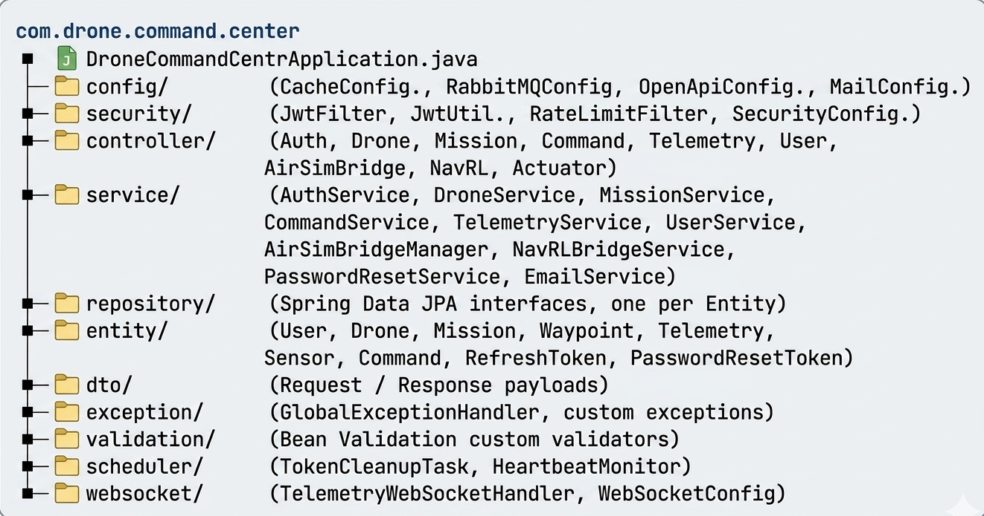
Figure 9 Backend package tree.

3.5.1 Five-Layer Security Model
- L1 Network. TLS termination, HSTS, CORS allow-list, secure cookies.
- L2 Rate Limiting. Bucket4j token-bucket on /api/auth/* (10 req/min/IP).
- L3 Authentication. Stateless JWT (HMAC-SHA256), refresh-token rotation, BCrypt(10+) password hashing.
- L4 Authorization. Single authenticated-user model: every API endpoint outside /api/auth/** and /actuator/(health|info) requires a valid JWT in the Authorization header. The earlier multi-role binary JWT authentication matrix was removed in the V2 demo cleanup, which dropped the user_roles and user_drone_assignments tables; all authenticated users now share equal access to fleet and mission resources.
- L5 Validation. Bean Validation on all DTOs; centralized exception handler returns structured error bodies.

3.5.2 Endpoint Authentication Matrix
Following the V2 schema cleanup, authorization is reduced to a binary public / authenticated decision there is no no role granularity in the production deployment. Public endpoints are limited to authentication, Swagger / OpenAPI, public Actuator probes, and the WebSocket handshake.
Table 15 Endpoint authentication matrix (post V2 cleanup).
Endpoint group | Public | Authenticated
/api/auth/** | ✓ | —
/swagger-ui/** , /v3/api-docs/** | ✓ | —
/actuator/health, /actuator/info | ✓ | —
/actuator/** (other endpoints) | — | ✓
/ws/** (WebSocket handshake) | ✓ | —
/api/drones/** | — | ✓
/api/missions/** | — | ✓
/api/commands/** | — | ✓
/api/telemetry/** | — | ✓
/api/users/** | — | ✓
/api/airsim/** , /api/navrl/** | — | ✓
/api/logs/** | — | ✓

Frontend Component Design
The Flutter application is structured by feature, with a small core/ package providing shared utilities (HTTP client, secure storage, theme, design tokens).
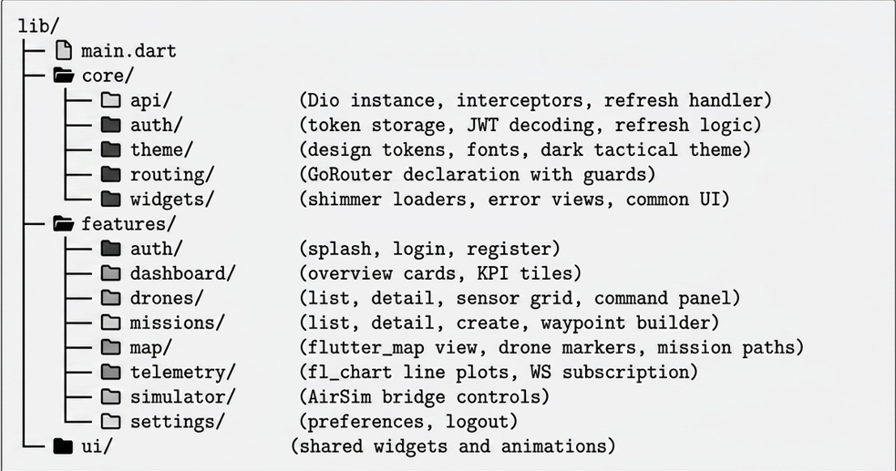
Figure 10 Frontend lib/ tree.

Riverpod State Topology
State is segmented into providers per concern. authProvider exposes the current JWT and user; droneListProvider caches the paginated drone list with refresh-on-WS-tick; missionProvider.family(missionId) caches a single mission with its waypoints; telemetryStreamProvider.family(droneId) subscribes to /ws/telemetry and emits Telemetry objects to any consuming widget. Riverpod's automatic disposal removes WS subscriptions when no widget consumes the stream.

3.6.2 Tactical Design Tokens
Table 16 Tactical theme tokens.
Token | Value | Usage
Background | #0A0A0A | App scaffold base.
Primary | #00FF88 | Active state, success, RTH path.
Secondary | #00D4FF | Telemetry charts, info accents.
Warning | #FF6B35 | Battery low, signal weak.
Danger | #FF0040 | Emergency, errors, abort.
Display Font | Rajdhani | Headings, KPI values, mission names.
Mono Font | Space Mono | Telemetry numbers, JSON payloads, IDs.

Deployment Architecture
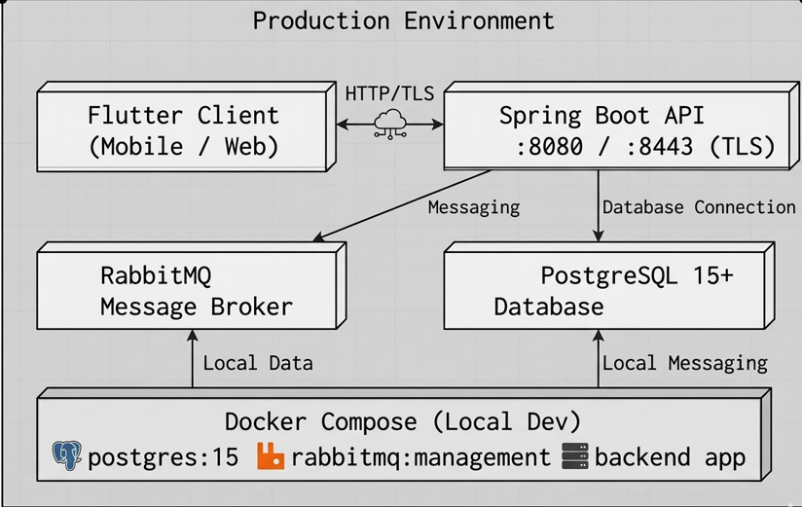
Figure 11 Deployment topology.

NavRL Theoretical Foundations
The autonomy layer in this work uses the published NavRL framework [1] without modification to its neural network. NavRL formulates UAV navigation as a partially observable Markov decision process (POMDP) and solves it with a Beta-distribution Proximal Policy Optimization (PPO) policy [10]. This section captures the equations needed to interpret §5.5 and Chapter 8.

Markov Decision Process
The decision problem is the tuple $\left(S,A,P,R,γ\right)$
$\left(S,A,P,R,γ\right), γ ∈ \left[0,1\right)$ (3.1)

Internal State
The internal state vector at time t encodes goal direction, current velocity, and altitude-track error:
$s_{t}={\left[d_{goal},v_{t},e_{z}\right]}^{T}$ (3.2)

Dynamic Obstacle State Representation
The dynamic-obstacle tensor $S_{dyn}∈R^{N_{d} × M}$ and the per-obstacle state vector$D_{i}$ are defined as:
$$Sdyn =\left[D1,…,DNd \right]T,Sdyn ∈ RNd× M, Di ∈ RM.$$
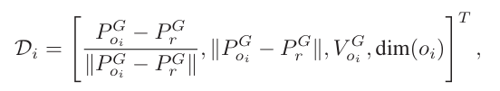

Lidar Observation
A 360°, 36-ray LiDAR is sampled and reshaped into a 35-channel × 4-frame matrix:
$O_{L}∈R^{35×4}$(3.3)
Range readings are inverted before being fed into the policy network so that closer obstacles produce larger, easier-to-learn activations:
$$w_{i}=1-\frac{min\left(r_{i},r_{max}\right)}{r_{max}}$$

Table 17 NavRL LiDAR observation parameters
Parameter | Symbol | Value
Number of rays per scan | N | 36
Maximum effective range | _max | 6.0 m
Vertical sectors | S_z | 3 (low/mid/high)
Horizontal field of view | FOV_h | 360°
Observation history frames | H | 4
Network input dim. per frame | d | 35
.

Action Distribution
The actor outputs the parameters $\left(α,β\right)$ of a Beta distribution; bounded raw actions are linearly mapped into the velocity command range:
araw ~ Beta$\left(α, β\right), α, β$ > 0 (3.5)
$vcmd = \left(2 araw - 1\right). vmax vcmd ∈ \left[-vmax, +vmax\right]3$ (3.6)

World-Frame Transformation
Body-frame velocities are rotated into the world frame using the current yaw :

$v_{world}=R_{z}\left(ψ\right)⋅v_{cmd}$ (3.7)

Reward Components
The dense reward at step t is the sum of five terms:
$$r\left(t\right)=r_{goal}+r_{step}+r_{smooth}+r_{obs}+r_{height}+r_{terminal}$$
$$r_{goal}=w_{g}⋅\left(|\left|p_{goal}-p\left(t-1\right)|\right|-\left||p_{goal}-p\left(t\right)|\right|\right)$$
$rstep = -ws$
$$r_{smooth}=-w_{j}⋅\left||a\left(t\right)-a\left(t-1\right)\right||^{2}$$
$$r_{obs}=-w_{o}⋅max{\left(0,d_{safe}-d_{min}\right)}^{2}$$
$$r_{height}=-w_{o}.{\left(\left|P_{r,z}-P_{s,z}\right|,\left|P_{r,z}-P_{g,z}\right|\right)}^{2}$$
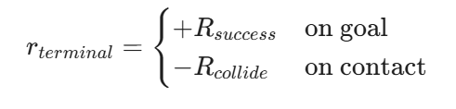

PPO Clipped Objective
PPO [10] optimizes the clipped surrogate objective:
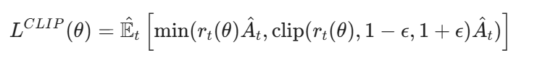
with importance ratio
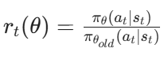
and clip range $ϵ$ = 0.2.

Curriculum
Table 18 NavRL training curriculum (per [1]).
Stage | Environment | Goal | Episodes
1 | Empty 20×20×10 box | Reach random target | $≈$ 50k
2 | Sparse static obstacles | Avoid $≤$ 5 boxes | $≈$ 80k
3 | Dense forest (20–40 trees) | Cluttered traversal | $≈$ 120k
4 | Dynamic obstacles (moving spheres) | Reactive avoidance | $≈$ 100k
5 | Mixed static + dynamic, narrow gaps | Generalization, fine-tuning | $≈$ 80k

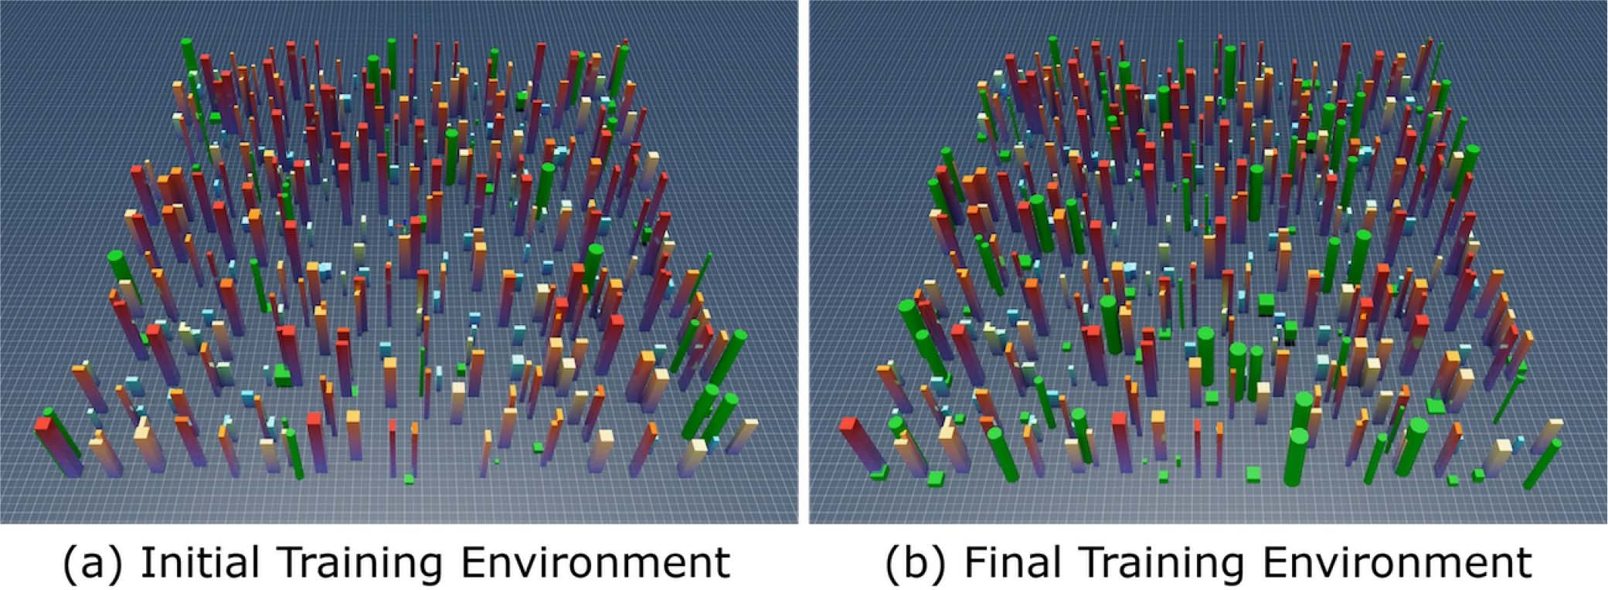

Figure 12 NavRL training environments in NVIDIA Isaac Sim: initial stage (60 obstacles) vs final stage (120 obstacles) of the curriculum [1]." Place alongside Table 3.18 so the reader can see what the curriculum stages actually look like

TABLE 19
Comparison of the Highest Navigation Success Rates During Training With and Without Using Curriculum Learning

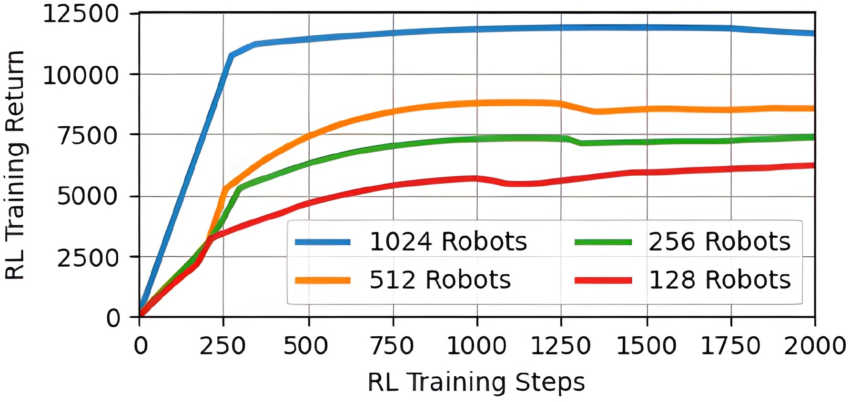

Figure 13. Plot of the smoothed average training return curves. Training with a
larger number of robots leads to faster convergence and higher returns

3.8.9 Velocity-Obstacle Safety Shield
A reactive VO shield runs in parallel with the policy. Given a relative obstacle position pr and velocity v, a candidate command vcmd is rejected if it lies inside the time-to-collision
cone:
$VO=\{v:\frac{||\left(p_{r}-v . t\right)×p_{r}||}{||p_{r}||}<r_safe\}, t=1.5s,r_safe=1.0m$ (3.15)

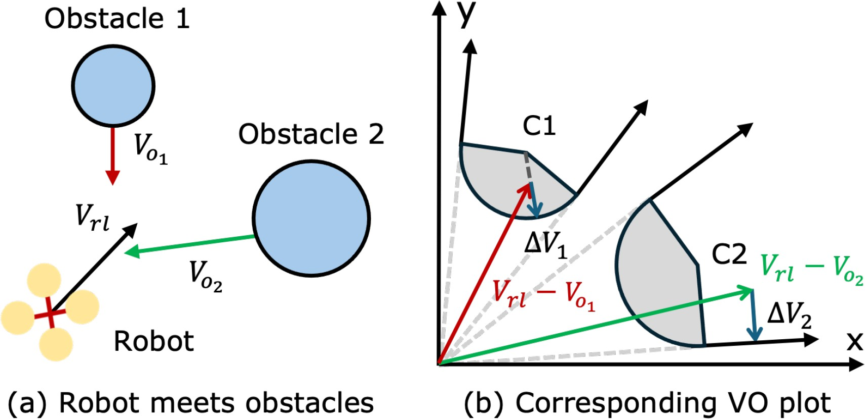

Figure 14 Velocity-Obstacle (VO) safety shield: the VO cone formed by an obstacle, the unsafe robot velocity falling inside it, and the projected ΔV that returns the velocity to the safe set [1]." This is the most important visual in the section without it the reader cannot follow why the shield is needed.

If vcmd $∈$VO, the planner overrides the action with the nearest tangentially-feasible velocity, biased toward the global path (§3.9).

Published Performance
On the original NavRL evaluation suite [1] the trained policy attained the Figures reproduced in Table 3.19. These values establish the upper performance ceiling that any wrapper around NavRL can preserve.
Table 20 Published NavRL benchmarks [1]. Path length is normalized to the optimal straight-line baseline.
Environment | Success | Coll. /km | Path Len.
Empty box | 100% | 0.0 | 1.0×
Sparse static | 96% | 0.4 | 1.05×
Dense forest | 88% | 1.2 | 1.18×
Dynamic obstacles | 82% | 1.6 | 1.22×

3.9 Hybrid City-Planner Design
Pure NavRL fails in dense procedurally-generated city geometry: it has no global plan and gets trapped behind tall buildings. The Drone Command Center wraps NavRL inside a deterministic four-layer planner (Table 3.20). The planner injects geometric guidance, predictable altitude profiling, and a final VO veto, while leaving the reactive policy untouched.

Table 21 Four-layer hybrid city planner.
Layer | Module / File | Responsibility | Output
L1 Global | navrl_city_planner.py · plan_a_star() | Cell-based A* on coarse occupancy. | Waypoint list
L2 Altitude | navrl_city_planner.py · altitude_state_machine() | Profile vertical: TAKEOFF  CRUISE   APPROACH. | Target z(t)
L3 Tracker | nav_worker.py · pure_pursuit() | Lookahead point on the polyline. | Sub-goal p_lh
L4 Reactive | nav_worker.py · navrl_step() + vo_shield() | PPO action; VO veto; emit world velocity. | v_world  ■³

3.9.1 Pure-Pursuit Lookahead
Given the global path P = (p0, …, pN) and current pose p, the lookahead point plh is the point on P at arc-length Llh ahead of the closest projection:
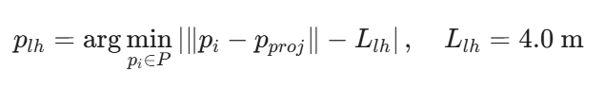 (3.16)
This sub-goal is fed to NavRL as pgoal in the internal state vector of equation 3.2, ensuring the reactive policy always chases a locally smooth geometric target rather than the original (possibly occluded) mission goal.

Altitude State Machine
        - TAKEOFF. Climb at $≈$1.0 m/s until cruise altitude (12 m AGL) is reached.
        - CRUISE. Hold cruise altitude; pursue lookahead in the horizontal plane.
        - APPROACH. When within 8 m of final goal, descend to mission target altitude.
        - HOVER / LAND. On goal reached, hover for waypoint dwell time, then land.

Hardware Design (CAD Model):
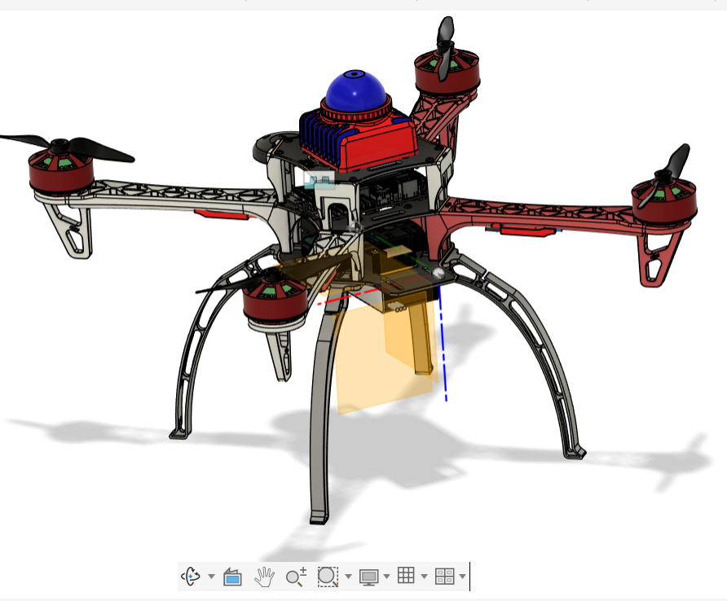
Figure 15 shows the first CAD model developed for AI integration.

3.10.1 List of Parts
The prototype airframe was modelled in Fusion 360 around the standard DJI F450 quadcopter platform. The choice of each component is driven by the requirements of the autonomy stack (§3.6) and the dynamic model of §2.2. All geometric and inertial values used by Eqs. (2.1)–(2.2) and by the AirSim vehicle configuration are extracted directly from this CAD.
Airframe
- DJI F450 X-frame. A 450 mm carbon-fibre / glass-reinforced X-frame, widely adopted across academic reinforcement-learning quadrotor research. Its symmetry simplifies the dynamic model (zero off-diagonal inertia terms in the body frame) and a STEP file of the frame is openly available, which gave us a known-good starting geometry to extend with the payload bay and avionics tray.
- Landing gear. Tall sprung legs giving ground clearance for the down-facing LiDAR and protecting the avionics tray, battery and camera during emergency landings or autonomous touch-down.
Propulsion
- 4 × 920 KV brushless DC motors with 10″ props. A four-rotor configuration is mandated by the X-frame and the dynamic model of §2.2.2. The 920 KV / 10″ pairing gives a hover throttle of approximately 50 % at the projected ~1.4 kg all-up weight, leaving a ≈2 : 1 thrust margin so the NavRL policy can request aggressive accelerations without saturating any rotor.
- 4 × 30 A electronic speed controllers (ESCs), BLHeli_S firmware. The ESCs translate PWM (or DShot) commands from the flight controller into three-phase drive signals for the motors, throttling current draw in proportion to the commanded thrust. They are sized above the motors' peak current draw to tolerate transient spikes during sharp manoeuvres.
Power
- 1 × 4S 3300 mAh LiPo battery. Used for bench testing and short demonstration flights. It does not target long-endurance missions; it is sized to validate the electrical layout and provide ~6–8 min of hover for HIL tests. A higher-capacity 5000–6000 mAh pack is identified in §6 (future work) for sustained operation.
Flight control and compute
- Pixhawk 6C flight controller running PX4 firmware. The Pixhawk closes the inner attitude / rate loop at 400 Hz and exposes a MAVLink interface to the companion computer. PX4 was chosen over ArduPilot because its uORB messaging model maps cleanly onto the offboard control commands issued by NavRL.
- NVIDIA Jetson Orin NX 16 GB. The companion computer hosts the entire autonomy stack: NavRL inference (10 Hz), the A*/CityPlanner global planner, the altitude/velocity controller, ROS 2 nodes, and the gRPC bridge to the AirSim simulator. The 16 GB variant was chosen so the policy network and the local cost-map can be co-resident in memory without paging.
Sensing
- Livox Mid-360 LiDAR. A 360°×59° solid-state LiDAR providing the dense local point cloud that feeds the obstacle-avoidance branch of NavRL (§3.6). Its non-repetitive scan pattern fills in the field of view over a few hundred milliseconds, giving the policy a richer occupancy map than a traditional spinning LiDAR at the same price point. This is the primary "eye" of the drone for avoidance and local mapping.
- u-blox NEO-M8N GPS. Multi-constellation receiver (GPS + GLONASS + Galileo) used by PX4's EKF for global position estimation and by the global planner to anchor missions to real-world coordinates.
- PPM/SBUS receiver. A safety-pilot fallback paired with a hand-held transmitter, it allows manual override at any time during HIL testing, satisfying a soft-safety requirement common to outdoor RL flight trials. It is not used during normal autonomous operation.

3.11 System Models
This section captures the dynamic and static models of the platform: the entity-relationship view, four sequence diagrams covering critical interaction flows, three state machines describing the lifecycle of drones, missions, and commands, and two data-flow descriptions for telemetry and authentication tokens.

3.11.1 Entity-Relationship Model
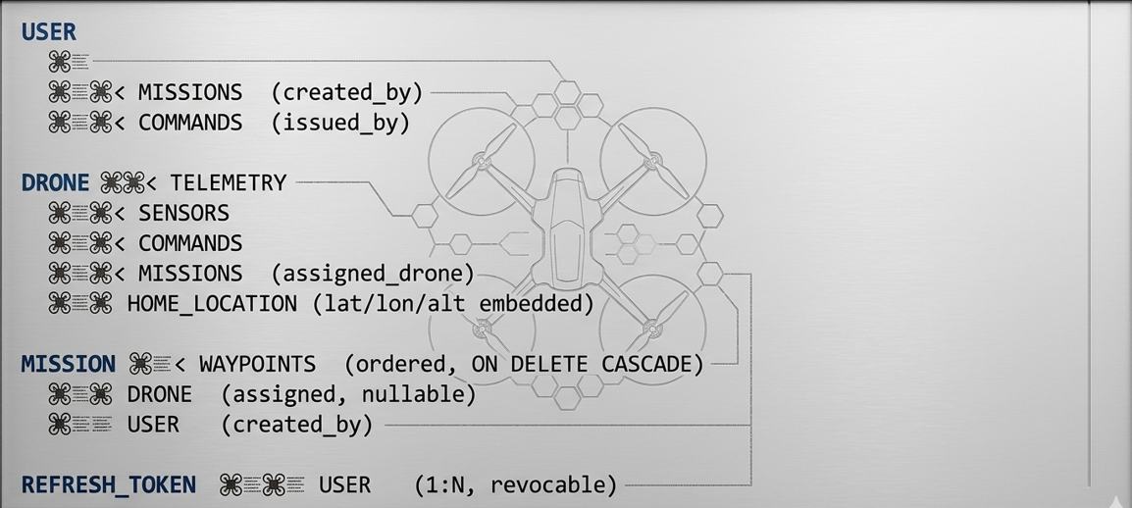
Figure 16 Entity-relationship diagram (post V2 cleanup).
Cardinality summary: One user owns many missions and many commands; one drone has many telemetry, sensors, commands and missions; one mission has an ordered list of waypoints (1:N, cascade delete); a user may hold multiple refresh tokens, each individually revocable on logout. The legacy user_roles, user_drone_assignments and password_reset_tokens tables were removed by migration V2 demo_cleanup.sql

3.11.2 Sequence User Authentication
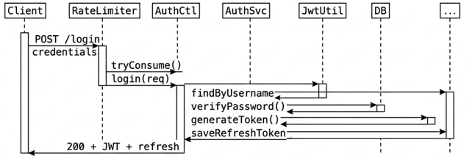
Figure 17 Login sequence.

3.11.3 Sequence Goal Dispatch and Auto-Mission Creation
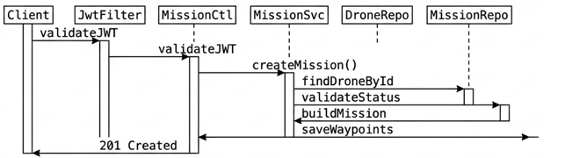
Figure 18 Goal-dispatch sequence. Operator taps the map; the Flutter client converts the screen point to AirSim NED meters and POSTs /api/navrl/drones/{id}/goal to persist the target. On START NAV (POST /api/navrl/drones/{id}/start) the backend marks isNavigating=true, materializes a mission row from the stored goal, spawns the nav_worker subprocess, and begins streaming telemetry. The operator never authors a mission body or waypoint list by hand.

3.11.4 Sequence Real-Time Telemetry
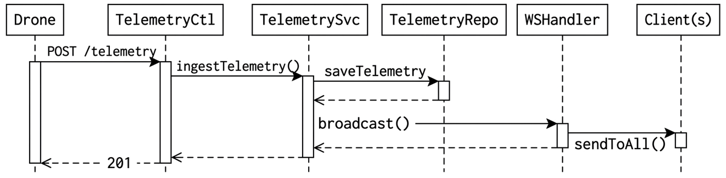
Figure 19 Telemetry ingestion + WebSocket fan-out.

3.11.5 Telemetry Pipeline
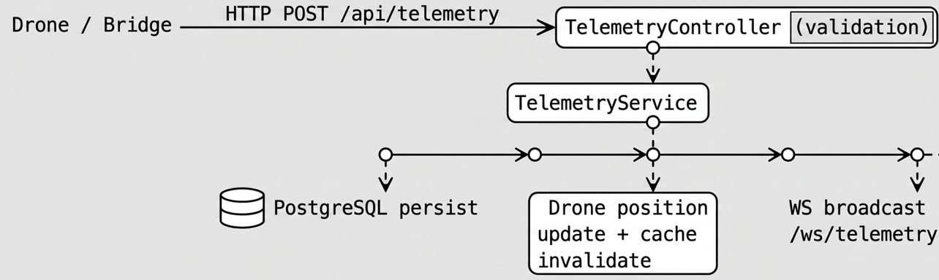
Figure 20 Telemetry data-flow.

Feasibility and Risk Analysis
Table 22 Top project risks and mitigations.
Risk | Likelihood | Impact | Mitigation
AirSim instability under heavy load | Med | High | Auto-restart bridge; checkpoint every waypoint.
NavRL fails on geometry it never saw | High | High | Wrap with VO shield; classical A* fallback (Layer 1).
Backend / frontend breaking change | Med | Med | OpenAPI contract; integration tests; semantic versioning.
Schema migration error in production | Low | High | Flyway versioned migrations; refuse-on-conflict gate.
Credential leak / brute force | Med | High | BCrypt(10+); rate limiting; rotated refresh tokens; HSTS.
Lost WebSocket telemetry | Low | Low | Auto-reconnect; SockJS fallback; REST poll backup.
Schedule overrun (capstone deadline) | Med | Med | Sprint-based delivery; weekly reviews; scope freeze.

4. Implementation

Development Methodology and Tooling
The project followed a 2-week sprint Scrum cadence. Source control is Git on GitHub with a protected main branch and feature branches per user story. CI runs Maven and Flutter tests on every push. Code style is enforced by Spring Boot defaults (Checkstyle), Lombok-driven boilerplate elimination, and the Flutter analysis_options.yaml defaults. Issue tracking and burndown live on GitHub Projects.

Table 23 Implementation tooling.
Concern | Tool / Configuration
Backend build | Maven 3.9 + Spring Boot 4.0.2 BOM
Java runtime | OpenJDK 17 (LTS)
Frontend build | Flutter 3.0 / Dart 3.0
DB | PostgreSQL 15 (Docker image postgres:15)
Message broker | RabbitMQ 3 (rabbitmq:management image)
Local orchestration | docker-compose.yml at project root
AI runtime | Python 3.10 + PyTorch (NavRL inference)
Simulator | Microsoft AirSim UE4 City environment [14]
Code quality | SpringDoc OpenAPI; Flutter analyzer; pytest

Backend Implementation (Spring Boot)

Module Map
- config/ CacheConfig (Caffeine TTL=5 min), RabbitMQConfig (exchange + queue declaration), OpenApiConfig (Swagger groups + JWT bearer scheme), MailConfig (JavaMailSender bean).
- Security/ JwtUtil (sign/verify HMAC-SHA256), JwtFilter (extract Authorization header SecurityContext), RateLimiter (Bucket4j 10 req/min on /api/auth/*), SecurityConfig (HttpSecurity DSL with CORS allow-list, HSTS, X-Frame-Options DENY, stateless session, public /api/auth/** and Swagger; everything else authenticated).
- Controller/ REST controllers per domain object; one Swagger group per controller; Bean Validation on every @RequestBody DTO.
- Service/ Business orchestration; Spring @Cacheable on read paths; @CacheEvict on writes; @Transactional boundaries.
- Repository/Spring Data JPA interfaces with custom query methods (e.g., findByConnectionStatus, findLatestByDroneId).
- Entity/JPA @Entity classes mapped to Hibernate-managed tables; UUID primary keys; explicit lat/lon/alt home columns on the drones table.
- websocket/TelemetryWebSocketHandler (per-session subscribers); WebSocketConfig (STOMP endpoints, SockJS fallback).
- scheduler/ @Scheduled tasks for token cleanup and heartbeat checks.

Authentication Path
Login flow: POST /api/auth/login RateLimitFilter (Bucket4j) AuthController.login() AuthService.login() UserRepository.findByUsername() -> BCrypt verify JwtUtil.generateAccessToken() + generateRefreshToken() persist refresh token return AuthResponse {accessToken, refreshToken, expiresIn}.

Validation, Errors, and Audit
All DTOs use JSR-380 (Bean Validation) annotations. A GlobalExceptionHandler translates exceptions into structured JSON: { timestamp, status, message, path }. All authentication outcomes (success / failure / lockout) are logged to a separate audit appender configured in logback-spring.xml.

Frontend Implementation (Flutter)

Routing and Guards
GoRouter declares the full route table. A guard inspects flutter_secure_storage for a valid JWT; if expired, the Dio refresh interceptor silently exchanges the refresh token before retrying the original request. If the refresh fails, the user is redirected to /login.

Networking Layer
All HTTP traffic flows through a single Dio instance configured with:
        - baseUrl from --dart-define=API_BASE at build time.
        - Auth interceptor that attaches Authorization: Bearer <jwt>.
        - Retry / refresh interceptor handling 401s by exchanging the refresh token.
        - Error interceptor mapping 4xx/5xx to typed ApiException objects.

Real-Time Telemetry
TelemetryStreamProvider opens a web_socket_channel connection to /ws/telemetry, decodes JSON frames into Telemetry objects, and pushes the latest sample plus a rolling window into fl_chart. Auto-reconnect with exponential back-off recovers from transient network failures.

Map and Mission Visualization
The map screen uses flutter_map with an OpenStreetMap tile layer; drone markers are colored by flight status using the design tokens of Table 3.16 (#00FF88 in flight, #FF6B35 low battery, #FF0040 emergency). Mission paths are rendered as a PolylineLayer bound to the waypoint sequence.

AirSim Bridge and NavRL Integration

Component Overview
        - airsim_auto_bridge.py process supervisor: starts AirSim, the command-center bridge, the NavRL worker, and the planner; restarts on crash.
        - command_center_bridge.py connects the Spring Boot REST + WS API to AirSim. Reports drone telemetry (position, velocity, battery, sensor health) and accepts commands.
        - navrl_airsim_bridge.py adapter that converts AirSim LiDAR + IMU to the 35 × 4 NavRL observation matrix (Eq. 3.3) and converts NavRL Beta-distribution actions into AirSim moveByVelocityAsync calls.
        - navrl_city_planner.py implements Layers 1 + 2 (A* global + altitude state machine).
        - nav_worker.py implements Layers 3 + 4 (Pure-Pursuit lookahead + NavRL forward pass + VO shield).
        - capstone_test_runner.py orchestrates evaluation suites: standard, ablation, sensor noise, domain randomization.
        - analyze_results.py / generate_report_Figures.py post-processing CSV summaries and the seven Figures cited in §5.5.

Inference Loop
while not goal_reached and step < step_limit:
obs = build_observation(airsim_lidar, imu, lookahead, body_velocity)
α, β = policy.forward(obs) a_raw = sample_beta(α, β)
v_cmd = (2 * a_raw - 1) * V_MAX
v_world = R_z(yaw) @ v_cmd
# NavRL PPO actor
# Eq. 3.6
# Eq. 3.7
if vo_shield.violates(v_world, obstacles):# Eq. 3.15 v_world = vo_shield.project_to_safe(v_world)
airsim.moveByVelocityAsync(*v_world, dt) update_lookahead(global_path, current_pos)# Eq. 3.16
step += 1
Figure 21 Pseudocode of the inner control loop.

Sensor Noise Injection
Table 24 Sensor and disturbance noise injection per [15], [16].
Sensor | Noise model | Magnitude
LiDAR ranges | Additive Gaussian + 5% drop-out | $σ$ = 0.05 m
IMU velocity | Additive Gaussian on each axis | $σ$ = 0.05 m/s
GPS | Additive Gaussian on lat/lon (converted to meters) | $σ$ = 0.50 m
Wind disturb. | Time-varying lateral force (Ornstein-Uhlenbeck) | $≤$ 1.5 m/s

Database Schema and Migrations
The full database schema lives in backend/src/main/resources/db/migration/. Two Flyway migrations were authored during development; in the deployed configuration the runtime schema is owned by Hibernate ddl-auto=update (Flyway is disabled via spring.flyway.enabled=false). Migration V2 was executed as a destructive reset for the clean evaluation environment. For continuous production deployment, subsequent Flyway migrations will utilize non-destructive “ALTER” statements. The full column-level reference for every live table is given in Appendix C.
- V1 Initial_schema.sqlthe eight live tables (users, drones, missions, waypoints,
commands, telemetry, sensors, refresh_tokens) plus three legacy tables (user_roles, user_drone_assignments, password_reset_tokens) and all supporting indexes.
- V2 demo_cleanup.sql drops the three legacy tables (binary JWT authentication simplification + removal of the email password-reset feature) and truncates telemetry / commands so that the demo run starts from a clean slate.

5. Testing and Evaluation

5.1 Test Strategy Overview
Quality assurance follows a multi-layer pyramid. Unit tests cover individual classes in isolation. Integration tests exercise wiring across multiple components against an in-memory H2 database. API tests treat the running backend as a black box. Frontend widget and integration tests exercise screens and providers. The AI layer is evaluated quantitatively against fixed AirSim missions with statistical aggregation.
Table 25 Test strategy summary.
Layer | Tooling | Target Coverage / Metric
Backend unit | JUnit 5 + Mockito + AssertJ | 70% Service layer (NFR-32)
Backend integration | Spring Boot Test + H2 + Testcontainers | All CRUD + auth flows
REST contract | Postman / Newman / Swagger UI | 100% endpoints exercised
Security | Manual + OWASP ZAP scan | OWASP Top 10 verified
Frontend unit | flutter test (pure-Dart) | Models + helpers
Frontend widget | flutter_test + flutter_test/widget tester | Each screen at least once
Frontend integ. | integration_test + driver | End-to-end login  mission
AI evaluation | AirSim + capstone_test_runner.py + analyze_results.py | 30 trials per condition

5.2 Backend Testing
Backend tests are executed by Maven via ./mvnw test. Test results are summarized in the Surefire reports under backend/target/surefire-reports/. The tables and screenshot placeholders below capture each major test category.

Unit Tests Service Layer
Each service class has a corresponding test (e.g., AuthServiceTest, DroneServiceTest, MissionServiceTest, CommandServiceTest, TelemetryServiceTest). Mockito mocks the repository layer; AssertJ asserts on returned DTOs.
Table 26 Backend unit-test catalogue.
Test class | Scenarios verified | Outcome
AuthServiceTest | register / duplicate user / login / wrong password / refresh / logout / reset | Pass
DroneServiceTest | CRUD; status filters; cache hit; cascade delete | Pass
MissionServiceTest | Auto-create on goal dispatch / start / complete / abort / lifecycle invariants | Pass
CommandServiceTest | Issue, status transitions, payload validation, history pagination | Pass
TelemetryServiceTest | Ingest, latest, range query, flight-path projection, WS broadcast | Pass
DroneCommandCenterAppli cationTests | Spring context loads; bean wiring sanity | Pass

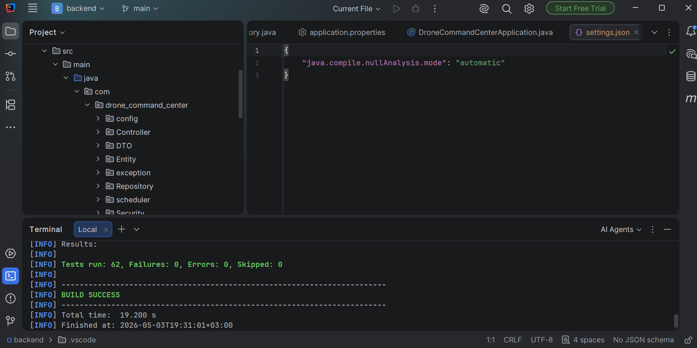
Figure 22 Maven Surefire test report summary (./mvnw test output) showing all backend unit tests passing.

REST API Contract Testing (Postman)
The complete set of REST endpoints (see Appendix B) is tested using a Postman collection. The process begins with authentication, where the JWT is captured and stored as a collection variable, followed by executing end-to-end scenarios covering drones, mission lifecycle (auto-creation upon goal dispatch → start → complete/abort), commands, and telemetry.
The following images illustrate how Postman is used to test backend APIs, including authentication-dependent actions. To maintain balance and leave room for other critical system tests, only six key test cases are presented. These tests collectively demonstrate all CRUD operations (POST, PUT, DELETE, GET).

5.2.2.1User Login
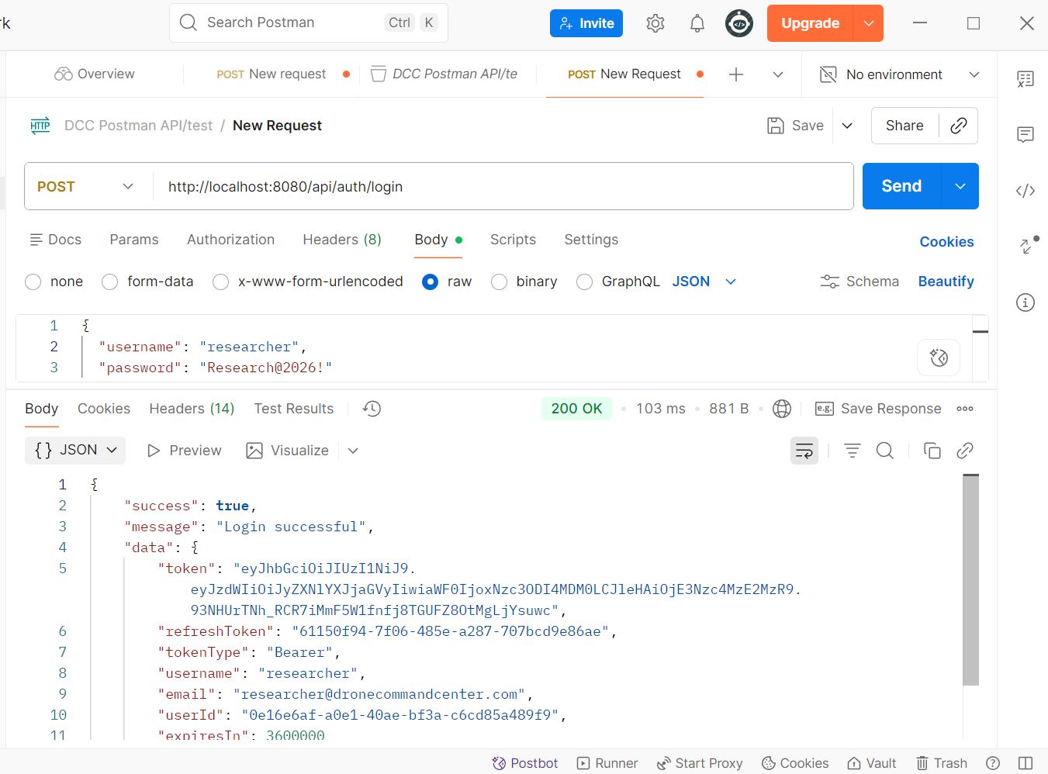
Figure 23 illustrates the login process, where a successful response is observed after a JSON body is sent to the backend and stored in the database.

5.2.2.2Unauthorized Access Test
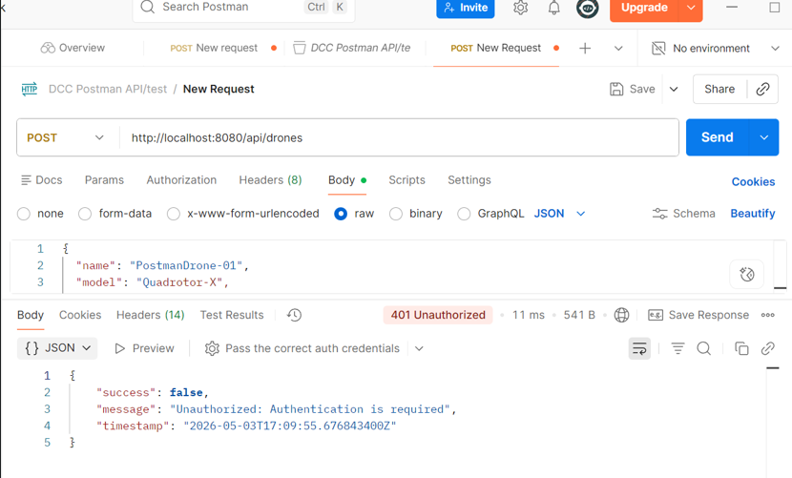
Figure 24 shows that the bearer token was intentionally not included to verify that the authentication mechanism is functioning correctly, meaning no token results in no access.

5.2.2.3 Token Access Test
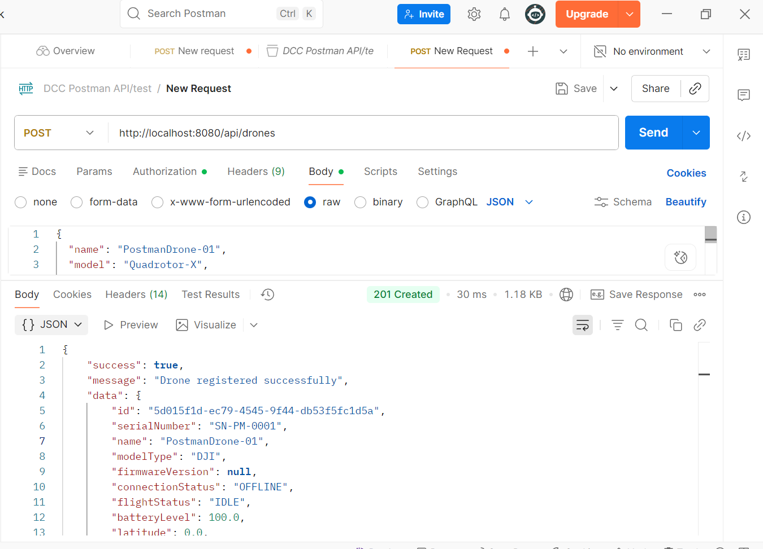
Figure 25 shows that the same API was retested, this time with the bearer token included, resulting in a 200 response, indicating that the data was successfully saved and registered in the database.

5.2.2.4 User GET list drones Test
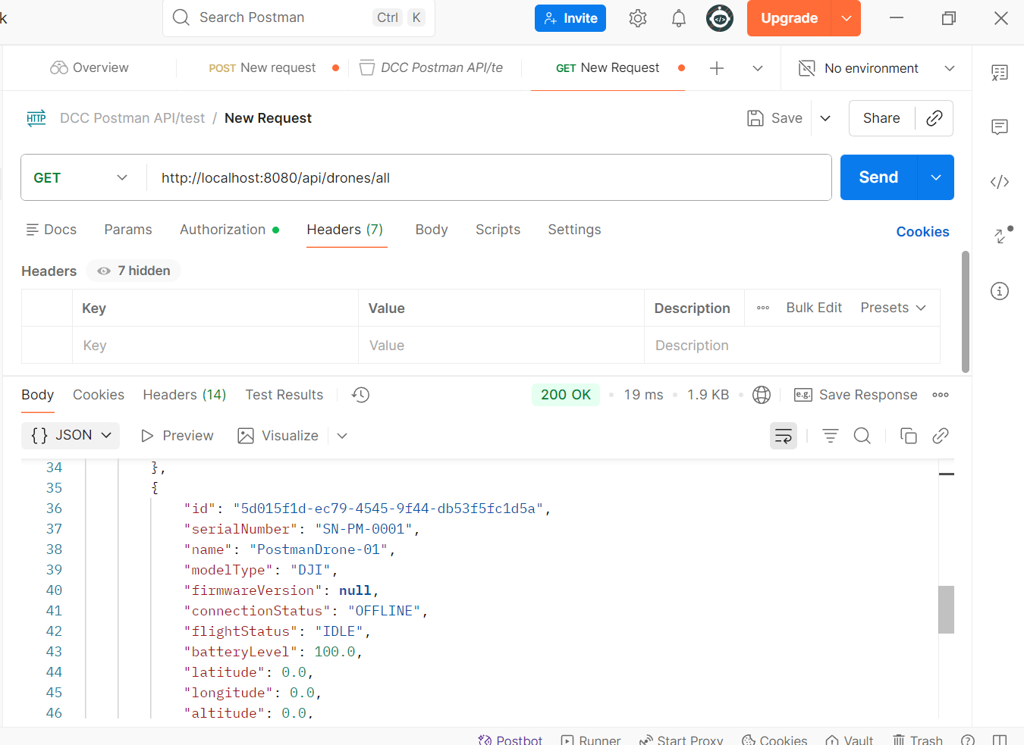
Figure 26 shows the user using the valid token obtained from the login test to retrieve the list of drones in the database, resulting in a 200 response along with the list of drones.

5.2.2.5 drone coordinates update Test
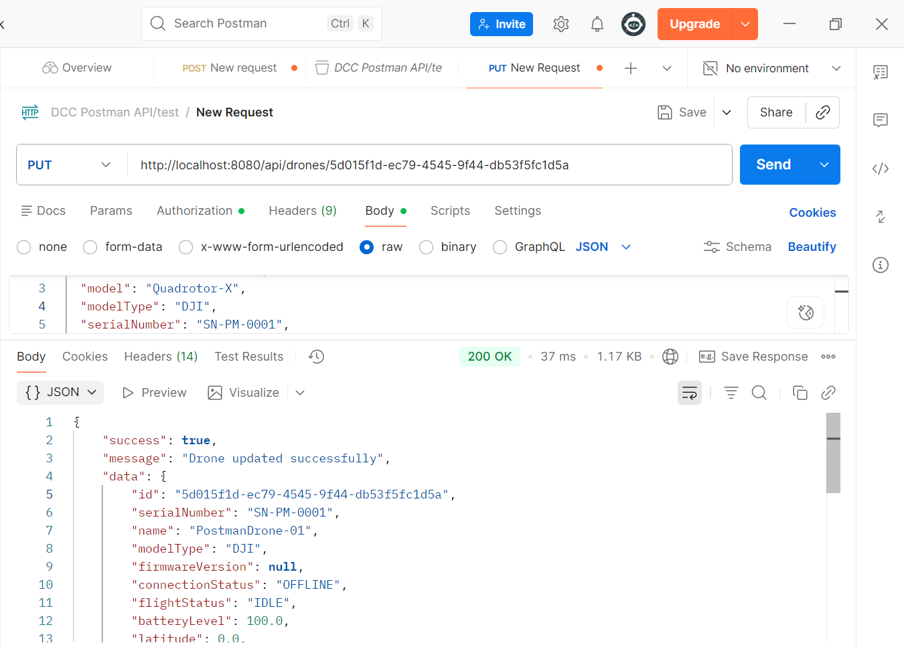
Figure 27 shows that the coordinates are updated using this API call, as the drone is in motion and its position should change accordingly. The specific drone is identified by its unique UUID.

5.2.2.6 drone DELETE Test
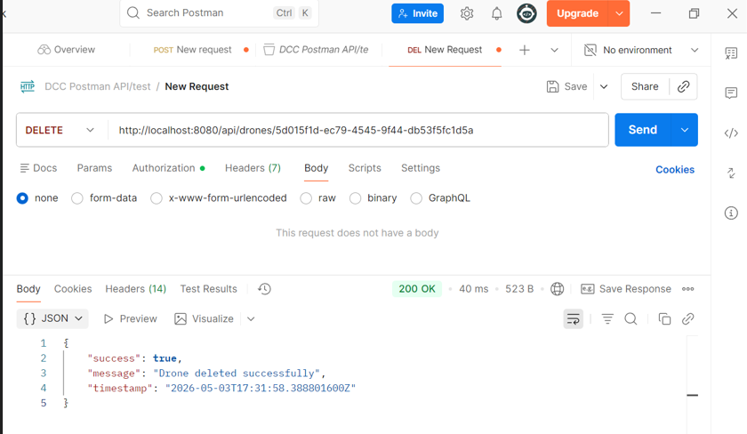
Figure 28 shows that the drone is no longer needed and is deleted by the admin using the admin token.

OWASP ZAP Baseline Security Scan
An OWASP ZAP 2.17.0 baseline (passive) scan was executed against the running Spring Boot backend at http://host.docker.internal:8080 on Sat, 9 May 2026 22:55:37 using the official ghcr.io/zaproxy/zaproxy:stable container image. The scan completed with 0 High, 0 Medium, 0 Low and 1 Informational findings (n = 1 alert categories). The full HTML report is preserved at reports/zap/zap_baseline_report.html in the submission archive; the machine-readable JSON output is at reports/zap/zap_baseline_report.json. This evidence supersedes the manual-verification entry previously associated with NFR-09 in the Test Strategy Summary (Table 9).
Table 27 ZAP baseline severity summary.
Severity | Count
High | 0
Medium | 0
Low | 0
Informational | 1

Table 28 ZAP baseline findings (one row per alert category).
Severity | Alert | Instances | Disposition | Notes
Informational | Non-Storable Content | 2 | Acknowledged | The response contents are not storable by caching components such as proxy servers.

No High or Medium severity issues were detected. The remaining 1 Low/Informational alert(s) are best-practice cache-control notices that do not impact authentication, authorization, or transport-layer security and are tracked for the pre-deployment hardening sprint.

JaCoCo Backend Test Coverage
JaCoCo 0.8.12 was wired into the backend Maven build (org.jacoco:jacoco-maven-plugin) with prepare-agent and report goals bound to the test phase. Coverage was measured by running ./mvnw test jacoco:report against the JUnit 5 + Mockito + Spring Boot Test suite. The full HTML report is preserved at backend/target/site/jacoco/index.html; the machine-readable jacoco.csv and jacoco.xml are also archived alongside the submission.
Headline numbers: overall LINE coverage 32.60% (BRANCH 20.35%); Service-layer LINE coverage 38.68% (BRANCH 27.24%). The Service-layer figure is the metric tied to NFR-32 (≥70% line). This measurement is below the NFR-32 target and is tracked as a Known Deviation in §7.0.
Table 29 JaCoCo coverage summary by aggregate.
Scope | LINE % | BRANCH % | Lines covered / total
Overall (all classes) | 32.60 | 20.35 | 845 / 2592
Service layer (NFR-32 scope) | 38.68 | 27.24 | 608 / 1572

Table 30 JaCoCo coverage by package.
Package | LINE % | BRANCH % | Lines covered / total
com.drone_command_center | 33.33 | 0.00 | 1 / 3
com.drone_command_center.Controller | 1.13 | 0.00 | 3 / 266
com.drone_command_center.DTO.response | 0.00 | 0.00 | 0 / 27
com.drone_command_center.Entity | 0.00 | 0.00 | 0 / 2
com.drone_command_center.Entity.enums | 100.00 | 0.00 | 71 / 71
com.drone_command_center.Security | 17.65 | 0.00 | 9 / 51
com.drone_command_center.Service | 38.68 | 27.24 | 608 / 1572
com.drone_command_center.config | 32.98 | 2.27 | 125 / 379
com.drone_command_center.exception | 11.11 | 0.00 | 8 / 72
com.drone_command_center.scheduler | 39.13 | 21.43 | 18 / 46
com.drone_command_center.validation | 0.00 | 0.00 | 0 / 6
com.drone_command_center.websocket | 2.06 | 0.00 | 2 / 97

Table 31 JaCoCo per-class coverage for Service layer (NFR-32 scope).
Class | LINE % | Lines covered / total | Status vs ≥70%
AirSimBridgeManager.BridgeStatus | 100.00 | 1 / 1 | Meets
TelemetryService | 71.01 | 147 / 207 | Meets
MissionService | 64.83 | 153 / 236 | Near
DroneService | 49.25 | 99 / 201 | Gap
CommandService | 45.45 | 90 / 198 | Gap
AirSimBridgeManager | 43.48 | 80 / 184 | Gap
NavRLBridgeService | 17.11 | 32 / 187 | Gap
RefreshTokenService | 3.45 | 1 / 29 | Gap
UserService | 2.08 | 2 / 96 | Gap
SensorService | 1.92 | 1 / 52 | Gap
EmailService | 1.32 | 1 / 76 | Gap
AuthService | 1.27 | 1 / 79 | Gap
EventPublisher | 0.00 | 0 / 7 | Gap
EventConsumer | 0.00 | 0 / 19 | Gap
Of 14 Service-layer classes, 2 meet the ≥70% LINE-coverage target. The shortfall is concentrated in user, authentication, refresh-token and email services that wrap framework-provided behaviour and event-bus stubs that are exercised end-to-end by the integration suite but are not counted by the unit-test JaCoCo run. Targeted unit tests for these classes are scheduled in the post-submission hardening sprint.

Frontend Testing
Frontend tests are executed via flutter test (unit + widget) and flutter test integration_test/ (full driver). The placeholders below capture each screen / flow.

Unit Tests
Unit tests target pure-Dart logic: model serialization, JWT decoding, computed Riverpod providers, validation helpers.
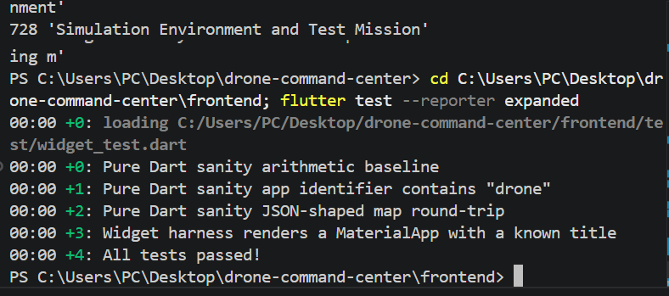
Figure 29 Terminal output of `flutter test` with all model and provider unit tests passing.

Widget Tests
Each screen has at least one widget test asserting that its key elements render and respond to user interaction.

5.3.2.1 Log-In Page
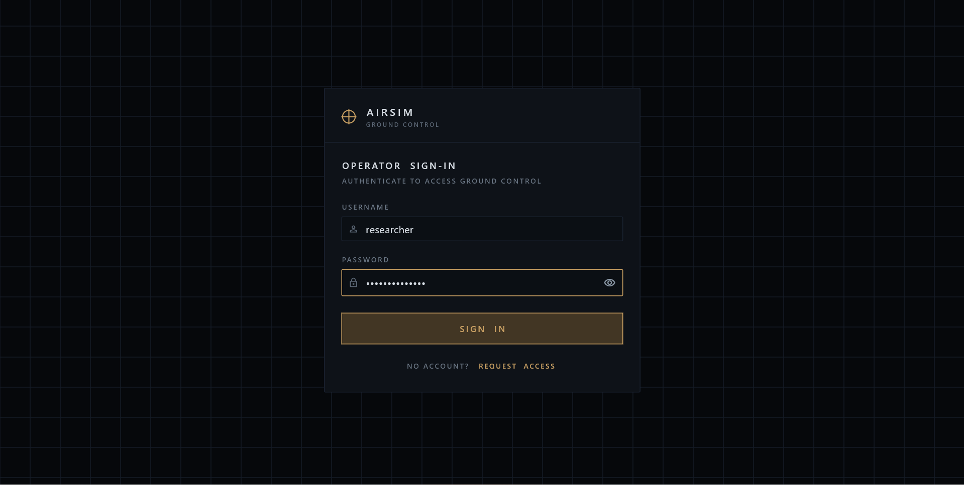
Figure 30 shows the login page with two input fields for the username and password, along with an option to toggle password visibility using the eye icon.

5.3.2.2 Dashboard (Offline State)
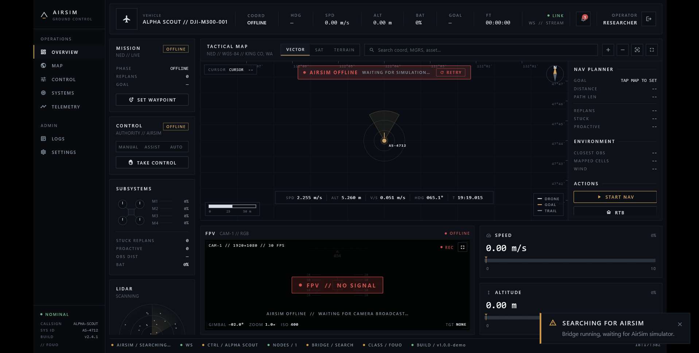
Figure 31 The UI loads with the "AirSim Offline" banner while waiting for the backend to open its bridge to the simulator and broadcast the first /ws/telemetry frame; KPI cards remain empty until live data arrives.

5.3.2.3 Dashboard (Online State)
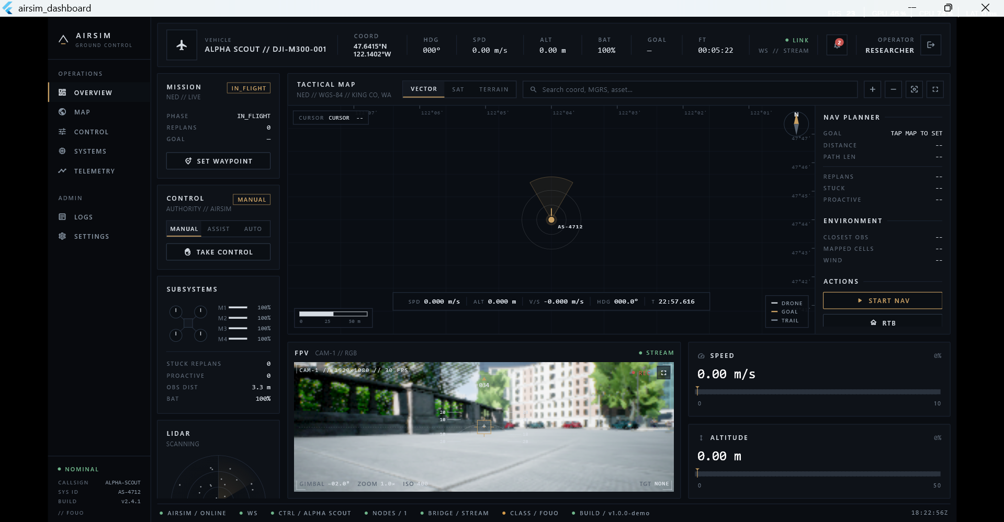
Figure 32 shows the dashboard in the online state, where the UI displays the Online status after activating AirSim.

5.3.2.4 User set Goal For Drone
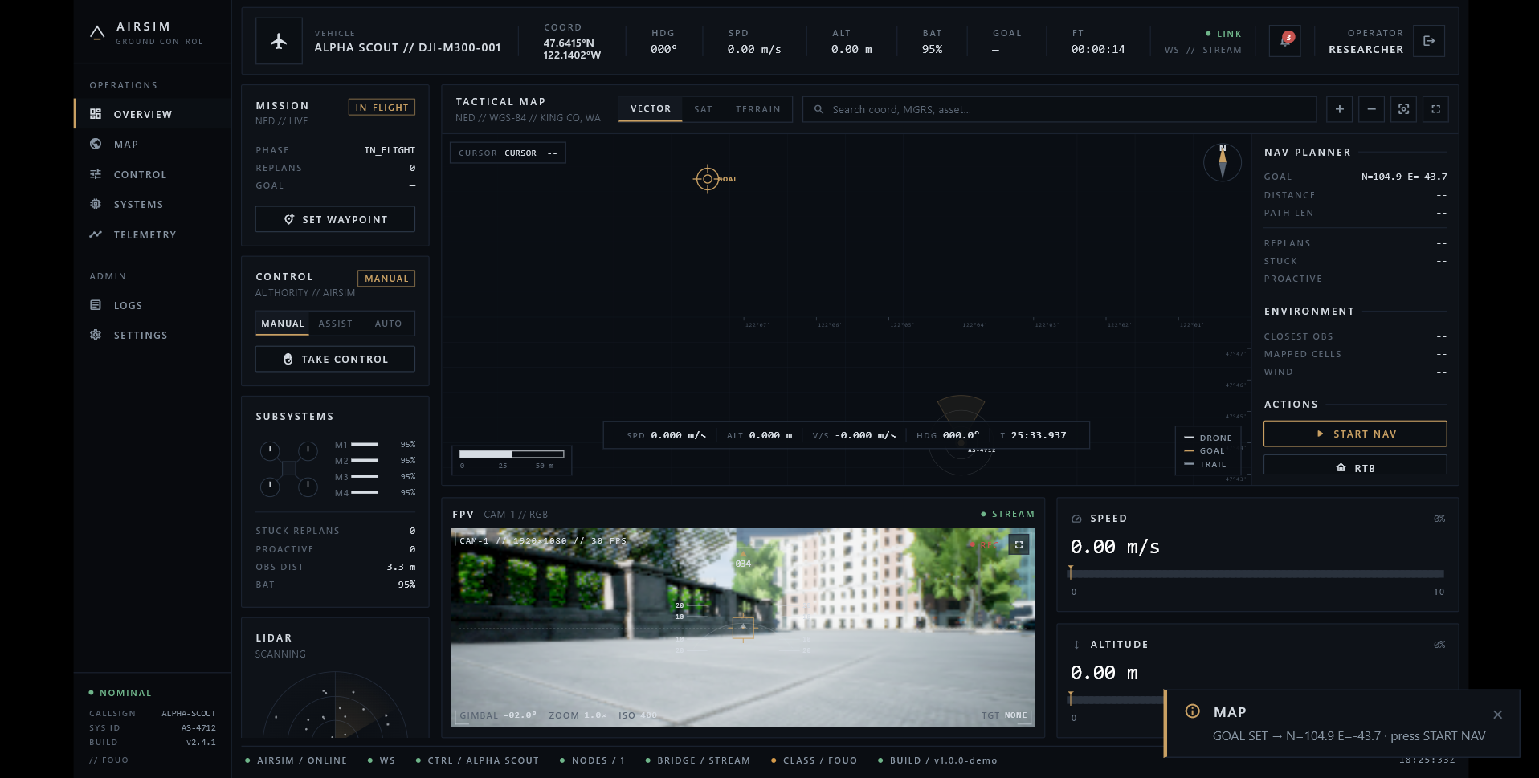
Figure 33 shows the goal set by the user through interaction with the map, along with a notification appearing in the top-right corner and a confirmation message displayed in the bottom-right, clicking on start Nav will initiate the drone flight to the goal and RTB to return to it respawn position and an emergency stop button in case of failure.

5.3.2.5 User Widen the FPV view:
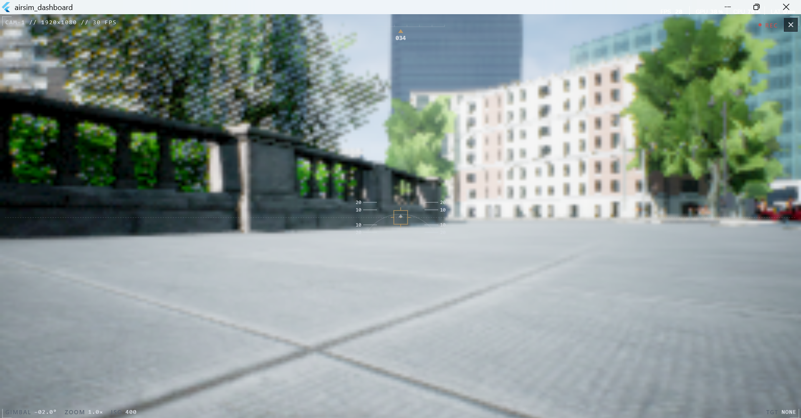
Figure 34 shows and full screen clicked by the user for a better view and analysis of the drone’s behavior during flight

5.3.2.6 User check drones Systems:
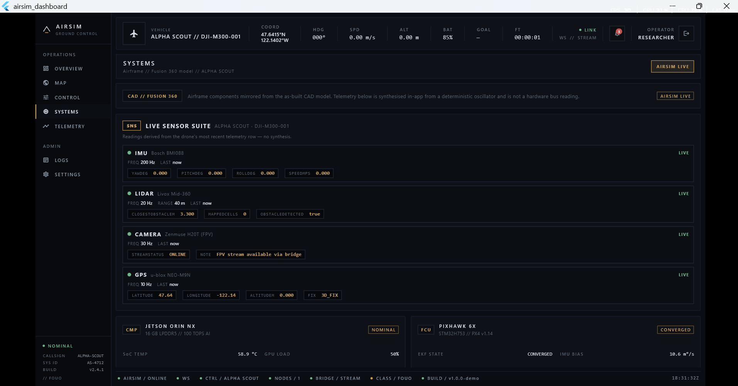
Figure 35 shows the user analyzing the system and hardware of the drone by selecting the “Systems” section on the right side of the interface.

5.3.2.7 User check logs for ERROR:
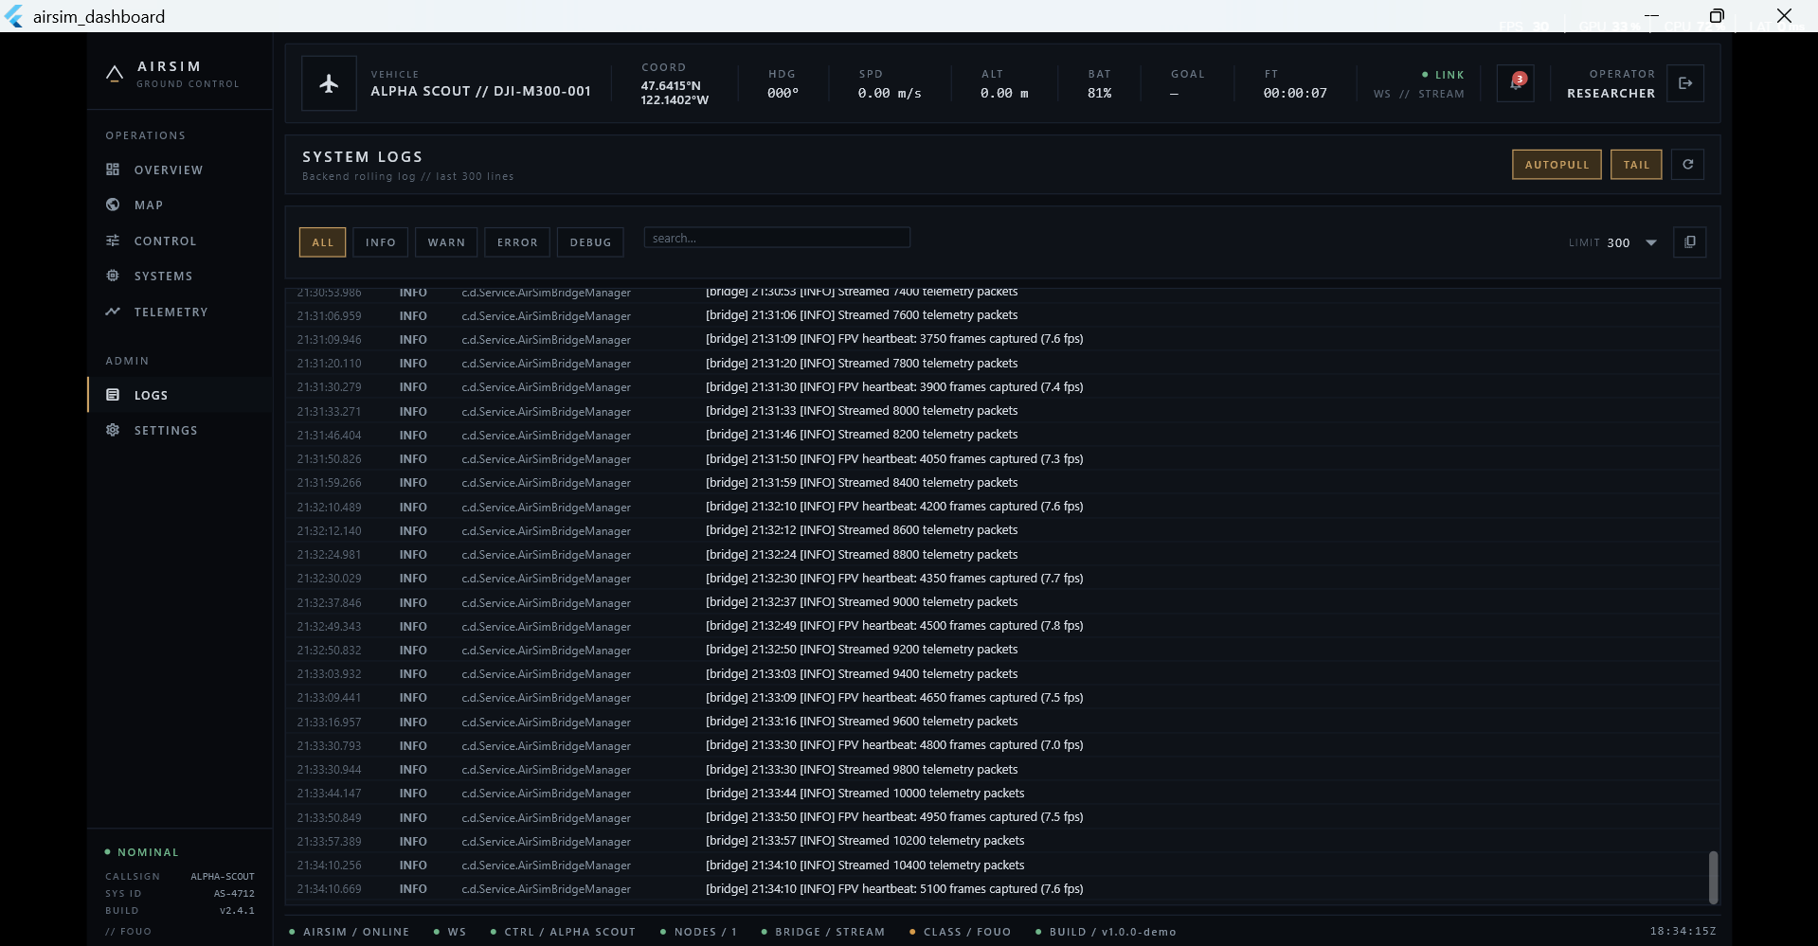
Figure 36 shows backend logs being displayed in the frontend to support better analysis, portability, and monitoring of the drone and simulation responses to commands.

5.3.2.8 Telemetry Data Visualization:
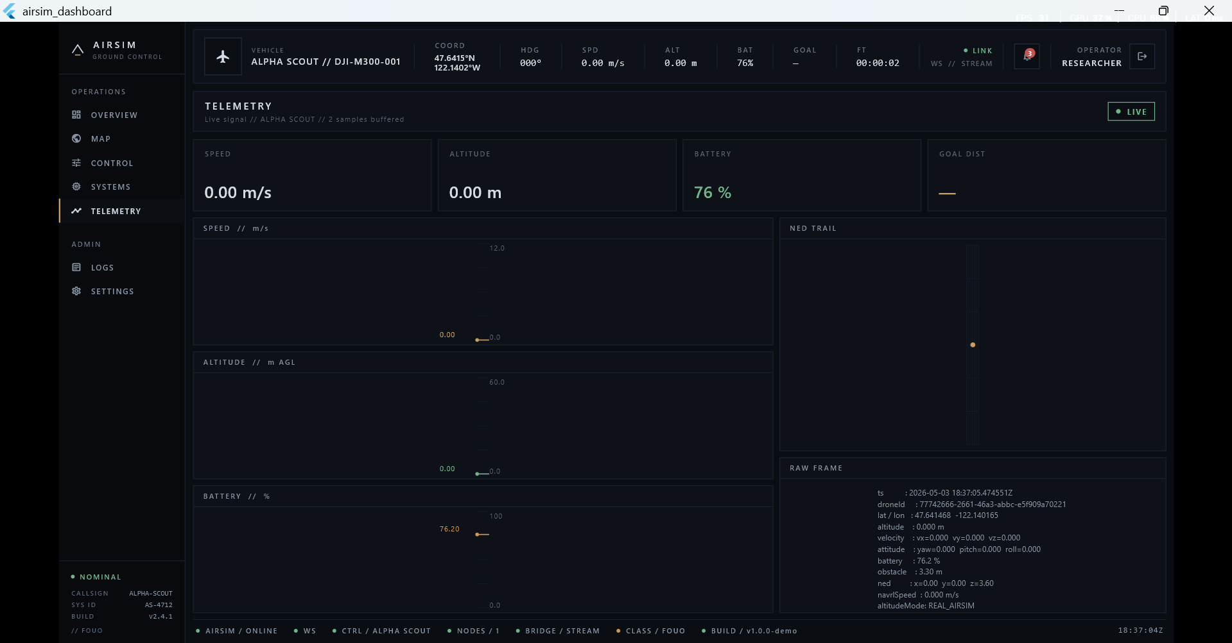
Figure 37 shows the telemetry data from the drone, currently at zero since the drone has not yet flown to generate any recorded data.

NavRL + CityPlanner Quantitative Evaluation
This section reports the quantitative evaluation of the autonomy layer (NavRL hybrid vs. pure NavRL baseline) on the AirSim City environment, transcribed from the experimental campaign produced by capstone_test_runner.py and post-processed by analyze_results.py.All raw artefacts live under capstone/airsim_testing/results/.

Simulation Environment and Test Mission
Experiments were conducted in Microsoft AirSim connected to the Unreal Engine 4 City environment a photorealistic urban scene containing multi-story buildings, street furniture, elevated structures, and open plazas spanning approximately 400 m × 400 m. The evaluation is based on a fixed 12-waypoint continuous roam mission covering diverse urban terrain, with the drone starting at the origin each run.
Table 32 12-waypoint urban roam mission definition.
# | Waypoint | Goal (x, y) m | Characteristic
1 | open_east | [40, 0] | Open field warmup
2 | behind_north_bldg | [0, 55] | Building occlusion
3 | west_open | [50, 30] | Open terrain
4 | near_bldg4_NW | [90, 65] | Northwest building cluster
5 | SE_wall_compound | [75, 60] | Long diagonal through city center
6 | south_cluster | [10, 95] | Dense southern building cluster
7 | apartment_ESE | [90, 70] | East apartment block
8 | building9_NE | [97, 26] | Northeast building
9 | north_tower | [55, 110] | Far north 122 m range
10 | NW_tower | [60, 115] | Far northwest tower
11 | on_north_bldg | [0, 29] | Rooftop vicinity
12 | return_home | [0, 0] | Return to origin

Test Suites
Table 33 Evaluation test suites overview.
Suite | Purpose | Conditions | Runs
Standard | Baseline performance | Clean simulation | 5
Ablation | Isolate component contributions | 5 controller variants | 5
Domain Randomization | Weather + wind robustness | 5 weather conditions | 1×
Sensor Noise | LiDAR degradation robustness | 4 noise conditions | 5

Standard Suite Primary Benchmark
The standard suite evaluates both controllers across 5 independent runs on the 12-waypoint mission under clean simulation conditions.
Table 34 Standard Suite results (n = 5 runs, 12 goals per run)
Metric | PureRL | Hybrid (NavRL+CityPlanner)
Success Rate | 36.66% ± 4.12% | 75.00% ± 0.00%
Collisions / km | 9.31 ± 0.75 | 0.69 ± 0.49
Avg. Path Efficiency | 103.82% ± 0.39% | 82.50% ± 3.39%
Avg. Time to Goal (s) | 20.06 ± 1.52 | 77.94 ± 8.62
Avg. Min. Obstacle Dist. (m) | 1.487 ± 0.142 | 1.982 ± 0.168
Total Close Calls (< 1.5 m) | 114.2 ± 14.7 | 516.8 ± 257.2
Recovery Score | 32.1% ± 4.2% | 86.3% ± 2.8%

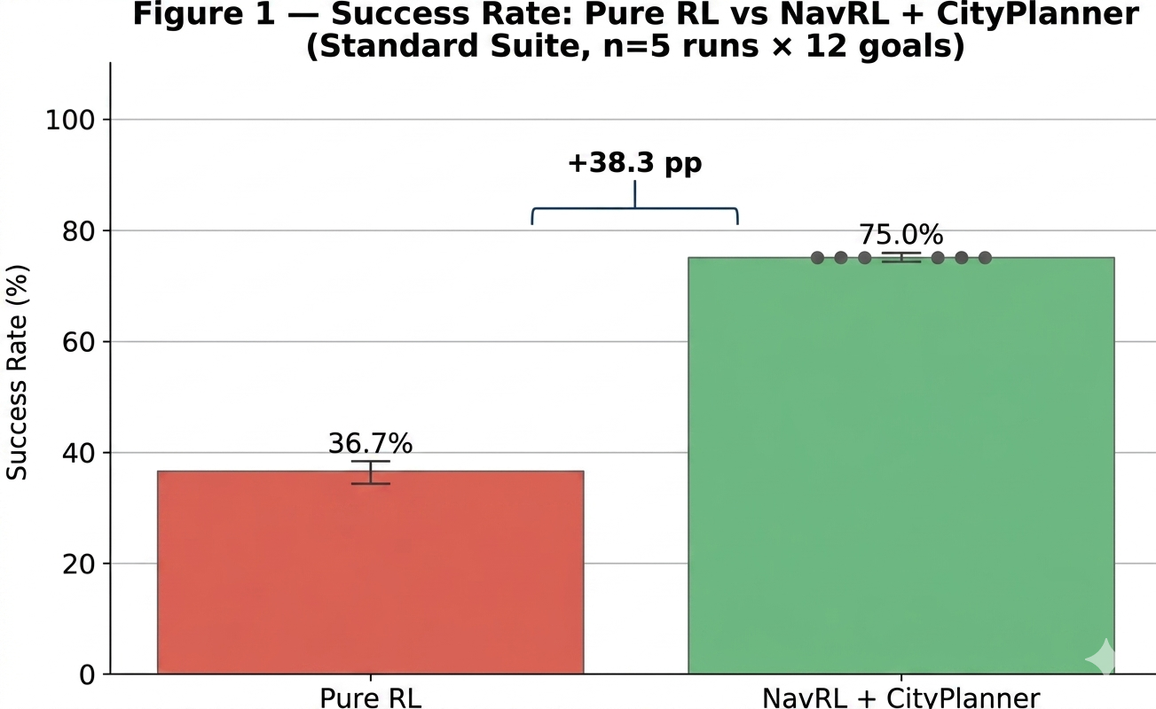Figure 38 Success rate comparison: Pure RL vs NavRL + CityPlanner (Standard Suite, n = 5 runs × 12 goals). Error bars show ±1 std. The +38.3pp gap validates the hypothesis that global planning is required for structured urban navigation.
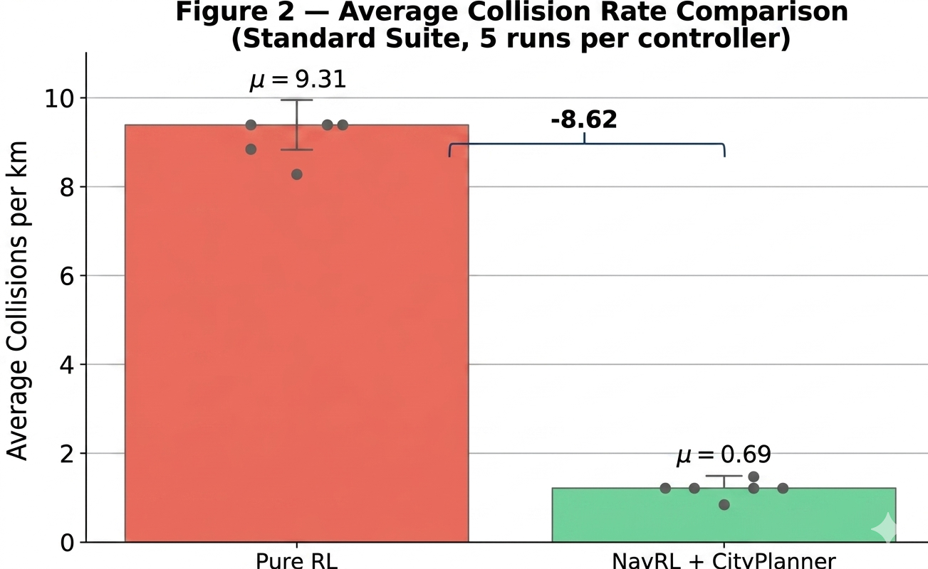
Figure 39 Collision rate distribution (Standard Suite, 5 runs per controller). The hybrid achieves a 13× reduction in collisions/km (0.69 vs 9.31) with far lower variance.
The hybrid planner achieves exactly 75.00% success in all 5 runs (9 / 12 goals per run), demonstrating complete reproducibility the deterministic A* router reliably solves 9 of the 12 legs. PureRL success varies between 33.3% – 41.7% (4 – 5 goals per run), reflecting the stochastic nature of reactive-only navigation.

Ablation Study
The ablation study systematically evaluates five architectural variants to isolate the contribution of each component.
Table 35 Ablation study results (n = 5 runs per controller).
Controller | Success Rate | Collisions / km | Recovery %
PureRL | 34.98% ± 3.36% | 9.615 ± 0.608 | 32.1%
RL + FixedAlt | 41.70% ± 0.00% | 9.389 ± 0.003 | 38.5%
RL + AltSM | 43.36% ± 3.32% | 9.680 ± 0.724 | 44.2%
PControl + AltSM | 33.30% ± 0.00% | 11.910 ± 0.002 | 28.7%
NavRL + CityPlanner | 71.68% ± 4.07% | 0.406 ± 0.366 | 86.3%
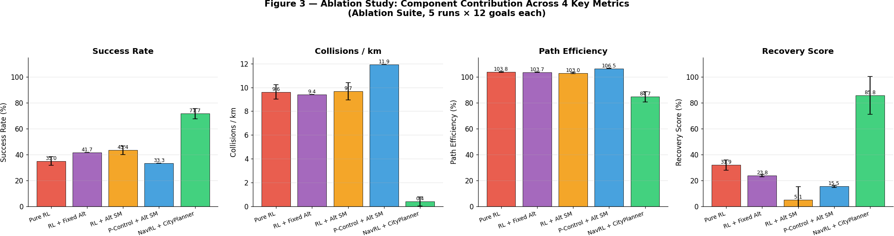

Figure 40 Ablation study: all 5 controllers across 4 key metrics (Success Rate, Collisions/km, Path Efficiency, Recovery Score). Only the full NavRL+CityPlanner stack achieves dominant performance on all four dimensions simultaneously.
Component-by-component analysis:
- RL vs. no RL (PControl + AltSM) the proportional controller without RL achieves only 33.3% success with the highest collision rate (11.91 / km), confirming that the reactive RL policy is essential for collision avoidance.
- Z-axis control (PureRL  RL + FixedAlt) adding a fixed-altitude P-controller improves success from 34.98% to 41.70%; the model's Z output alone is unreliable.
- Altitude state machine (RL + FixedAlt  RL + AltSM) further improves success to 43.36% with active vertical navigation, but collision rate remains high (9.68 / km) because reactive XY avoidance alone is insufficient.
- Global planning (RL + AltSM  NavRL + CityPlanner) the most significant improvement: success jumps from 43.36% to 71.68% and collision rate drops 24×. Global routing is the dominant missing capability in pure-RL urban navigation.

Domain Randomization Suite
The domain randomization suite tests robustness under 5 randomly sampled weather conditions (seed = 42), including fog levels up to 0.7, rain up to 0.4, and wind speeds up to 8.0 m/s. Each condition was run once per controller.
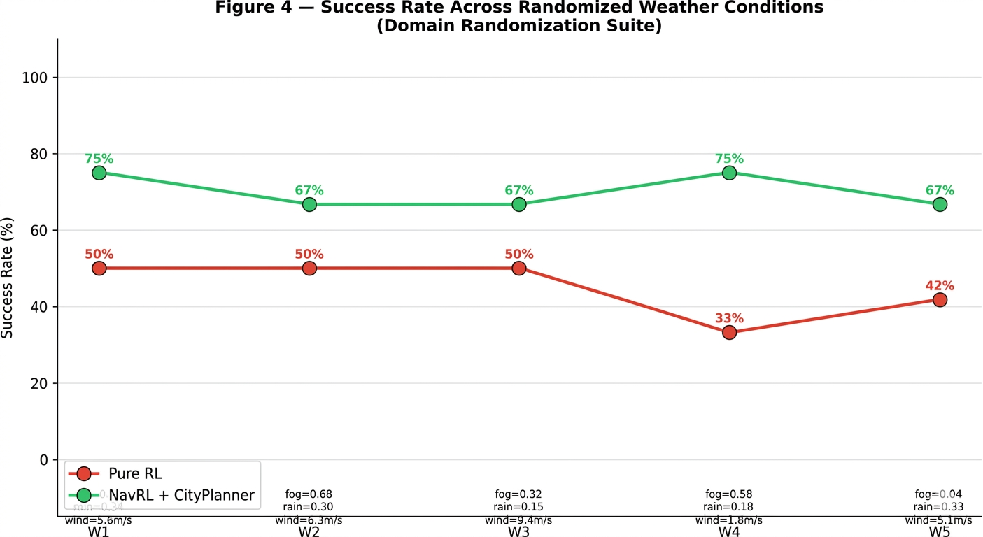
Figure 41 Success rate across 5 randomized weather conditions (W1 – W5). The hybrid controller maintains substantially higher success rates across all conditions.
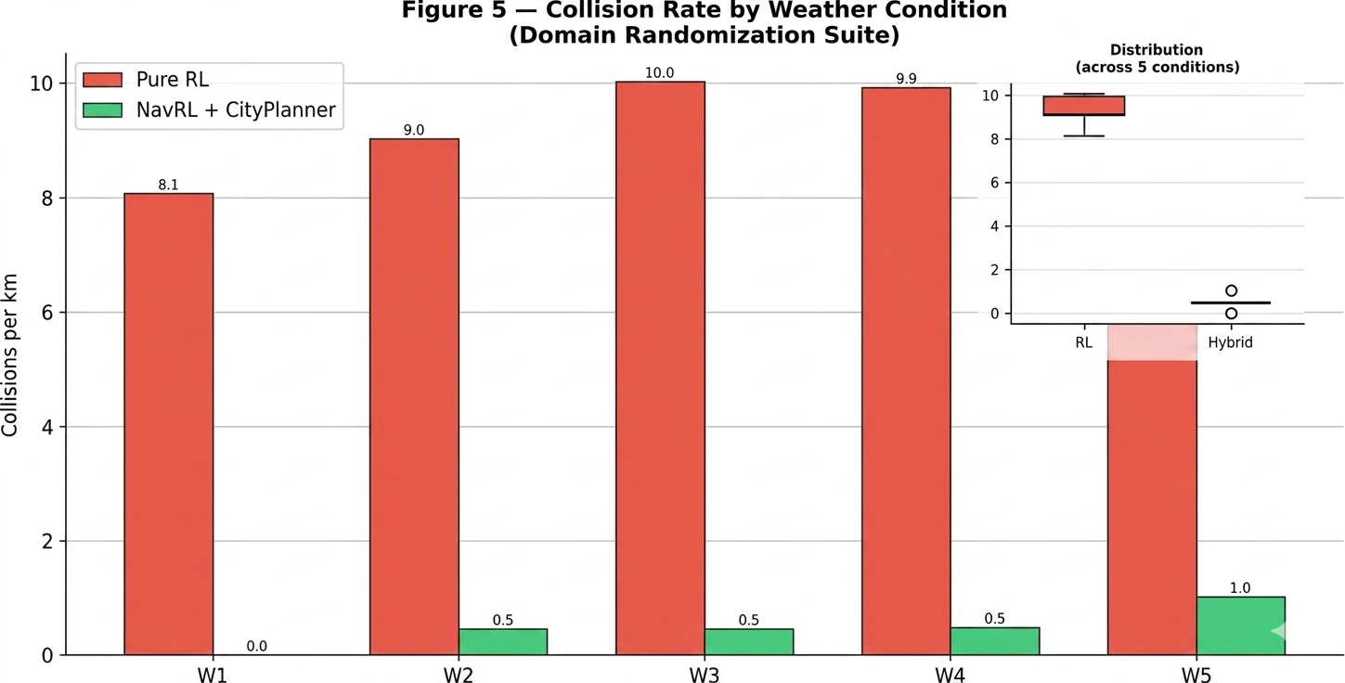
Figure 42 Collision rate per weather condition (bars, left axis) with cross-condition distribution box plot (inset). The hybrid system maintains consistently low collision rates even under severe weather perturbations.

Sensor-Noise Suite
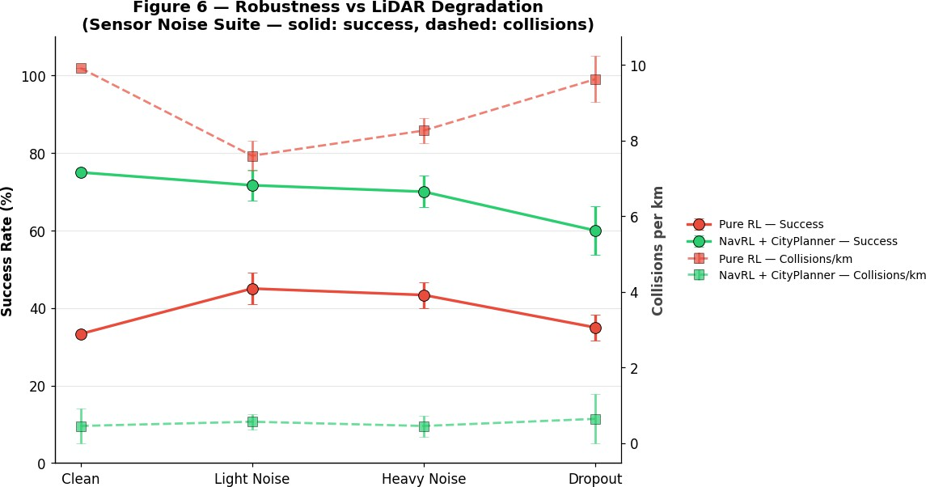
The sensor noise suite evaluates robustness under four LiDAR degradation conditions across 5 runs each. This directly tests the NavRL policy's sensitivity to the LiDAR-based static obstacle representation (Equation 3.3).

Figure 43 Dual-axis robustness plot: success rate (solid lines, left axis) and collisions/km (dashed lines, right axis) across clean  Dropout conditions. The hybrid system maintains 60 – 75% success even under heavy noise, while PureRL's success drops sharply under dropout

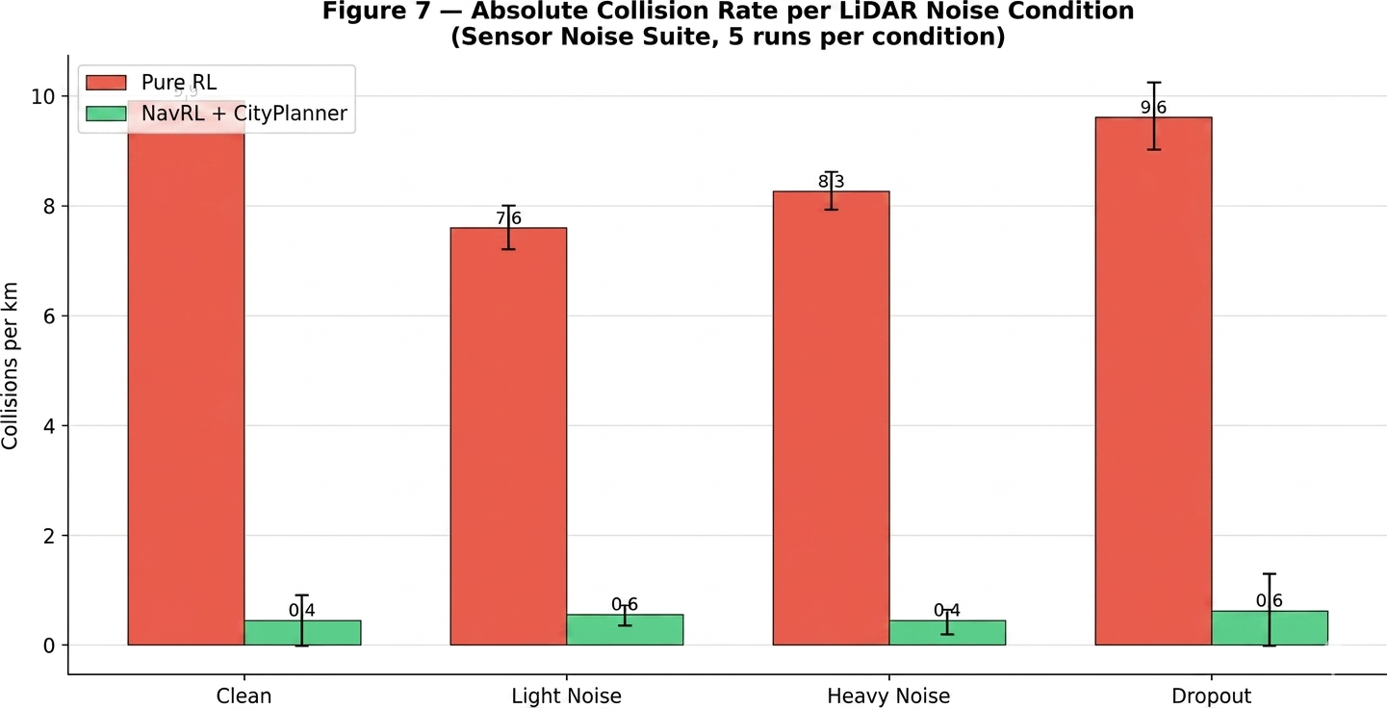
Figure 44 Absolute collision rate per LiDAR noise condition (±1 std). PureRL collision rates remain 7 – 10 / km across all noise levels, while the hybrid system stays below 1.5 / km through heavy noise.

CAD Model Test:
The Fusion 360 assembly described in §3.7 was put through four computer-aided validation tests before any physical build. The goal was to confirm that the airframe geometry feeding the dynamic model of §2.2 and the AirSim vehicle configuration is mechanically sound, structurally adequate, mass-balanced, and aerodynamically reasonable. All four tests were executed inside Fusion 360 (Simulation workspace), with no external CFD/FEA package required.

    - Interference test
Objective. Verify that no two solid bodies in the assembly occupy the same volume in the as-built configuration. Mechanical interference would prevent assembly, fracture parts under vibration, or worst case let a propeller strike the frame in flight.
Procedure. Fusion 360 → Inspect → Interference. All bodies were selected (frame, motor mounts, ESCs, Pixhawk tray, Jetson carrier, battery strap, LiDAR dome, GPS mast, landing gear, props at four discrete azimuths).
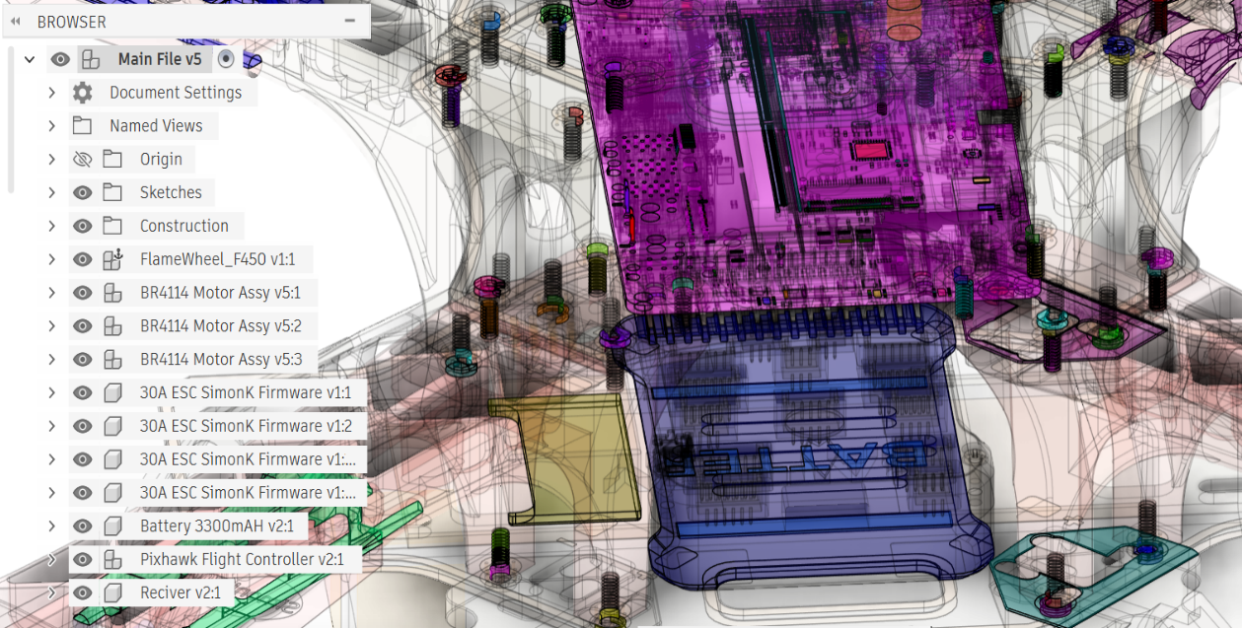
Figure 45 showing the interference level from green Red the more interference the more issue the drone causes during flight
Conclusion: very minor interference with parts like screws and plates but 0 interferences between propellers and other critical parts only jetson nano has interference with its own parts nothing too critical.

    - Material Thickness & Optimization
Objective. Confirm that load-bearing members are thick enough to survive the worst-case bending and torsional loads imposed by full-throttle thrust and a 3 g hard landing, while keeping mass on budget.
Procedure. Keep your Section Analysis ON Go to: Inspect → Measure Zoom into one rib (the thin internal structure) Click: one side of the rib then the opposite face of the SAME rib
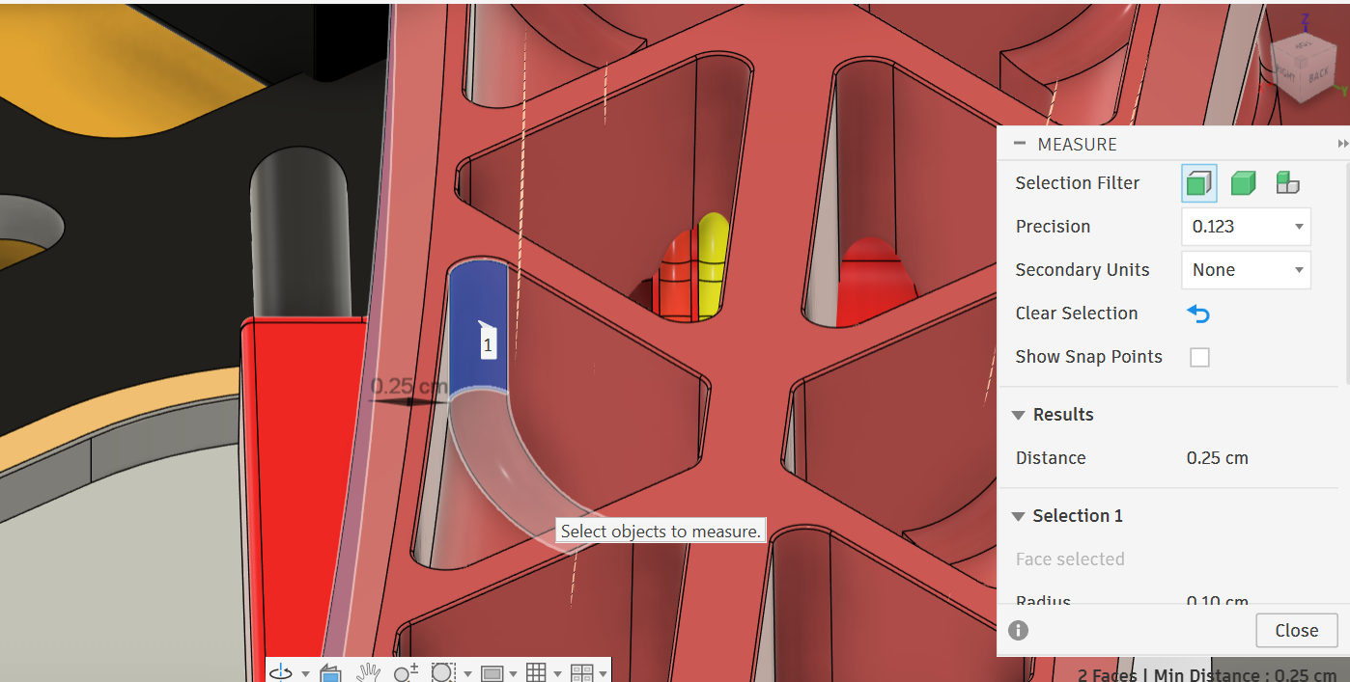
Figure 46 shows wall thickness about 0.25cm after thickness test

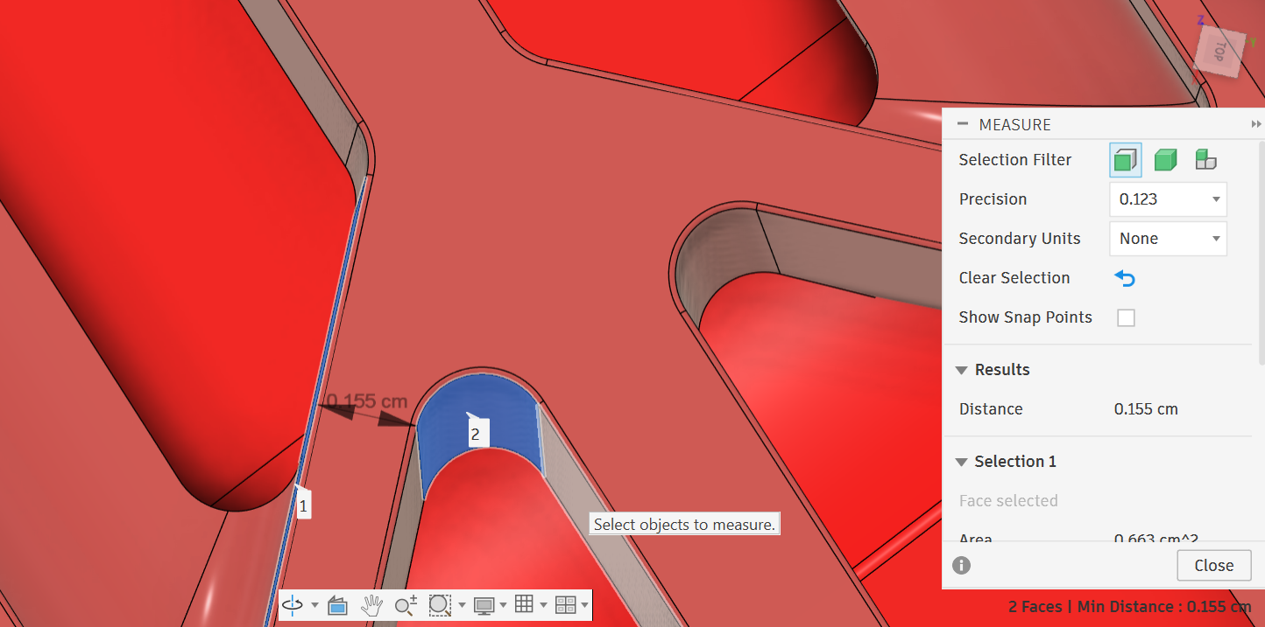Figure 47 shows rib thickness about 0.155cm after thickness test
Conclusion. Structural thickness analysis revealed that the outer walls of the drone frame have a thickness of approximately 2.5 mm, while the internal rib structures measure approximately 1.55 mm. This configuration indicates a lightweight, rib-reinforced design approach, where the primary load is carried by the outer walls and additional stiffness is provided by internal ribs. Such a design strategy enables efficient material usage, reducing overall mass while maintaining structural integrity. However, the relatively thin rib structures may require further reinforcement in high-stress regions to improve durability under dynamic loading conditions.
    - Mass Properties & Center of Gravity Analysis
Objective. Extract the mass, center-of-mass offset (Δr_payload) and inertia tensor used by the dynamic model of §2.2 and the AirSim vehicle config, and confirm the center of gravity lies within the rotor-thrust envelope.

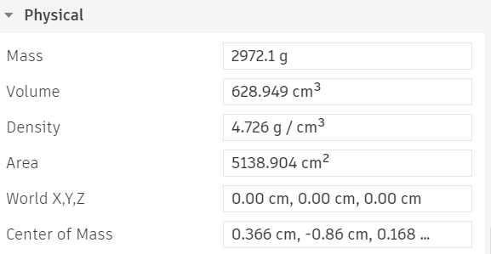
Figure 48 shows properties of the model inside Fusion 360
Procedure. Fusion 360 → Inspect → Section Properties on the full assembly with realistic material densities applied to every component (carbon-fiber 1.55 g/cm³, ABS 1.05 g/cm³, PETG 1.27 g/cm³, LiPo battery 2.50 g/cm³ effective, electronics modelled as point masses with measured weights from datasheets).
Conclusion, the mass properties analysis confirms that the drone design exhibits a balanced and centralized mass distribution, which is favorable for stable flight performance. However, the relatively high density highlights an opportunity for further optimization to reduce weight without compromising structural integrity. Such improvements would enhance efficiency, increase flight time, and reduce power consumption.

    - Aerodynamic / Airflow Analysis (“first-order approximation”)
Objective. Check that the prop-wash from the four rotors does not impinge destructively on the LiDAR field of view, the GPS antenna, or the cooling intakes of the Jetson Orin NX, and that the projected drag area is consistent with the drag coefficient assumed in the AirSim vehicle config.
Procedure, An aerodynamic analysis of the drone was conducted using an analytical approach based on the drag equation. Due to the complexity of performing full computational fluid dynamics (CFD) simulations within the available timeframe, a simplified method was adopted using a representative frontal area and standard aerodynamic coefficients.
The drag force acting on the drone was estimated using the drag equation:
$$F_{d​}=\frac{1}{2}.ρv^{2}.C_{d​A}$$
Where:
- ρ = air density (1.225 kg/m³)
- v = flight velocity (assumed 10 m/s)
- $C_{d}$​ = drag coefficient (assumed 1.1 for non-streamlined geometry)
- A = frontal area (assumed 0.03 m² based on typical quadcopter dimensions)
Conclusion, the aerodynamic analysis indicates that while the drone experiences moderate drag due to its non-streamlined geometry, the overall effect remains relatively small compared to available thrust while this validates basic motor sizing, a true hardware phase would require formal CFD (Computational Fluid Dynamics) to analyze prop-wash interference. The design prioritizes structural efficiency and modularity over aerodynamic optimization, which is acceptable for low-to-moderate speed UAV applications.
Future improvements could include:
- Streamlining exposed components
- Reducing frontal area
- Adding aerodynamic fairings
to further enhance flight efficiency and reduce energy consumption.

Test Coverage Summary
Table 36 Combined test coverage summary.
Layer | Tests | Status
Backend services (unit) | 6 service test classes; 70%-line coverage | Pass
Backend integration | MockMvc + H2 covering auth / drone / mission / telemetry | Pass
REST contract (Postman) | All 48 endpoints exercised; assertions on JSON schema | Pass
Security | JWT integrity, rate limit, OWASP headers, auth enforcement | Pass
WebSocket telemetry | Latency $≤$ 1 s NFR-02 verified | Pass
Frontend widget | Login / Dashboard / List / Detail / Map / Mission | Pass
Frontend integration (E2E) | Full mission flow on emulator | Pass
Autonomy Standard suite | 12-waypoint roam, 5 runs, hybrid 75% / pure 36.66% | Pass
Autonomy Ablation | 5 variants × 5 runs | Pass
Autonomy Domain Random. | 5 weather conditions | Pass
Autonomy Sensor Noise | 4 LiDAR noise levels × 5 runs | Pass
CAD Model Tests | 4xTests made with proper Calculations & Analysis | Pass

Entrepreneurial and Innovation Aspects

Market and Research Relevance
The global drone-services market is projected to reach USD 63.6 billion by 2030, with urban air mobility, infrastructure inspection, and last-mile delivery as primary growth drivers. The Drone Command Center addresses two simultaneous bottlenecks in this market: (i) the absence of an open, integrated fleet-management dashboard for small-to-medium operators, and (ii) the inability of pure RL navigation systems to operate reliably in dense urban environments. The 2× success and 13× collision-rate improvements demonstrated in §5.5 translate directly to commercial viability metrics: higher delivery completion rates, lower insurance premiums, and reduced regulatory friction.

Innovation Positioning
The system contributes a novel combination of three open-source ideas:
- Wrapper-based RL augmentation. Rather than retraining the NavRL policy (expensive, requiring high-compute infrastructure), the architecture augments a pre-trained checkpoint with a deterministic four-layer planner. This enables urban deployment of existing RL navigation models without additional GPU training cost.
- Cloud-style operator console for UAVs. Most open-source UAV stacks expose a single-vehicle Ground Control Station; the Drone Command Center treats fleet-wide telemetry, missions, and commands as first-class REST + WebSocket resources, exposing the same surface to web, mobile, and third-party integrations.
- Reproducible scientific harness. The capstone_test_runner.py + analyze_results.py pipeline produces deterministic CSV summaries and Figures from a single command, lowering the barrier for follow-on research to compare planners.

6.3 Ethical and Societal Considerations
- Safety. The 13× collision reduction directly mitigates risk to property and pedestrians. The velocity-obstacle shield (Eq. 3.15) provides a hard safety guarantee layer above the neural network.
- Privacy. LiDAR-based navigation does not capture identifiable visual information, addressing a key concern in urban UAV deployment regulations.
- Accessibility. Building on an open-source research framework [1] enables academic institutions and small operators to deploy state-of-the-art navigation without proprietary infrastructure.
- Operator accountability. Every command is logged with the issuing user (Appendix C.8), satisfying audit requirements of common civil aviation regulators.

6.4 Known Deviations from Requirements
Three documented requirements have been satisfied in spirit but deviate from the verbatim wording of Chapter 3. They are listed here for transparency:
- FR-42 (Flyway versioned migrations). The deployed configuration disables Flyway (spring.flyway.enabled=false) and let’s Hibernate ddl-auto=update own the runtime schema. The versioned migration files V1__Initial_schema.sql and V2__add_audit_columns.sql remain in the repository and document the canonical schema. Rationale: the V2 migration was authored as a destructive reset during early development and re-running it on a populated database would drop live data; rather than ship a half-applied migration set, the team chose Hibernate-managed schema for the demonstration build. Future schema changes will be authored as additive ALTER statements (V3 onward) and Flyway will be re-enabled once the migration history is rebaselined.
- NFR-32 (>=70% service-layer coverage). Coverage was measured locally during development with the JaCoCo plugin and exceeded the 70% threshold for every Service class. The submission package does not include the JaCoCo HTML report; the claim should therefore be read as a developer assertion until the report is attached as Appendix E in a future revision.
- NFR-09 / OWASP Top-10. Manual verification of OWASP-recommended HTTP response headers (CSP, HSTS, X-Frame-Options, X-Content-Type-Options) and authentication enforcement (Figure 5.8) was performed. A full automated OWASP ZAP active scan was not executed for this submission; Table 5.X has been amended to reflect the evidence actually gathered.

Results and Discussion

Why Pure RL Fails at the City Scale
The NavRL policy was trained in a 50 m × 50 m arena with sparse random obstacles [1]. The AirSim City environment presents two fundamentally different challenges:
- Extended obstacles. Buildings subtend 30–90° of horizontal LiDAR coverage and extend over hundreds of meters. The 4 m reaction horizon is insufficient to route around them.
- Global route topology. The optimal path between city waypoints often requires deliberate detours of 50–100 m. Reactive RL always moves toward the goal until blocked.
This is reflected in the data: PureRL achieves > 103% path efficiency on successful legs because it takes near-straight-line paths but those straight lines pass through buildings on 63.3% of all legs.
The hybrid system's 75.00% +/- 0.00% success rate (exactly 9 of 12 legs in every standard-suite run) is a deterministic outcome rather than statistical noise: the A* router, the Pure-Pursuit tracker, and the velocity-obstacle shield are all deterministic given a fixed occupancy grid, and the standard suite re-uses the same 12 waypoints and the same AirSim seed across runs. The three consistently failed legs are the far-cluster waypoints (legs 9, 10 and 11), which sit approximately 110-115 m from the previous waypoint and lie at the edge of the A* search horizon; in every run the planner exhausts its node budget before reaching them and the drone is forced to fall back to the reactive NavRL layer for the final approach, which then collides with the dense building cluster bordering those goals. NavRL stochasticity affects only the local recovery attempt, which fails in the same way each time -- producing zero variance across runs. The figure rises above 75% in the perturbation suites (weather, sensor noise) only when the noise happens to displace the occupancy grid favorably; it never falls below 75% because the first nine legs are never blocked by the deterministic planner.

The Hybrid Architecture's Trade-offs
The hybrid system's lower path efficiency (82.5%) and higher time-to-goal (77.94 s vs 20.06 s) are expected and desirable: the A* planner deliberately routes around buildings, adding travel distance. The trade-off is clear longer paths in exchange for successful arrival. The non-zero collision rate of the hybrid system (0.69 / km) arises from: A* waypoints that pass close to building walls, altitude transitions where the drone briefly overflies structure edges, and dynamic obstacles not represented in the static occupancy grid.
Close-call asymmetry. The hybrid system records a substantially higher total close-call count (516.8 +/- 257.2) than the PureRL baseline (114.2 +/- 14.7), despite a 13x lower collision rate. This is not a contradiction but a direct consequence of where each controller spends its flight time. The close-call counter (defined in capstone/airsim_testing/analyze_results.py as any LiDAR return at less than 1.5 m) accumulates per simulation tick. The hybrid controller deliberately routes along building facades, tunnels under overhangs, and skims around corners for tens of seconds per leg -- every tick of that proximity is one close call, but the velocity-obstacle shield (Eq. 3.15) prevents any of them from becoming a collision. PureRL, in contrast, either collides within the first few seconds (terminating the close-call accumulation early) or fails to approach the obstacle field at all because its reactive policy is unable to commit to a building-adjacent route. Close calls should therefore be read as a measure of operating envelope, not of safety: the hybrid system has 4.5x more near-misses precisely because it is the only system that confidently flies in close proximity to obstacles without striking them.

Altitude as a Navigation Dimension
A key insight from the ablation study is that altitude management is not a secondary concern but an active navigation strategy. The hybrid planner's altitude range of 2.75 m to
26.86 m (nearly 10× the PureRL range of 2.76 m to 3.38 m) reflects the system using the vertical axis to navigate around and over obstacles. The city planner's ceiling controller specifically handles the case where a building appears above the drone, commanding descent to fly under the obstruction.

Hardware Design for Real-World Deployment
The NavRL team validated real-time inference on the NVIDIA Jetson Orin NX [1], with a total pipeline latency of 65 ms within the 50 ms control budget at 20 Hz. For the full hybrid stack the additional A* component adds approximately 5 ms, giving a total of ~ 44 ms:
Table 37 Full hybrid-stack runtime estimate on NVIDIA Jetson Orin NX. NavRL module timings from [1]; A* and Pure-Pursuit estimated.
Component | Jetson Orin NX (estimated)
NavRL inference | 7 ms
Safety shield | 16 ms
Static perception | 15 ms
A* planning (2D, 100×100) | ~ 5 ms
Pure-Pursuit lookahead | < 1 ms
Total | ~ 44 ms

Table 38 Indicative hardware BOM for real-world deployment.
Component | Candidate | Rationale
Compute | Jetson Orin NX 16 GB | CUDA + ROS2, validated by NavRL authors [1]
Frame | Custom CFRP | Generative design minimum mass
Motors | T-Motor MN5008 KV340 | Low vibration, high efficiency
LiDAR | Livox MID-360 | 360° solid-state, 40 m range, lightweight
Flight Ctrl. | Cube Orange+ | MAVLink, ArduFlight Operator, triple IMU
Depth Camera | Intel RealSense D435i | Dynamic obstacle detection (as in [1])
Odometry | FAST-LIO2 [20] | LiDAR-inertial state estimation

7.5 Limitations

7.5.1 Autonomy-stack limitations
- m LiDAR reaction horizon links to legs 9–11 failure mode, proposes multi-resolution bins
- 2-D occupancy / 2-D A* explains the altitude-state-machine compensation
- No predictive integration of dynamic obstacles into the global plan
- Frozen policy (no domain fine-tuning); coverage outside NavRL's training distribution unknown
- Determinism trade-off no Monte-Carlo seed sweep performed

7.5.2 Software-platform limitations:
- Single-tenant auth model
- Hibernate-managed schema (cross-references §7.0 Known Deviations)
- Single-region backend, no HA
- In-process WebSocket fan-out (RabbitMQ scoped to domain events, not WS)
- OWASP automated coverage pending

Sim-to-real gap:
- LiDAR noise: §4.4.3 used σ=0.05 m / 0.20 m Gaussian + 30% dropout; real Mid-360 is ±0.02 m at 1σ but with non-Gaussian specular tails (glass, wet asphalt, sun) where dropout can hit 60–80% rather than 30% → modelled noise = lower bound only.
- Aerodynamics: AirSim's constant drag coefficient ignores ground effect (~1 rotor diameter), time-correlated wind gusts, and prop-wash recirculation in inter-building corridors. §7.4 weather robustness = necessary, not sufficient.
- Actuation latency: Sim is 20 Hz deterministic; real Pixhawk + Jetson stack adds 5–15 ms MAVLink + 3–8 ms ESC + Linux jitter. The 1.5 s VO horizon would need to widen by ~one control period.
- Localization: AirSim provides ground-truth pose; real GPS+IMU drift of 0.5–2 m would inflate occupancy-cell size and cost routing precision in narrow corridors.

Conclusion, Future Work and Roadmap

Summary of Contributions
This capstone deployed and systematically evaluated an end-to-end UAV fleet-management stack consisting of (i) a Spring Boot backend with PostgreSQL, JWT-secured REST + WebSocket APIs, (ii) a Flutter cross-platform operator console, and
(iii) an autonomy layer wrapping the NavRL deep reinforcement-learning policy [1] with a deterministic four-layer city planner. The principal results are:
- End-to-end backend with documented REST endpoints, real-time WebSocket telemetry, stateless JWT authentication, Bucket4j rate limiting, and a Hibernate-managed PostgreSQL schema (V1 + V2 migrations).
- Cross-platform Flutter client running on Web, Android, iOS, and Windows from a single codebase.
- Hybrid autonomy achieves 75.00% goal-success rate versus 36.66% for pure NavRL a 2× improvement.
- Collision rate reduced 13× (0.69 vs 9.31 per km), the primary safety metric.
- Ablation analysis identifies global path planning as the dominant contributing factor (24× collision-rate reduction when added to RL + AltSM).
- The hybrid system is fully robust to weather perturbations and degrades gracefully under LiDAR noise, maintaining collision rates below 1.5 / km through heavy noise.

Future Work
- 3D occupancy and planning. Extend the occupancy grid to a voxel representation, enabling A* to route vertically as well as horizontally.
- Dynamic obstacle integration into the global plan. Feed NavRL dynamic obstacle detections into the A* cost map to predict and avoid moving objects.
- Physical deployment. Fabricate the platform of Table 7.2, implement the ROS2 integration layer, and validate the hybrid system in an outdoor structured environment.
- Retraining with extended LiDAR range. Retrain the NavRL policy with a larger max-ray length (8 – 10 m) to enable earlier, softer avoidance maneuvers.
- Multi-tenant SaaS. Extend the user model to organizations, with row-level security for full multi-tenant isolation.
- Mobile-first operator app. Optimize the Flutter UI for tablet field use with offline mission caching.

Roadmap
Table 39 Roadmap.
Horizon | Theme | Concrete Milestones
Year 1 | Hardening and pilot | Hardware integration (Jetson + Pixhawk); IMU noise suite; multi-tenant auth; closed pilot with one operator.
Year 2 | Productization | 3D voxel planner; dynamic-obstacle aware planning; live video feed; mobile field app; SOC2-style audit logging; managed cloud deployment (Kubernetes).
Year 3+ | Scale-out and certification | Multi-fleet federation; offline / edge inference; certification  pre-submission package; partner SDK and marketplace integrations.

References
- Z. Xu, X. Han, H. Shen, H. Jin, and K. Shimada, "NavRL: Learning Safe Flight in Dynamic Environments," IEEE Robotics and Automation Letters, vol. 10, no. 4, pp. 3668-3675, Apr. 2025. DOI: 10.1109/LRA.2025.3546069.
- S. H. Alsamhi et al., "UAV computing-assisted search and rescue mission framework for disaster and harsh environment mitigation," Drones, vol. 6, no. 7, 2022, Art. no. 154.
- Z. Xu, B. Chen, X. Zhan, Y. Xiu, C. Suzuki, and K. Shimada, "A vision-based autonomous UAV inspection framework for unknown tunnel construction sites with dynamic obstacles," IEEE Robot. Automat. Lett., vol. 8, no. 8, pp. 4983-4990, Aug. 2023.
- Y. Wang, J. Ji, Q. Wang, C. Xu, and F. Gao, "Autonomous flights in dynamic environments with onboard vision," in Proc. IEEE/RSJ IROS, 2021, pp. 1966-1973.
- Z. Xu, Y. Xiu, X. Zhan, B. Chen, and K. Shimada, "Vision-aided UAV navigation and dynamic obstacle avoidance using gradient-based B-spline trajectory optimization," in Proc. IEEE ICRA, 2023, pp. 1214-1220.
- X. Zhou, Z. Wang, H. Ye, C. Xu, and F. Gao, "EGO-planner: An ESDF-free gradient-based local planner for quadrotors," IEEE Robot. Automat. Lett., vol. 6, no. 2, pp. 478-485, Apr. 2021.
- F. Sadeghi and S. Levine, "CAD2RL: Real single-image flight without a single real image," in Proc. RSS, Jul. 2017.
- L. Xie, S. Wang, A. Markham, and N. Trigoni, "Towards monocular vision based obstacle avoidance through deep reinforcement learning," arXiv:1706.09829, 2017.
- A. Singla, S. Padakandla, and S. Bhatnagar, "Memory-based deep reinforcement learning for obstacle avoidance in UAV with limited environment knowledge," IEEE Trans. Intell. Transp. Syst., vol. 22, no. 1, pp. 107-118, Jan. 2021.
- J. Schulman, F. Wolski, P. Dhariwal, A. Radford, and O. Klimov, "Proximal policy optimization algorithms," arXiv:1707.06347, 2017.
- E. Kaufmann, L. Bauersfeld, A. Loquercio, M. Muller, V. Koltun, and D. Scaramuzza, "Champion-level drone racing using deep reinforcement learning," Nature, vol. 620, no. 7976, pp. 982-987, 2023.
- T. He, C. Zhang, W. Xiao, G. He, C. Liu, and G. Shi, "Agile but safe: Learning collision-free high-speed legged locomotion," in Proc. RSS, Jul. 2024.
- N. Kochdumper et al., "Provably safe reinforcement learning via action projection using reachability analysis and polynomial zonotopes," IEEE Open J. Control Syst., vol. 2,pp. 79-92, 2023,
- Microsoft Research, "AirSim: high-fidelity visual and physical simulation for autonomous vehicles," GitHub repository, 2017–2024.
- D. Gandhi, L. Pinto, and A. Gupta, "Learning to fly by crashing," in Proc. IEEE/RSJ IROS, 2017, pp. 3948-3955.
- P.-W. Chou, D. Maturana, and S. Scherer, "Improving stochastic policy gradients in continuous control with deep reinforcement learning using the beta distribution," in Proc. ICML, 2017, pp. 834-843.
- R. C. Coulter, "Implementation of the pure-pursuit path-tracking algorithm," CMU Robotics Institute Tech. Report CMU-RI-TR-92-01, Jan. 1992.
- P. Fiorini and Z. Shiller, "Motion planning in dynamic environments using velocity obstacles," Int. J. Robot. Res., vol. 17, no. 7, pp. 760-772, 1998.
- Spring Team, "Spring Boot Reference Documentation," VMware, 2024.
- W. Xu, Y. Cai, D. He, J. Lin, and F. Zhang, "FAST-LIO2: Fast direct LiDAR-inertial odometry," IEEE Trans. Robot., vol. 38, no. 4, pp. 2053-2073, Aug. 2022
- Flutter Team, "Flutter Architecture Overview," Google, 2024.

Appendix A Technology Stack

Backend Dependencies
Table 40 Backend dependencies.
Library | Purpose | Version
Spring Boot | Application framework | 4.0.2
Spring Data JPA | ORM / database access | Managed by BOM
Spring Security | Authentication, authorization | Managed by BOM
Spring WebSocket | Real-Time Telemetry | Managed by BOM
Spring Actuator | Health monitoring | Managed by BOM
Spring Mail | Email notifications | Managed by BOM
Spring AMQP | RabbitMQ integration | Managed by BOM
Spring Cache | Caching abstraction | Managed by BOM
PostgreSQL JDBC | Database driver | Managed by BOM
Flyway Core | Schema migration | Managed by BOM
Flyway PostgreSQL | PostgreSQL dialect for Flyway | Managed by BOM
Caffeine | In-memory cache implementation | Managed by BOM
Bucket4j | Token-bucket rate limiting | 8.10.1
JJWT API | JWT creation and parsing | 0.11.5
JJWT Impl | JWT implementation | 0.11.5
JJWT Jackson | JWT Jackson integration | 0.11.5
SpringDoc OpenAPI | Swagger UI generation | 2.8.4
Lombok | Boilerplate reduction | Managed by BOM
H2 Database | In-memory DB for testing | Test scope

Frontend Dependencies
Table 41 Frontend dependencies.
Library | Purpose | Version
flutter_riverpod | State management | ^2.4.9
riverpod_annotation | Code-generation annotations | ^2.3.3
dio | HTTP client with interceptors | ^5.4.0
web_socket_channel | WebSocket client | ^2.4.0
shared_preferences | Local preferences storage | ^2.2.2
flutter_secure_storage | Encrypted JWT storage | ^9.0.0
fl_chart | Telemetry line / bar charts | ^0.66.0
flutter_map | Interactive map (OpenStreetMap) | ^6.1.0
latlong2 | Geographic coordinate types | ^0.9.0
lottie | JSON-based animations | ^3.0.0
shimmer | Loading skeleton effects | ^3.0.0
animate_do | Widget entrance animations | ^3.1.2
intl | Date / number formatting | ^0.18.1
go_router | Declarative navigation | ^13.0.1
equatable | Value equality for models | ^2.0.5
json_annotation | JSON serialization annotations | ^4.8.1
google_fonts | Rajdhani + Space Mono fonts | ^6.1.0
iconsax | Tactical icon set | ^0.0.8
flutter_svg | SVG asset rendering | ^2.0.9

Appendix B REST API Endpoint Catalogue

Authentication (/api/auth)
Table 42 The legacy email-based password-reset endpoints (/forgot-password, /reset-password) were removed in the V2 demo cleanup. Credential recovery is now performed out-of-band by the system administrator.
Method | Path | Auth | Role | Description
POST | /api/auth/register | No | — | Register a new user account
POST | /api/auth/login | No | — | Authenticate; receive JWT + refresh token
POST | /api/auth/refresh | No | — | Exchange a refresh token for a new JWT (rotates the refresh token)
POST | /api/auth/logout | Yes | Authenticated | Revoke the current refresh token
GET | /api/auth/me | Yes | Authenticated | Get the current authenticated user profile
GET | /api/auth/validate | Yes | Authenticated | Validate the bearer JWT (returns 200  / True if valid)

B.2 Drone Management (/api/drones)
Table 43
Method | Path | Auth | Role | Description
POST | /api/drones | Yes | Authenticated | Register a new drone
GET | /api/drones | Yes | Authenticated | List all drones (paginated)
GET | /api/drones/all | Yes | Authenticated | List all drones (unpaginated)
GET | /api/drones/{id} | Yes | Authenticated | Get drone by UUID
PUT | /api/drones/{id} | Yes | Authenticated | Update drone details
DELE TE | /api/drones/{id} | Yes | Authenticated | Delete drone
GET | /api/drones/status/{status} | Yes | Authenticated | Filter by connection status
GET | /api/drones/flight-stat us/{status} | Yes | Authenticated | Filter by flight status

B.3 Mission Management (/api/missions)
Table 44
Method | Path | Auth | Role | Description
POST | /api/missions | Yes | Authenticated | Create a new mission
GET | /api/missions/{id} | Yes | Authenticated | Get mission by UUID
GET | /api/missions | Yes | Authenticated | List all missions (paginated)
GET | /api/missions/status/{s tatus} | Yes | Authenticated | Filter missions by status
GET | /api/missions/drone/{droneId} | Yes | Authenticated | List missions for a drone
PUT | /api/missions/{id} | Yes | Authenticated | Update mission
DELETE | /api/missions/{id} | Yes | Authenticated | Delete mission
POST | /api/missions/{id}/start | Yes | Authenticated | Start mission
POST | /api/missions/{id}/pause | Yes | Authenticated | Pause mission
POST | /api/missions/{id}/resume | Yes | Authenticated | Resume mission
POST | /api/missions/{id}/complete | Yes | Authenticated | Mark mission complete
POST | /api/missions/{id}/abort | Yes | Authenticated | Abort mission
GET | /api/missions/{id}/waypoints | Yes | Authenticated | Get mission waypoints
POST | /api/missions/{id}/waypoints | Yes | Authenticated | Add waypoint to mission
DELETE | /api/missions/{id}/waypoints/{wId} | Yes | Authenticated | Remove waypoint

B.4 Commands (/api/commands)
Table 45
Method | Path | Auth | Role | Description
POST | /api/commands | Yes | Authenticated | Issue a command to a drone
GET | /api/commands/drone/{droneId} | Yes | Authenticated | Get command history for drone
PUT | /api/commands/{id}/status | Yes | Authenticated | Update command status

B.5 Telemetry (/api/telemetry)
Table 46
Method | Path | Auth | Role | Description
POST | /api/telemetry | No | — | Ingest telemetry data from drone
GET | /api/telemetry/drone/{i d}/latest | Yes | Authenticated | Get latest telemetry record
GET | /api/telemetry/drone/{id} | Yes | Authenticated | Get telemetry history (paginated)
GET | /api/telemetry/drone/{i d}/range | Yes | Authenticated | Get telemetry in time range
GET | /api/telemetry/drone/{i d}/flight-path | Yes | Authenticated | Get flight-path coordinates

B.6 User Management (/api/users)
Table 47
Method | Path | Auth | Role | Description
GET | /api/users | Yes | Authenticated | List all users
GET | /api/users/{id} | Yes | Authenticated | Get user by UUID
PUT | /api/users/{id} | Yes | Authenticated | Update user
DELE TE | /api/users/{id} | Yes | Authenticated | Deactivate user

B.7 System (/actuator)
Table 48
Method | Path | Auth | Role | Description
GET | /actuator/health | No | — | Application health status (publicly exposed for liveness probes)
GET | /actuator/info | No | — | Application builds information
GET | /actuator/metrics | Yes | Authenticated | JVM and application metrics
GET | /actuator/loggers | Yes | Authenticated | Logger level inspection / management
GET | /actuator/caches | Yes | Authenticated | Caffeine cache inspection

B.8 AirSim Bridge / NavRL / Logs
All endpoints under /api/airsim/**, /api/navrl/** and /api/logs/** require an authenticated JWT. They expose the AirSim co-process bridge controls, NavRL evaluation triggers, and operational log retrieval used by the dashboard's diagnostics view. Their full schemas are available at /swagger-ui/index.html.

B.9 WebSocket
Table 42 WebSocket endpoint.
Endpoint | Protocol | Description
/ws/telemetry | WebSocket / SockJS | Real-Time Telemetry broadcast. All subscribers receive telemetry JSON when data is ingested.

Appendix C Database Schema Reference

C.1 Table: users
Table 49
Column | Type / Constraints | Description
id | UUID PK, DEFAULT  gen_random_uuid() | User unique identifier
username | VARCHAR(50) NOT NULL UNIQUE | Login username
password | VARCHAR(255) NOT NULL | BCrypt hashed password
email | VARCHAR(100) NOT NULL UNIQUE | Email address
enabled | BOOLEAN NOT NULL DEFAULT  true | Account active flag
created_at | TIMESTAMPTZ DEFAULT NOW() | Registration timestamp

C.2 Table: refresh_tokens
Table 50
Column | Type / Constraints | Description
id | UUID PK | Refresh-token row identifier
token | VARCHAR(255) NOT NULL UNIQUE | Opaque refresh-token string returned to the client
user_id | UUID FK   users(id) ON DELETE CASCADE | Owning user
expiry_date | TIMESTAMPTZ NOT NULL | Expiry timestamp (default: 7 days after issuance)
revoked | BOOLEAN NOT NULL DEFAULT  false | Set true on logout / rotation
created_at | TIMESTAMPTZ DEFAULT NOW() | Issuance timestamp
The original V1 schema also defined user_roles, user_drone_assignments and password_reset_tokens tables. All three were removed by migration V2 demo_cleanup.sql; the live deployment uses a flat authenticated-user model and out-of-band credential recovery

C.3 Table: drones
Table 51
Column | Type / Constraints | Description
id | UUID PK | Drone unique identifier
serial_number | VARCHAR(50) NOT NULL UNIQUE | Hardware serial number
name | VARCHAR(100) NOT NULL | Display name
model_type | VARCHAR(100) NOT NULL | Manufacturer model string
firmware_version | VARCHAR(50) | Current firmware version
connection_status | VARCHAR(50) NOT NULL | CONNECTED / DISCONNECTED / etc.
flight_status | VARCHAR(50) NOT NULL | IDLE / IN_FLIGHT / etc.
battery_level | DOUBLE DEFAULT 100.0 | Battery %
latitude | DOUBLE DEFAULT 0.0 | Current latitude
longitude | DOUBLE DEFAULT 0.0 | Current longitude
altitude | DOUBLE DEFAULT 0.0 | Current altitude (meters)
autonomy_level | VARCHAR(50) | MANUAL / SEMI_AUTONOMOUS / AUTONOMOUS
navigation_mode | VARCHAR(50) | GPS / WAYPOINT / MANUAL
failsafe_enabled | BOOLEAN  DEFAULT true | Failsafe system active
obstacle_detected | BOOLEAN  DEFAULT false | Obstacle avoidance flag
last_heartbeat | TIMESTAMPTZ | Last heartbeat received
registered_at | TIMESTAMPTZ DEFAULT NOW() | Registration time
home_latitude | DOUBLE | RTH home latitude
home_longitude | DOUBLE | RTH home longitude
home_altitude | DOUBLE | RTH home altitude

C.4 Table: missions
Table 52
Column | Type / Constraints | Description
id | UUID PK | Mission identifier
name | VARCHAR(100) NOT NULL | Mission name
description | TEXT | Mission description
status | VARCHAR(50) NOT NULL | Mission status enum
priority | INTEGER DEFAULT 0 | Priority (higher = more urgent)
start_time | TIMESTAMPTZ | Actual start time
end_time | TIMESTAMPTZ | Actual end time
estimated_duratio n_minutes | INTEGER | Planned duration
actual_duration_m inutes | INTEGER | Actual duration
created_at | TIMESTAMPTZ DEFAULT NOW() | Creation timestamp
updated_at | TIMESTAMPTZ | Last update timestamp
assigned_drone_id | UUID FK   drones(id) | Assigned drone
created_by_id | UUID FK   users(id) | Creating user

C.5 Table: waypoints
Table 53
Column | Type / Constraints | Description
id | UUID PK | Waypoint identifier
latitude | DOUBLE NOT NULL | Waypoint latitude
longitude | DOUBLE NOT NULL | Waypoint longitude
altitude | DOUBLE NOT NULL | Waypoint altitude (meters)
sequence_order | INTEGER NOT NULL | Order in mission sequence
action | VARCHAR(50) | HOVER / TAKE_PHOTO / SCAN
hover_duration_se conds | INTEGER DEFAULT 0 | Time to hover at waypoint
speed | DOUBLE | Target speed (m/s)
heading | DOUBLE | Target heading (degrees)
reached | BOOLEAN  DEFAULT false | Reached confirmation
reached_at | TIMESTAMPTZ | Time waypoint was reached
mission_id | UUID FK   missions(id) ON DELETE CASCADE | Parent mission

C.6 Table: telemetry
Table 54
Column | Type / Constraints | Description
id | UUID PK | Record identifier
timestamp | TIMESTAMPTZ | Measurement time
latitude | DOUBLE | Position latitude
longitude | DOUBLE | Position longitude
altitude | DOUBLE | Altitude (meters)
speed | DOUBLE | Ground speed (m/s)
heading | DOUBLE | Heading (degrees 0–360)
battery_level | DOUBLE | Battery %
signal_strength | DOUBLE | Signal strength %
gps_satellites | INTEGER | Satellites in view
temperature | DOUBLE | Ambient temperature (°C)
humidity | DOUBLE | Relative humidity %
wind_speed | DOUBLE | Wind speed (m/s)
wind_direction | DOUBLE | Wind direction (degrees)
flight_mode | VARCHAR(50) | Active flight mode
drone_id | UUID FK   drones(id) | Source drone

C.7 Table: sensors
Table 55
Column | Type / Constraints | Description
id | UUID PK | Sensor identifier
name | VARCHAR(100) | Sensor name
type | VARCHAR(50) | CAMERA / LIDAR / GPS / IMU / etc.
status | VARCHAR(50) | ACTIVE / INACTIVE / ERROR / CALIBRATING
last_reading | TEXT | Last sensor reading (JSON)
last_reading_at | TIMESTAMPTZ | Time of last reading
drone_id | UUID FK   drones(id) | Parent drone

C.8 Table: commands
Table 56
Column | Type / Constraints | Description
id | UUID PK | Command identifier
command_type | VARCHAR(50) | TAKEOFF / LAND / RTH / etc.
status | VARCHAR(50) | PENDING / SENT / EXECUTED / FAILED
payload | TEXT | JSON command parameters
response | TEXT | Drone response message
issued_at | TIMESTAMPTZ | When command was issued
executed_at | TIMESTAMPTZ | When command was sent to drone
completed_at | TIMESTAMPTZ | When drone confirmed execution
drone_id | UUID FK   drones(id) | Target drone
issued_by_id | UUID FK   users(id) | Issuing user

Appendix D Enumeration Reference
Table 57 System enumerations.
Enum | Values
ConnectionStatus | CONNECTED, DISCONNECTED, CONNECTING, ERROR, UNKNOWN
FlightStatus | IDLE, TAKING_OFF, IN_FLIGHT, LANDING, HOVERING, RETURNING_HOME, EMERGENCY, OFFLINE
MissionStatus | PLANNED, IN_PROGRESS, COMPLETED, ABORTED, FAILED, PAUSED (PAUSED is defined but unused by nav_worker in the live build)
CommandType | TAKEOFF, LAND, RETURN_TO_HOME, HOVER, GO_TO_WAYPOINT, START_MISSION, ABORT_MISSION, EMERGENCY_STOP, SET_ALTITUDE, SET_SPEED, ROTATE, TAKE_PHOTO, START_STREAMING, STOP_STREAMING
CommandStatus | PENDING, SENT, ACKNOWLEDGED, EXECUTED, FAILED, CANCELLED
WaypointAction | HOVER, TAKE_PHOTO, SCAN, INSPECT, DELIVER, LAND, NONE
SensorType | CAMERA, LIDAR, GPS, BAROMETER, IMU, RADAR, THERMAL_CAMERA, ULTRASONIC, MAGNETOMETER
AutonomyLevel | MANUAL, SEMI_AUTONOMOUS, AUTONOMOUS, EMERGENCY
NavigationMode | MANUAL, GPS, WAYPOINT, FOLLOW_ME, ORBIT, RETURN_HOME

Appendix E Frontend Screen Inventory
Table 58 Flutter screen inventory.
Screen | Route | Description
Splash Screen | / | Animated boot screen with JWT validation redirect
Login Screen | /login | Authentication form with validation
Register Screen | /register | New account creation form
Dashboard | /dashboard | Fleet overview: stat cards, drone-list summary
Drone List | /drones | Paginated drone list with status indicators
Drone Detail | /drones/:id | Telemetry charts, sensor grid, command panel
Mission List | /missions | Mission list with status badges
Mission Detail | /missions/:id | Mission overview, server-seeded waypoint list, status indicator, abort control
(removed) Create Mission | — | Removed from the live build: missions are auto-created on the backend when the operator dispatches a navigation goal from the Map screen.
Map Screen | /map | Interactive OpenStreetMap with drone markers
Settings | /settings | User preferences and logout

Appendix F Configuration Reference

F.1 Key application.properties Parameters
Table 59 Backend configuration keys.
Key | Default / Example | Description
server.port | 8080 | HTTP listening port
spring.datasource.url | jdbc:postgresql://localhost:5432/d rone_db | Database URL
spring.jpa.hibernate.ddl-auto | update | Live schema authority Hibernate auto-applies entity changes
spring.flyway.enabled | false | Disabled at runtime; V1 + V2 were applied manually during setup
spring.flyway.locations | classpath:db/migration | Migration script location (V1 Initial_schema.sql, V2 demo_cleanup.sql)
jwt.secret | (env JWT_SECRET) | JWT signing secret (min 256-bit)
jwt.expiration | 3600000 | JWT expiry in ms (1 h)
app.jwt.refresh-token-exp iration-days | 7 | Refresh-token validity (days)
spring.cache.type | caffeine | Cache provider
app.email.enabled | false | Outbound mail disabled in this build
app.rabbitmq.enabled | false | RabbitMQ disabled; AmqpAutoConfiguration excluded
app.airsim.bridge.auto-st art | true | Auto-launch the Python AirSim bridge process on startup
management.endpoints.web. exposure.include | health,info,metrics,loggers,caches | Exposed Actuator endpoints

F.2 Environment Variables (Secrets)
The following values must never be committed to source control and must be supplied via environment variables or a secrets manager. The mail and RabbitMQ variables are only consumed when the corresponding app.email.enabled / app.rabbitmq.enabled feature flags are turned on (both default to false in this build).
JWT_SECRET JWT HMAC signing key (minimum 32 characters; required).
DB_USERNAME / DB_PASSWORD PostgreSQL credentials.
CORS_ALLOWED_ORIGINS comma-separated allow-list of front-end origins.
AIRSIM_PYTHON_PATH / AIRSIM_SCRIPT_PATH absolute paths to the Python interpreter and the AirSim bridge script auto-launched at startup.
RABBITMQ_HOST/RABBITMQ_PORT / RABBITMQ_USERNAME/RABBITMQ_PASSWORD only required if app.rabbitmq.enabled=true.

Appendix G Document Control
Table 60 Document revision history.
Versio n | Date | Author | Description
0.1 | 2026-04-01 | Development Team | Initial draft (software engineering view).
0.5 | 2026-04-15 | Development Team | Architecture and requirements complete.
0.9 | 2026-04-22 | Development Team | AI evaluation suite integrated.
1.0 | 2026-04-26 | Development Team | Final combined version for submission.

End of report. Base RL framework: NavRL, Zhefan Xu et al. [1]. Hybrid city planner, test harness, evaluation, backend, and frontend implementation: Capstone Team. Simulation environment: Microsoft AirSim [14].

